Data Structures Tutorial

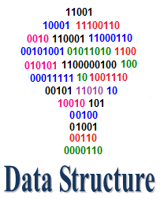

Data Structures (DS) tutorial provides basic and advanced concepts of Data Structure. Our Data Structure tutorial is designed for beginners and professionals.

Data Structure is a way to store and organize data so that it can be used efficiently.

Our Data Structure tutorial includes all topics of Data Structure such as Array, Pointer, Structure, Linked List, Stack, Queue, Graph, Searching, Sorting, Programs, etc.

What is Data Structure?

The data structure name indicates itself that organizing the data in memory. There are many ways of organizing the data in the memory as we have already seen one of the data structures, i.e., array in C language. Array is a collection of memory elements in which data is stored sequentially, i.e., one after another. In other words, we can say that array stores the elements in a continuous manner. This organization of data is done with the help of an array of data structures. There are also other ways to organize the data in memory. Let's see the different types of data structures.

The data structure is not any programming language like C, C++, java, etc. It is a set of algorithms that we can use in any programming language to structure the data in the memory.

To structure the data in memory, 'n' number of algorithms were proposed, and all these algorithms are known as Abstract data types. These abstract data types are the set of rules.

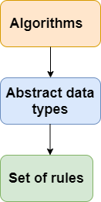

Types of Data Structures

There are two types of data structures:

* Primitive data structure
* Non-primitive data structure

**Primitive Data structure**

The primitive data structures are primitive data types. The int, char, float, double, and pointer are the primitive data structures that can hold a single value.

**Non-Primitive Data structure**

The non-primitive data structure is divided into two types:

* Linear data structure
* Non-linear data structure

**Linear Data Structure**

The arrangement of data in a sequential manner is known as a linear data structure. The data structures used for this purpose are Arrays, Linked list, Stacks, and Queues. In these data structures, one element is connected to only one another element in a linear form.

**When one element is connected to the 'n' number of elements known as a non-linear data structure. The best example is trees and graphs. In this case, the elements are arranged in a random manner.**

We will discuss the above data structures in brief in the coming topics. Now, we will see the common operations that we can perform on these data structures.

**Data structures can also be classified as:**

* **Static data structure:** It is a type of data structure where the size is allocated at the compile time. Therefore, the maximum size is fixed.
* **Dynamic data structure:** It is a type of data structure where the size is allocated at the run time. Therefore, the maximum size is flexible.

Major Operations

The major or the common operations that can be performed on the data structures are:

* **Searching:** We can search for any element in a data structure.
* **Sorting:** We can sort the elements of a data structure either in an ascending or descending order.
* **Insertion:** We can also insert the new element in a data structure.
* **Updation:** We can also update the element, i.e., we can replace the element with another element.
* **Deletion:** We can also perform the delete operation to remove the element from the data structure.

Which Data Structure?

A data structure is a way of organizing the data so that it can be used efficiently. Here, we have used the word efficiently, which in terms of both the space and time. For example, a stack is an ADT (Abstract data type) which uses either arrays or linked list data structure for the implementation. Therefore, we conclude that we require some data structure to implement a particular ADT.

An ADT tells **what** is to be done and data structure tells **how** it is to be done. In other words, we can say that ADT gives us the blueprint while data structure provides the implementation part. Now the question arises: how can one get to know which data structure to be used for a particular ADT?.

As the different data structures can be implemented in a particular ADT, but the different implementations are compared for time and space. For example, the Stack ADT can be implemented by both Arrays and linked list. Suppose the array is providing time efficiency while the linked list is providing space efficiency, so the one which is the best suited for the current user's requirements will be selected.

Advantages of Data structures

**The following are the advantages of a data structure:**

* **Efficiency:** If the choice of a data structure for implementing a particular ADT is proper, it makes the program very efficient in terms of time and space.
* **Reusability:** The data structure provides reusability means that multiple client programs can use the data structure.
* **Abstraction:** The data structure specified by an ADT also provides the level of abstraction. The client cannot see the internal working of the data structure, so it does not have to worry about the implementation part. The client can only see the interface.

# Data Structure

## Introduction

Data Structure can be defined as the group of data elements which provides an efficient way of storing and organising data in the computer so that it can be used efficiently. Some examples of Data Structures are arrays, Linked List, Stack, Queue, etc. Data Structures are widely used in almost every aspect of Computer Science i.e. Operating System, Compiler Design, Artifical intelligence, Graphics and many more.

Data Structures are the main part of many computer science algorithms as they enable the programmers to handle the data in an efficient way. It plays a vital role in enhancing the performance of a software or a program as the main function of the software is to store and retrieve the user's data as fast as possible.

### Basic Terminology

Data structures are the building blocks of any program or the software. Choosing the appropriate data structure for a program is the most difficult task for a programmer. Following terminology is used as far as data structures are concerned.

**Data:** Data can be defined as an elementary value or the collection of values, for example, student's name and its id are the data about the student.

**Group Items:** Data items which have subordinate data items are called Group item, for example, name of a student can have first name and the last name.

**Record:** Record can be defined as the collection of various data items, for example, if we talk about the student entity, then its name, address, course and marks can be grouped together to form the record for the student.

**File:** A File is a collection of various records of one type of entity, for example, if there are 60 employees in the class, then there will be 20 records in the related file where each record contains the data about each employee.

**Attribute and Entity:** An entity represents the class of certain objects. it contains various attributes. Each attribute represents the particular property of that entity.

**Field:** Field is a single elementary unit of information representing the attribute of an entity.

### Need of Data Structures

As applications are getting complexed and amount of data is increasing day by day, there may arrise the following problems:

**Processor speed:** To handle very large amout of data, high speed processing is required, but as the data is growing day by day to the billions of files per entity, processor may fail to deal with that much amount of data.

**Data Search:** Consider an inventory size of 106 items in a store, If our application needs to search for a particular item, it needs to traverse 106 items every time, results in slowing down the search process.

**Multiple requests:** If thousands of users are searching the data simultaneously on a web server, then there are the chances that a very large server can be failed during that process

in order to solve the above problems, data structures are used. Data is organized to form a data structure in such a way that all items are not required to be searched and required data can be searched instantly.

### Advantages of Data Structures

**Efficiency:** Efficiency of a program depends upon the choice of data structures. For example: suppose, we have some data and we need to perform the search for a perticular record. In that case, if we organize our data in an array, we will have to search sequentially element by element. hence, using array may not be very efficient here. There are better data structures which can make the search process efficient like ordered array, binary search tree or hash tables.

**Reusability:** Data structures are reusable, i.e. once we have implemented a particular data structure, we can use it at any other place. Implementation of data structures can be compiled into libraries which can be used by different clients.

**Abstraction:** Data structure is specified by the ADT which provides a level of abstraction. The client program uses the data structure through interface only, without getting into the implementation details.

### Data Structure Classification

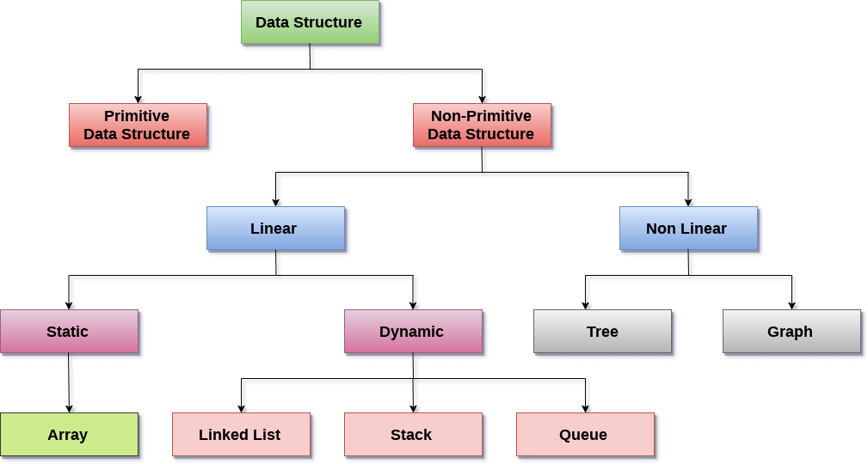

**Linear Data Structures:** A data structure is called linear if all of its elements are arranged in the linear order. In linear data structures, the elements are stored in non-hierarchical way where each element has the successors and predecessors except the first and last element.

Types of Linear Data Structures are given below:

**Arrays:** An array is a collection of similar type of data items and each data item is called an element of the array. The data type of the element may be any valid data type like char, int, float or double.

The elements of array share the same variable name but each one carries a different index number known as subscript. The array can be one dimensional, two dimensional or multidimensional.

The individual elements of the array age are:

age[0], age[1], age[2], age[3],......... age[98], age[99].

**Linked List:** Linked list is a linear data structure which is used to maintain a list in the memory. It can be seen as the collection of nodes stored at non-contiguous memory locations. Each node of the list contains a pointer to its adjacent node.

**Stack:** Stack is a linear list in which insertion and deletions are allowed only at one end, called **top**.

A stack is an abstract data type (ADT), can be implemented in most of the programming languages. It is named as stack because it behaves like a real-world stack, for example: - piles of plates or deck of cards etc.

**Queue:** Queue is a linear list in which elements can be inserted only at one end called **rear** and deleted only at the other end called **front**.

It is an abstract data structure, similar to stack. Queue is opened at both end therefore it follows First-In-First-Out (FIFO) methodology for storing the data items.

**Non Linear Data Structures:** This data structure does not form a sequence i.e. each item or element is connected with two or more other items in a non-linear arrangement. The data elements are not arranged in sequential structure.

Types of Non Linear Data Structures are given below:

**Trees:** Trees are multilevel data structures with a hierarchical relationship among its elements known as nodes. The bottommost nodes in the herierchy are called **leaf node** while the topmost node is called **root node**. Each node contains pointers to point adjacent nodes.

Tree data structure is based on the parent-child relationship among the nodes. Each node in the tree can have more than one children except the leaf nodes whereas each node can have atmost one parent except the root node. Trees can be classfied into many categories which will be discussed later in this tutorial.

**Graphs:** Graphs can be defined as the pictorial representation of the set of elements (represented by vertices) connected by the links known as edges. A graph is different from tree in the sense that a graph can have cycle while the tree can not have the one.

### Operations on data structure

1) **Traversing:** Every data structure contains the set of data elements. Traversing the data structure means visiting each element of the data structure in order to perform some specific operation like searching or sorting.

**Example:** If we need to calculate the average of the marks obtained by a student in 6 different subject, we need to traverse the complete array of marks and calculate the total sum, then we will devide that sum by the number of subjects i.e. 6, in order to find the average.

2) **Insertion:** Insertion can be defined as the process of adding the elements to the data structure at any location.

If the size of data structure is **n** then we can only insert **n-1** data elements into it.

3) **Deletion:**The process of removing an element from the data structure is called Deletion. We can delete an element from the data structure at any random location.

If we try to delete an element from an empty data structure then **underflow** occurs.

4) **Searching:** The process of finding the location of an element within the data structure is called Searching. There are two algorithms to perform searching, Linear Search and Binary Search. We will discuss each one of them later in this tutorial.

5) **Sorting:** The process of arranging the data structure in a specific order is known as Sorting. There are many algorithms that can be used to perform sorting, for example, insertion sort, selection sort, bubble sort, etc.

6) **Merging:** When two lists List A and List B of size M and N respectively, of similar type of elements, clubbed or joined to produce the third list, List C of size (M+N), then this process is called merging

# DS Algorithm

## What is an Algorithm?

An algorithm is a process or a set of rules required to perform calculations or some other problem-solving operations especially by a computer. The formal definition of an algorithm is that it contains the finite set of instructions which are being carried in a specific order to perform the specific task. It is not the complete program or code; it is just a solution (logic) of a problem, which can be represented either as an informal description using a Flowchart or Pseudocode.

### Characteristics of an Algorithm

**The following are the characteristics of an algorithm:**

* **Input:** An algorithm has some input values. We can pass 0 or some input value to an algorithm.
* **Output:** We will get 1 or more output at the end of an algorithm.
* **Unambiguity:** An algorithm should be unambiguous which means that the instructions in an algorithm should be clear and simple.
* **Finiteness:** An algorithm should have finiteness. Here, finiteness means that the algorithm should contain a limited number of instructions, i.e., the instructions should be countable.
* **Effectiveness:** An algorithm should be effective as each instruction in an algorithm affects the overall process.
* **Language independent:** An algorithm must be language-independent so that the instructions in an algorithm can be implemented in any of the languages with the same output.

### Dataflow of an Algorithm

* **Problem:** A problem can be a real-world problem or any instance from the real-world problem for which we need to create a program or the set of instructions. The set of instructions is known as an algorithm.
* **Algorithm:** An algorithm will be designed for a problem which is a step by step procedure.
* **Input:** After designing an algorithm, the required and the desired inputs are provided to the algorithm.
* **Processing unit:** The input will be given to the processing unit, and the processing unit will produce the desired output.
* **Output:** The output is the outcome or the result of the program.

### Why do we need Algorithms?

**We need algorithms because of the following reasons:**

* **Scalability:** It helps us to understand the scalability. When we have a big real-world problem, we need to scale it down into small-small steps to easily analyze the problem.
* **Performance:** The real-world is not easily broken down into smaller steps. If the problem can be easily broken into smaller steps means that the problem is feasible.

Let's understand the algorithm through a real-world example. Suppose we want to make a lemon juice, so following are the steps required to make a lemon juice:

Step 1: First, we will cut the lemon into half.

Step 2: Squeeze the lemon as much you can and take out its juice in a container.

Step 3: Add two tablespoon sugar in it.

Step 4: Stir the container until the sugar gets dissolved.

Step 5: When sugar gets dissolved, add some water and ice in it.

Step 6: Store the juice in a fridge for 5 to minutes.

Step 7: Now, it's ready to drink.

The above real-world can be directly compared to the definition of the algorithm. We cannot perform the step 3 before the step 2, we need to follow the specific order to make lemon juice. An algorithm also says that each and every instruction should be followed in a specific order to perform a specific task.

Now we will look an example of an algorithm in programming.

We will write an algorithm to add two numbers entered by the user.

**The following are the steps required to add two numbers entered by the user:**

Step 1: Start

Step 2: Declare three variables a, b, and sum.

Step 3: Enter the values of a and b.

Step 4: Add the values of a and b and store the result in the sum variable, i.e., sum=a+b.

Step 5: Print sum

Step 6: Stop

### Factors of an Algorithm

**The following are the factors that we need to consider for designing an algorithm:**

* **Modularity:** If any problem is given and we can break that problem into small-small modules or small-small steps, which is a basic definition of an algorithm, it means that this feature has been perfectly designed for the algorithm.
* **Correctness:** The correctness of an algorithm is defined as when the given inputs produce the desired output, which means that the algorithm has been designed algorithm. The analysis of an algorithm has been done correctly.
* **Maintainability:** Here, maintainability means that the algorithm should be designed in a very simple structured way so that when we redefine the algorithm, no major change will be done in the algorithm.
* **Functionality:** It considers various logical steps to solve the real-world problem.
* **Robustness:** Robustness means that how an algorithm can clearly define our problem.
* **User-friendly:** If the algorithm is not user-friendly, then the designer will not be able to explain it to the programmer.
* **Simplicity:** If the algorithm is simple then it is easy to understand.
* **Extensibility:** If any other algorithm designer or programmer wants to use your algorithm then it should be extensible.

### Importance of Algorithms

1. **Theoretical importance:** When any real-world problem is given to us and we break the problem into small-small modules. To break down the problem, we should know all the theoretical aspects.
2. **Practical importance:** As we know that theory cannot be completed without the practical implementation. So, the importance of algorithm can be considered as both theoretical and practical.

### Issues of Algorithms

**The following are the issues that come while designing an algorithm:**

* **How to design algorithms:** As we know that an algorithm is a step-by-step procedure so we must follow some steps to design an algorithm.
* **How to analyze algorithm efficiency**

### Approaches of Algorithm

**The following are the approaches used after considering both the theoretical and practical importance of designing an algorithm:**

* **Brute force algorithm:** The general logic structure is applied to design an algorithm. It is also known as an exhaustive search algorithm that searches all the possibilities to provide the required solution. Such algorithms are of two types:
  1. **Optimizing:** Finding all the solutions of a problem and then take out the best solution or if the value of the best solution is known then it will terminate if the best solution is known.
  2. **Sacrificing:** As soon as the best solution is found, then it will stop.
* **Divide and conquer:** It is a very implementation of an algorithm. It allows you to design an algorithm in a step-by-step variation. It breaks down the algorithm to solve the problem in different methods. It allows you to break down the problem into different methods, and valid output is produced for the valid input. This valid output is passed to some other function.
* **Greedy algorithm:** It is an algorithm paradigm that makes an optimal choice on each iteration with the hope of getting the best solution. It is easy to implement and has a faster execution time. But, there are very rare cases in which it provides the optimal solution.
* **Dynamic programming:** It makes the algorithm more efficient by storing the intermediate results. It follows five different steps to find the optimal solution for the problem:
  1. It breaks down the problem into a subproblem to find the optimal solution.
  2. After breaking down the problem, it finds the optimal solution out of these subproblems.
  3. Stores the result of the subproblems is known as memorization.
  4. Reuse the result so that it cannot be recomputed for the same subproblems.
  5. Finally, it computes the result of the complex program.
* **Branch and Bound Algorithm:** The branch and bound algorithm can be applied to only integer programming problems. This approach divides all the sets of feasible solutions into smaller subsets. These subsets are further evaluated to find the best solution.
* **Randomized Algorithm:** As we have seen in a regular algorithm, we have predefined input and required output. Those algorithms that have some defined set of inputs and required output, and follow some described steps are known as deterministic algorithms. What happens that when the random variable is introduced in the randomized algorithm?. In a randomized algorithm, some random bits are introduced by the algorithm and added in the input to produce the output, which is random in nature. Randomized algorithms are simpler and efficient than the deterministic algorithm.
* **Backtracking:** Backtracking is an algorithmic technique that solves the problem recursively and removes the solution if it does not satisfy the constraints of a problem.

The major categories of algorithms are given below:

* **Sort:** Algorithm developed for sorting the items in a certain order.
* **Search:** Algorithm developed for searching the items inside a data structure.
* **Delete:** Algorithm developed for deleting the existing element from the data structure.
* **Insert:** Algorithm developed for inserting an item inside a data structure.
* **Update:** Algorithm developed for updating the existing element inside a data structure.

### Algorithm Analysis

The algorithm can be analyzed in two levels, i.e., first is before creating the algorithm, and second is after creating the algorithm. The following are the two analysis of an algorithm:

* Priori Analysis: Here, priori analysis is the theoretical analysis of an algorithm which is done before implementing the algorithm. Various factors can be considered before implementing the algorithm like processor speed, which has no effect on the implementation part.
* Posterior Analysis: Here, posterior analysis is a practical analysis of an algorithm. The practical analysis is achieved by implementing the algorithm using any programming language. This analysis basically evaluate that how much running time and space taken by the algorithm.

### Algorithm Complexity

The performance of the algorithm can be measured in two factors:

* **Time complexity:** The time complexity of an algorithm is the amount of time required to complete the execution. The time complexity of an algorithm is denoted by the big O notation. Here, big O notation is the asymptotic notation to represent the time complexity. The time complexity is mainly calculated by counting the number of steps to finish the execution. Let's understand the time complexity through an example.

1. sum=0;
2. // Suppose we have to calculate the sum of n numbers.
3. **for** i=1 to n
4. sum=sum+i;
5. // when the loop ends then sum holds the sum of the n numbers
6. **return** sum;

In the above code, the time complexity of the loop statement will be atleast n, and if the value of n increases, then the time complexity also increases. While the complexity of the code, i.e., return sum will be constant as its value is not dependent on the value of n and will provide the result in one step only. We generally consider the worst-time complexity as it is the maximum time taken for any given input size.

* **Space complexity:** An algorithm's space complexity is the amount of space required to solve a problem and produce an output. Similar to the time complexity, space complexity is also expressed in big O notation.

For an algorithm, the space is required for the following purposes:

1. To store program instructions
2. To store constant values
3. To store variable values
4. To track the function calls, jumping statements, etc.

Auxiliary space: The extra space required by the algorithm, excluding the input size, is known as an auxiliary space. The space complexity considers both the spaces, i.e., auxiliary space, and space used by the input.

So,

**Space complexity = Auxiliary space + Input size.**

### Types of Algorithms

**The following are the types of algorithm:**

* **Search Algorithm**
* **Sort Algorithm**

**Search Algorithm**

On each day, we search for something in our day to day life. Similarly, with the case of computer, huge data is stored in a computer that whenever the user asks for any data then the computer searches for that data in the memory and provides that data to the user. There are mainly two techniques available to search the data in an array:

* **Linear search**
* **Binary search**

**Linear Search**

Linear search is a very simple algorithm that starts searching for an element or a value from the beginning of an array until the required element is not found. It compares the element to be searched with all the elements in an array, if the match is found, then it returns the index of the element else it returns -1. This algorithm can be implemented on the unsorted list.

**Binary Search**

A Binary algorithm is the simplest algorithm that searches the element very quickly. It is used to search the element from the sorted list. The elements must be stored in sequential order or the sorted manner to implement the binary algorithm. Binary search cannot be implemented if the elements are stored in a random manner. It is used to find the middle element of the list.

### Sorting Algorithms

Sorting algorithms are used to rearrange the elements in an array or a given data structure either in an ascending or descending order. The comparison operator decides the new order of the elements.

### Why do we need a sorting algorithm?

* An efficient sorting algorithm is required for optimizing the efficiency of other algorithms like binary search algorithm as a binary search algorithm requires an array to be sorted in a particular order, mainly in ascending order.
* It produces information in a sorted order, which is a human-readable format.
* Searching a particular element in a sorted list is faster than the unsorted list.

Asymptotic Analysis

As we know that data structure is a way of organizing the data efficiently and that efficiency is measured either in terms of time or space. So, the ideal data structure is a structure that occupies the least possible time to perform all its operation and the memory space. Our focus would be on finding the time complexity rather than space complexity, and by finding the time complexity, we can decide which data structure is the best for an algorithm.

The main question arises in our mind that on what basis should we compare the time complexity of data structures?. The time complexity can be compared based on operations performed on them. Let's consider a simple example.

Suppose we have an array of 100 elements, and we want to insert a new element at the beginning of the array. This becomes a very tedious task as we first need to shift the elements towards the right, and we will add new element at the starting of the array.

Suppose we consider the linked list as a data structure to add the element at the beginning. The linked list contains two parts, i.e., data and address of the next node. We simply add the address of the first node in the new node, and head pointer will now point to the newly added node. Therefore, we conclude that adding the data at the beginning of the linked list is faster than the arrays. In this way, we can compare the data structures and select the best possible data structure for performing the operations.

How to find the Time Complexity or running time for performing the operations?

The measuring of the actual running time is not practical at all. The running time to perform any operation depends on the size of the input. Let's understand this statement through a simple example.

Suppose we have an array of five elements, and we want to add a new element at the beginning of the array. To achieve this, we need to shift each element towards right, and suppose each element takes one unit of time. There are five elements, so five units of time would be taken. Suppose there are 1000 elements in an array, then it takes 1000 units of time to shift. It concludes that time complexity depends upon the input size.

Therefore, if the input size is n, then f(n) is a function of n that denotes the time complexity.

How to calculate f(n)?

Calculating the value of f(n) for smaller programs is easy but for bigger programs, it's not that easy. We can compare the data structures by comparing their f(n) values. We can compare the data structures by comparing their f(n) values. We will find the growth rate of f(n) because there might be a possibility that one data structure for a smaller input size is better than the other one but not for the larger sizes. Now, how to find f(n).

Let's look at a simple example.

f(n) = 5n2 + 6n + 12

where n is the number of instructions executed, and it depends on the size of the input.

When n=1

% of running time due to 5n2 = Asymptotic Analysis * 100 = 21.74%

% of running time due to 6n = Asymptotic Analysis * 100 = 26.09%

% of running time due to 12 = Asymptotic Analysis * 100 = 52.17%

From the above calculation, it is observed that most of the time is taken by 12. But, we have to find the growth rate of f(n), we cannot say that the maximum amount of time is taken by 12. Let's assume the different values of n to find the growth rate of f(n).

|  |  |  |  |
| --- | --- | --- | --- |
| n | 5n2 | 6n | 12 |
| 1 | 21.74% | 26.09% | 52.17% |
| 10 | 87.41% | 10.49% | 2.09% |
| 100 | 98.79% | 1.19% | 0.02% |
| 1000 | 99.88% | 0.12% | 0.0002% |

As we can observe in the above table that with the increase in the value of n, the running time of 5n2 increases while the running time of 6n and 12 also decreases. Therefore, it is observed that for larger values of n, the squared term consumes almost 99% of the time. As the n2 term is contributing most of the time, so we can eliminate the rest two terms.

**Therefore,**

f(n) = 5n2

Here, we are getting the approximate time complexity whose result is very close to the actual result. And this approximate measure of time complexity is known as an Asymptotic complexity. Here, we are not calculating the exact running time, we are eliminating the unnecessary terms, and we are just considering the term which is taking most of the time.

In mathematical analysis, asymptotic analysis of algorithm is a method of defining the mathematical boundation of its run-time performance. Using the asymptotic analysis, we can easily conclude the average-case, best-case and worst-case scenario of an algorithm.

It is used to mathematically calculate the running time of any operation inside an algorithm.

**Example:** Running time of one operation is x(n) and for another operation, it is calculated as f(n2). It refers to running time will increase linearly with an increase in 'n' for the first operation, and running time will increase exponentially for the second operation. Similarly, the running time of both operations will be the same if n is significantly small.

Usually, the time required by an algorithm comes under three types:

**Worst case:** It defines the input for which the algorithm takes a huge time.

**Average case:** It takes average time for the program execution.

**Best case:** It defines the input for which the algorithm takes the lowest time

Asymptotic Notations

The commonly used asymptotic notations used for calculating the running time complexity of an algorithm is given below:

* Big oh Notation (?)
* Omega Notation (Ω)
* Theta Notation (θ)

Big oh Notation (O)

* Big O notation is an asymptotic notation that measures the performance of an algorithm by simply providing the order of growth of the function.
* This notation provides an upper bound on a function which ensures that the function never grows faster than the upper bound. So, it gives the least upper bound on a function so that the function never grows faster than this upper bound.

It is the formal way to express the upper boundary of an algorithm running time. It measures the worst case of time complexity or the algorithm's longest amount of time to complete its operation. It is represented as shown below:

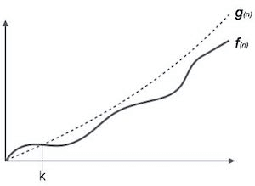

**For example:**

If **f(n)** and **g(n)** are the two functions defined for positive integers,

then **f(n)** = **O(g(n))** as **f(n) is big oh of g(n)** or f(n) is on the order of g(n)) if there exists constants c and no such that:

**f(n)≤c.g(n) for all n≥no**

This implies that f(n) does not grow faster than g(n), or g(n) is an upper bound on the function f(n). In this case, we are calculating the growth rate of the function which eventually calculates the worst time complexity of a function, i.e., how worst an algorithm can perform.

**Let's understand through examples**

Example 1: f(n)=2n+3 , g(n)=n

Now, we have to find **Is f(n)=O(g(n))?**

To check f(n)=O(g(n)), it must satisfy the given condition:

**f(n)<=c.g(n)**

First, we will replace f(n) by 2n+3 and g(n) by n.

2n+3 <= c.n

Let's assume c=5, n=1 then

2*1+3<=5*1

5<=5

For n=1, the above condition is true.

If n=2

2*2+3<=5*2

7<=10

For n=2, the above condition is true.

We know that for any value of n, it will satisfy the above condition, i.e., 2n+3<=c.n. If the value of c is equal to 5, then it will satisfy the condition 2n+3<=c.n. We can take any value of n starting from 1, it will always satisfy. Therefore, we can say that for some constants c and for some constants n0, it will always satisfy 2n+3<=c.n. As it is satisfying the above condition, so f(n) is big oh of g(n) or we can say that f(n) grows linearly. Therefore, it concludes that c.g(n) is the upper bound of the f(n). It can be represented graphically as:

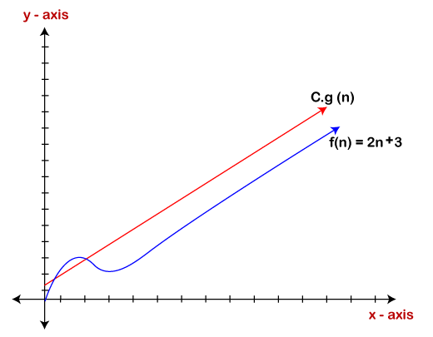

The idea of using big o notation is to give an upper bound of a particular function, and eventually it leads to give a worst-time complexity. It provides an assurance that a particular function does not behave suddenly as a quadratic or a cubic fashion, it just behaves in a linear manner in a worst-case.

Omega Notation (Ω)

* It basically describes the best-case scenario which is opposite to the big o notation.
* It is the formal way to represent the lower bound of an algorithm's running time. It measures the best amount of time an algorithm can possibly take to complete or the best-case time complexity.
* It determines what is the fastest time that an algorithm can run.

If we required that an algorithm takes at least certain amount of time without using an upper bound, we use big- Ω notation i.e. the Greek letter "omega". It is used to bound the growth of running time for large input size.

If **f(n)** and **g(n)** are the two functions defined for positive integers,

then **f(n) = Ω (g(n))** as **f(n) is Omega of g(n)** or f(n) is on the order of g(n)) if there exists constants c and no such that:

**f(n)>=c.g(n) for all n≥no and c>0**

**Let's consider a simple example.**

If f(n) = 2n+3, g(n) = n,

Is f(n)= **Ω** (g(n))?

It must satisfy the condition:

**f(n)>=c.g(n)**

To check the above condition, we first replace f(n) by 2n+3 and g(n) by n.

**2n+3>=c*n**

Suppose c=1

**2n+3>=n** (This equation will be true for any value of n starting from 1).

Therefore, it is proved that g(n) is big omega of 2n+3 function.

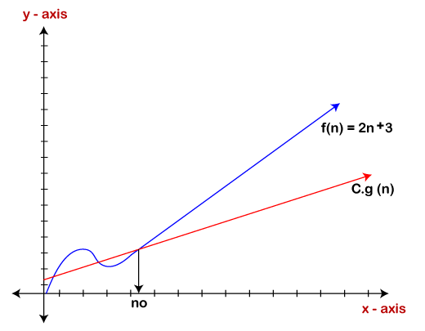

As we can see in the above figure that g(n) function is the lower bound of the f(n) function when the value of c is equal to 1. Therefore, this notation gives the fastest running time. But, we are not more interested in finding the fastest running time, we are interested in calculating the worst-case scenarios because we want to check our algorithm for larger input that what is the worst time that it will take so that we can take further decision in the further process.

Theta Notation (θ)

* The theta notation mainly describes the average case scenarios.
* It represents the realistic time complexity of an algorithm. Every time, an algorithm does not perform worst or best, in real-world problems, algorithms mainly fluctuate between the worst-case and best-case, and this gives us the average case of the algorithm.
* Big theta is mainly used when the value of worst-case and the best-case is same.
* It is the formal way to express both the upper bound and lower bound of an algorithm running time.

Let's understand the big theta notation mathematically:

Let f(n) and g(n) be the functions of n where n is the steps required to execute the program then:

**f(n)= θg(n)**

The above condition is satisfied only if when

**c1.g(n)<=f(n)<=c2.g(n)**

where the function is bounded by two limits, i.e., upper and lower limit, and f(n) comes in between. The condition **f(n)= θg(n)** will be true if and only if c1.g(n) is less than or equal to f(n) and c2.g(n) is greater than or equal to f(n). The graphical representation of theta notation is given below:

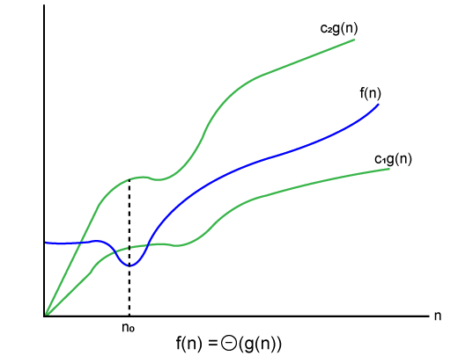

Let's consider the same example where  
f(n)=2n+3  
g(n)=n

As c1.g(n) should be less than f(n) so c1 has to be 1 whereas c2.g(n) should be greater than f(n) so c2 is equal to 5. The c1.g(n) is the lower limit of the of the f(n) while c2.g(n) is the upper limit of the f(n).

c1.g(n)<=f(n)<=c2.g(n)

Replace g(n) by n and f(n) by 2n+3

c1.n <=2n+3<=c2.n

if c1=1, c2=2, n=1

1*1 <=2*1+3 <=2*1

**1** <= **5** <= **2** // for n=1, it satisfies the condition c1.g(n)<=f(n)<=c2.g(n)

**If n=2**

1*2<=2*2+3<=2*2

2<=7<=4 // for n=2, it satisfies the condition c1.g(n)<=f(n)<=c2.g(n)

Therefore, we can say that for any value of n, it satisfies the condition c1.g(n)<=f(n)<=c2.g(n). Hence, it is proved that f(n) is big theta of g(n). So, this is the average-case scenario which provides the realistic time complexity.

Why we have three different asymptotic analysis?

As we know that big omega is for the best case, big oh is for the worst case while big theta is for the average case. Now, we will find out the average, worst and the best case of the linear search algorithm.

Suppose we have an array of n numbers, and we want to find the particular element in an array using the linear search. In the linear search, every element is compared with the searched element on each iteration. Suppose, if the match is found in a first iteration only, then the best case would be Ω(1), if the element matches with the last element, i.e., nth element of the array then the worst case would be O(n). The average case is the mid of the best and the worst-case, so it becomes **θ(n/1). The constant terms can be ignored in the time complexity so average case would be θ(n)**.

So, three different analysis provide the proper bounding between the actual functions. Here, bounding means that we have upper as well as lower limit which assures that the algorithm will behave between these limits only, i.e., it will not go beyond these limits.

Common Asymptotic Notations

|  |  |  |
| --- | --- | --- |
| constant | - | ?(1) |
| linear | - | ?(n) |
| logarithmic | - | ?(log n) |
| n log n | - | ?(n log n) |
| exponential | - | 2?(n) |
| cubic | - | ?(n3) |
| polynomial | - | n?(1) |
| quadratic | - | ?(n2) |

# Pointer

Pointer is used to points the address of the value stored anywhere in the computer memory. To obtain the value stored at the location is known as dereferencing the pointer. Pointer improves the performance for repetitive process such as:

* Traversing String
* Lookup Tables
* Control Tables
* Tree Structures

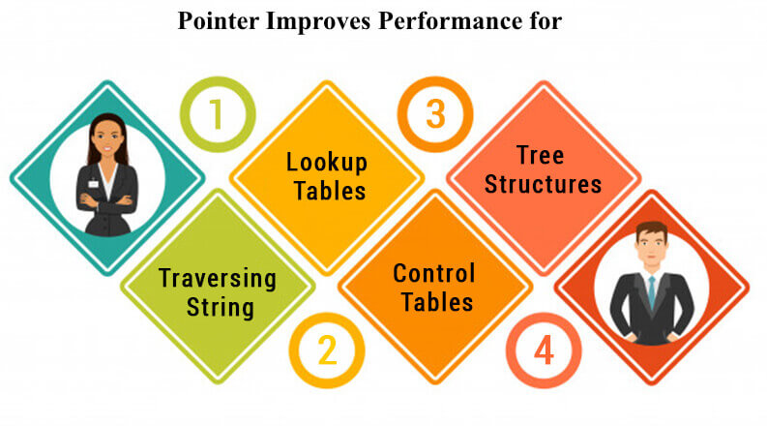

## Pointer Details

* **Pointer arithmetic:** There are four arithmetic operators that can be used in pointers: ++, --, +, -
* **Array of pointers:** You can define arrays to hold a number of pointers.
* **Pointer to pointer:** C allows you to have pointer on a pointer and so on.
* **Passing pointers to functions in C:** Passing an argument by reference or by address enable the passed argument to be changed in the calling function by the called function.
* **Return pointer from functions in C:** C allows a function to return a pointer to the local variable, static variable and dynamically allocated memory as well.

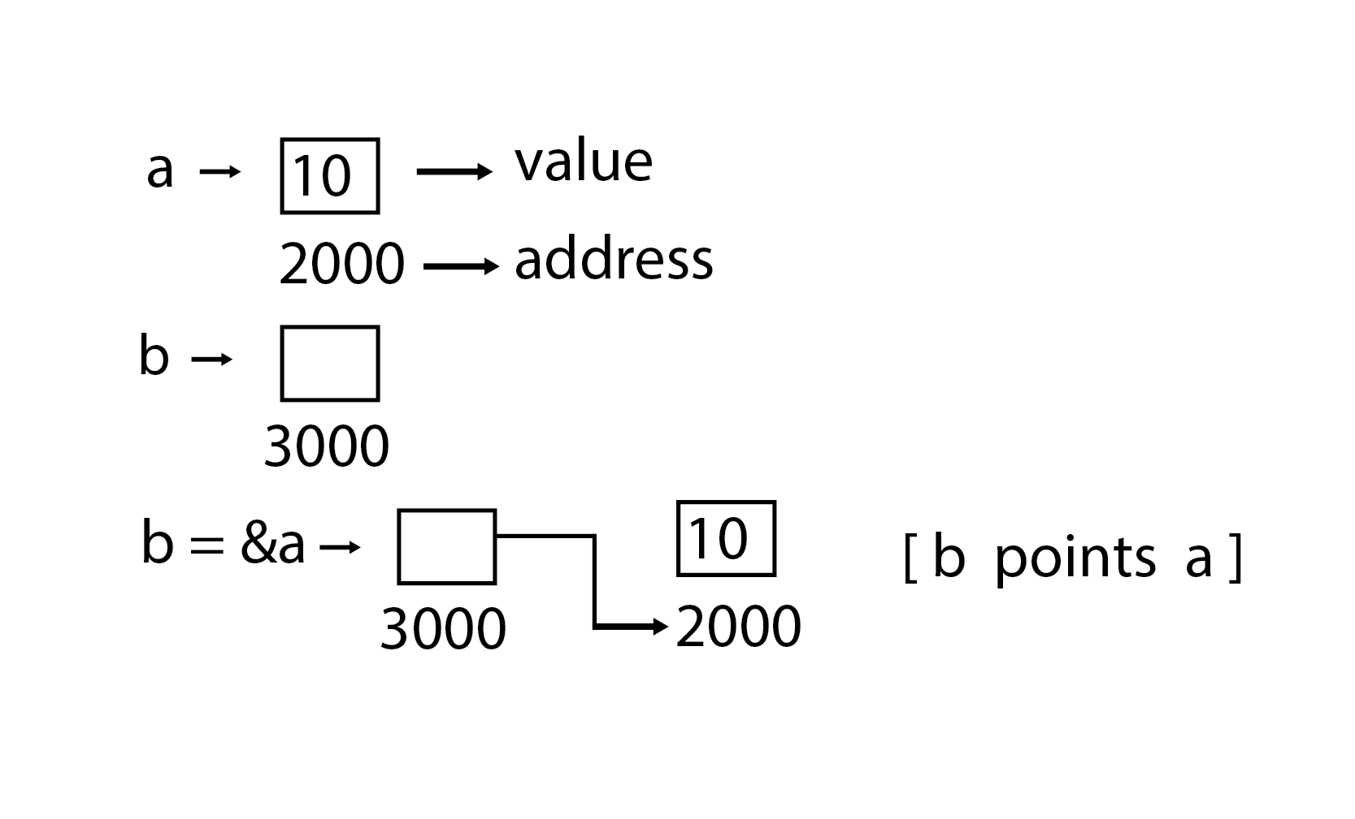

### Program

#### Pointer

1. #include <stdio.h>
3. **int** main( )
4. {
5. **int** a = 5;
6. **int** *b;
7. b = &a;
9. printf ("value of a = %d\n", a);
10. printf ("value of a = %d\n", *(&a));
11. printf ("value of a = %d\n", *b);
12. printf ("address of a = %u\n", &a);
13. printf ("address of a = %d\n", b);
14. printf ("address of b = %u\n", &b);
15. printf ("value of b = address of a = %u", b);
16. **return** 0;
17. }

#### Output

1. value of a = 5
2. value of a = 5
3. address of a = 3010494292
4. address of a = -1284473004
5. address of b = 3010494296
6. value of b = address of a = 3010494292

### Program

#### Pointer to Pointer

1. #include <stdio.h>
3. **int** main( )
4. {
5. **int** a = 5;
6. **int** *b;
7. **int** **c;
8. b = &a;
9. c = &b;
10. printf ("value of a = %d\n", a);
11. printf ("value of a = %d\n", *(&a));
12. printf ("value of a = %d\n", *b);
13. printf ("value of a = %d\n", **c);
14. printf ("value of b = address of a = %u\n", b);
15. printf ("value of c = address of b = %u\n", c);
16. printf ("address of a = %u\n", &a);
17. printf ("address of a = %u\n", b);
18. printf ("address of a = %u\n", *c);
19. printf ("address of b = %u\n", &b);
20. printf ("address of b = %u\n", c);
21. printf ("address of c = %u\n", &c);
22. **return** 0;
23. }

#### Pointer to Pointer

1. value of a = 5
2. value of a = 5
3. value of a = 5
4. value of a = 5
5. value of b = address of a = 2831685116
6. value of c = address of b = 2831685120
7. address of a = 2831685116
8. address of a = 2831685116
9. address of a = 2831685116
10. address of b = 2831685120
11. address of b = 2831685120
12. address of c = 2831685128

Structure

A structure is a composite data type that defines a grouped list of variables that are to be placed under one name in a block of memory. It allows different variables to be accessed by using a single pointer to the structure.

**Syntax**

1. struct structure_name
2. {
3. data_type member1;
4. data_type member2;
5. .
6. .
7. data_type memeber;
8. };

Advantages

* It can hold variables of different data types.
* We can create objects containing different types of attributes.
* It allows us to re-use the data layout across programs.
* It is used to implement other data structures like linked lists, stacks, queues, trees, graphs etc.

**Program**

1. #include<stdio.h>
2. #include<conio.h>
3. **void** main( )
4. {
5. struct employee
6. {
7. **int** id ;
8. **float** salary ;
9. **int** mobile ;
10. } ;
11. struct employee e1,e2,e3 ;
12. clrscr();
13. printf ("\nEnter ids, salary & mobile no. of 3 employee\n"
14. scanf ("%d %f %d", &e1.id, &e1.salary, &e1.mobile);
15. scanf ("%d%f %d", &e2.id, &e2.salary, &e2.mobile);
16. scanf ("%d %f %d", &e3.id, &e3.salary, &e3.mobile);
17. printf ("\n Entered Result ");
18. printf ("\n%d %f %d", e1.id, e1.salary, e1.mobile);
19. printf ("\n%d%f %d", e2.id, e2.salary, e2.mobile);
20. printf ("\n%d %f %d", e3.id, e3.salary, e3.mobile);
21. getch();
22. }

# Array in Data Structure

In this article, we will discuss the array in data structure. Arrays are defined as the collection of similar types of data items stored at contiguous memory locations. It is one of the simplest data structures where each data element can be randomly accessed by using its index number.

In C programming, they are the derived data types that can store the primitive type of data such as int, char, double, float, etc. For example, if we want to store the marks of a student in 6 subjects, then we don't need to define a different variable for the marks in different subjects. Instead, we can define an array that can store the marks in each subject at the contiguous memory locations.

### Properties of array

There are some of the properties of an array that are listed as follows -

* Each element in an array is of the same data type and carries the same size that is 4 bytes.
* Elements in the array are stored at contiguous memory locations from which the first element is stored at the smallest memory location.
* Elements of the array can be randomly accessed since we can calculate the address of each element of the array with the given base address and the size of the data element.

### Representation of an array

We can represent an array in various ways in different programming languages. As an illustration, let's see the declaration of array in C language -

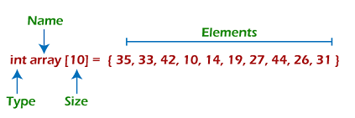

As per the above illustration, there are some of the following important points -

* Index starts with 0.
* The array's length is 10, which means we can store 10 elements.
* Each element in the array can be accessed via its index.

### Why are arrays required?

Arrays are useful because -

* Sorting and searching a value in an array is easier.
* Arrays are best to process multiple values quickly and easily.
* **Arrays are good for storing multiple values in a single variable -** In computer programming, most cases require storing a large number of data of a similar type. To store such an amount of data, we need to define a large number of variables. It would be very difficult to remember the names of all the variables while writing the programs. Instead of naming all the variables with a different name, it is better to define an array and store all the elements into it.

### Memory allocation of an array

As stated above, all the data elements of an array are stored at contiguous locations in the main memory. The name of the array represents the base address or the address of the first element in the main memory. Each element of the array is represented by proper indexing.

We can define the indexing of an array in the below ways -

1. 0 (zero-based indexing): The first element of the array will be arr[0].
2. 1 (one-based indexing): The first element of the array will be arr[1].
3. n (n - based indexing): The first element of the array can reside at any random index number.

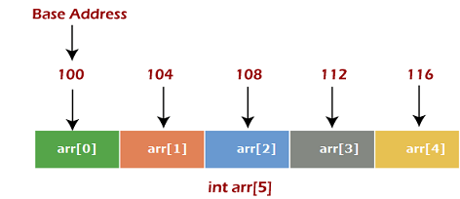

In the above image, we have shown the memory allocation of an array arr of size 5. The array follows a 0-based indexing approach. The base address of the array is 100 bytes. It is the address of arr[0]. Here, the size of the data type used is 4 bytes; therefore, each element will take 4 bytes in the memory.

### How to access an element from the array?

We required the information given below to access any random element from the array -

* Base Address of the array.
* Size of an element in bytes.
* Type of indexing, array follows.

The formula to calculate the address to access an array element -

1. Byte address of element A[i]  = base address + size * ( i - first index)

Here, size represents the memory taken by the primitive data types. As an instance, **int** takes 2 bytes, **float** takes 4 bytes of memory space in C programming.

We can understand it with the help of an example -

Suppose an array, A[-10 ..... +2 ] having Base address (BA) = 999 and size of an element = 2 bytes, find the location of A[-1].

L(A[-1]) = 999 + 2 x [(-1) - (-10)]

= 999 + 18

= 1017

## Basic operations

Now, let's discuss the basic operations supported in the array -

* Traversal - This operation is used to print the elements of the array.
* Insertion - It is used to add an element at a particular index.
* Deletion - It is used to delete an element from a particular index.
* Search - It is used to search an element using the given index or by the value.
* Update - It updates an element at a particular index.

### Traversal operation

This operation is performed to traverse through the array elements. It prints all array elements one after another. We can understand it with the below program -

1. #include <stdio.h>
2. **void** main() {
3. **int** Arr[5] = {18, 30, 15, 70, 12};
4. **int** i;
5. printf("Elements of the array are:\n");
6. **for**(i = 0; i<5; i++) {
7. printf("Arr[%d] = %d,  ", i, Arr[i]);
8. }
9. }

**Output**

Array in DS

### Insertion operation

This operation is performed to insert one or more elements into the array. As per the requirements, an element can be added at the beginning, end, or at any index of the array. Now, let's see the implementation of inserting an element into the array.

1. #include <stdio.h>
2. **int** main()
3. {
4. **int** arr[20] = { 18, 30, 15, 70, 12 };
5. **int** i, x, pos, n = 5;
6. printf("Array elements before insertion\n");
7. **for** (i = 0; i < n; i++)
8. printf("%d ", arr[i]);
9. printf("\n");
11. x = 50; // element to be inserted
12. pos = 4;
13. n++;
15. **for** (i = n-1; i >= pos; i--)
16. arr[i] = arr[i - 1];
17. arr[pos - 1] = x;
18. printf("Array elements after insertion\n");
19. **for** (i = 0; i < n; i++)
20. printf("%d ", arr[i]);
21. printf("\n");
22. **return** 0;
23. }

**Output**

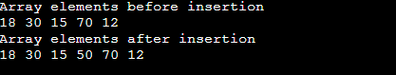

### Deletion operation

As the name implies, this operation removes an element from the array and then reorganizes all of the array elements.

1. #include <stdio.h>
3. **void** main() {
4. **int** arr[] = {18, 30, 15, 70, 12};
5. **int** k = 30, n = 5;
6. **int** i, j;
8. printf("Given array elements are :\n");
10. **for**(i = 0; i<n; i++) {
11. printf("arr[%d] = %d,  ", i, arr[i]);
12. }
14. j = k;
16. **while**( j < n) {
17. arr[j-1] = arr[j];
18. j = j + 1;
19. }
21. n = n -1;
23. printf("\nElements of array after deletion:\n");
25. **for**(i = 0; i<n; i++) {
26. printf("arr[%d] = %d,  ", i, arr[i]);
27. }
28. }

**Output**

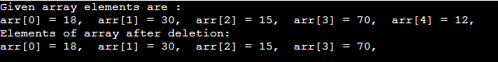

### Search operation

This operation is performed to search an element in the array based on the value or index.

1. #include <stdio.h>
3. **void** main() {
4. **int** arr[5] = {18, 30, 15, 70, 12};
5. **int** item = 70, i, j=0 ;
7. printf("Given array elements are :\n");
9. **for**(i = 0; i<5; i++) {
10. printf("arr[%d] = %d,  ", i, arr[i]);
11. }
12. printf("\nElement to be searched = %d", item);
13. **while**( j < 5){
14. **if**( arr[j] == item ) {
15. **break**;
16. }
18. j = j + 1;
19. }
21. printf("\nElement %d is found at %d position", item, j+1);
22. }

**Output**

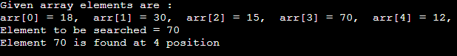

### Update operation

This operation is performed to update an existing array element located at the given index.

1. #include <stdio.h>
3. **void** main() {
4. **int** arr[5] = {18, 30, 15, 70, 12};
5. **int** item = 50, i, pos = 3;
7. printf("Given array elements are :\n");
9. **for**(i = 0; i<5; i++) {
10. printf("arr[%d] = %d,  ", i, arr[i]);
11. }
13. arr[pos-1] = item;
14. printf("\nArray elements after updation :\n");
16. **for**(i = 0; i<5; i++) {
17. printf("arr[%d] = %d,  ", i, arr[i]);
18. }
19. }

**Output**

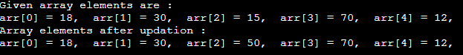

## Complexity of Array operations

Time and space complexity of various array operations are described in the following table.

**Time Complexity**

|  |  |  |
| --- | --- | --- |
| **Operation** | **Average Case** | **Worst Case** |
| Access | O(1) | O(1) |
| Search | O(n) | O(n) |
| Insertion | O(n) | O(n) |
| Deletion | O(n) | O(n) |

**Space Complexity**

In array, space complexity for worst case is **O(n)**.

## Advantages of Array

* Array provides the single name for the group of variables of the same type. Therefore, it is easy to remember the name of all the elements of an array.
* Traversing an array is a very simple process; we just need to increment the base address of the array in order to visit each element one by one.
* Any element in the array can be directly accessed by using the index.

## Disadvantages of Array

* Array is homogenous. It means that the elements with similar data type can be stored in it.
* In array, there is static memory allocation that is size of an array cannot be altered.
* There will be wastage of memory if we store less number of elements than the declared size.

## Conclusion

In this article, we have discussed the special data structure, i.e., array, and the basic operations performed on it. Arrays provide a unique way to structure the stored data such that it can be easily accessed and can be queried to fetch the value using the index.

# 2D Array

2D array can be defined as an array of arrays. The 2D array is organized as matrices which can be represented as the collection of rows and columns.

However, 2D arrays are created to implement a relational database look alike data structure. It provides ease of holding bulk of data at once which can be passed to any number of functions wherever required.

## How to declare 2D Array

The syntax of declaring two dimensional array is very much similar to that of a one dimensional array, given as follows.

1. **int** arr[max_rows][max_columns];

however, It produces the data structure which looks like following.

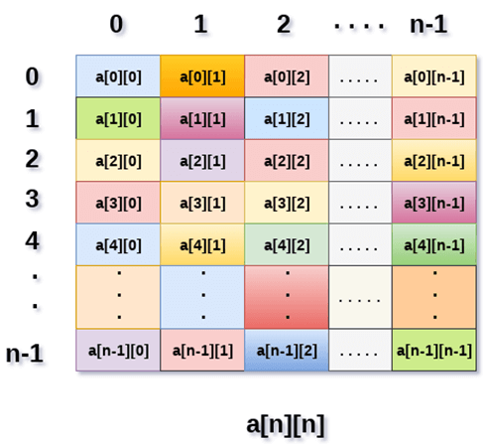

Above image shows the two dimensional array, the elements are organized in the form of rows and columns. First element of the first row is represented by a[0][0] where the number shown in the first index is the number of that row while the number shown in the second index is the number of the column.

## How do we access data in a 2D array

Due to the fact that the elements of 2D arrays can be random accessed. Similar to one dimensional arrays, we can access the individual cells in a 2D array by using the indices of the cells. There are two indices attached to a particular cell, one is its row number while the other is its column number.

However, we can store the value stored in any particular cell of a 2D array to some variable x by using the following syntax.

1. **int** x = a[i][j];

where i and j is the row and column number of the cell respectively.

We can assign each cell of a 2D array to 0 by using the following code:

1. **for** ( **int** i=0; i<n ;i++)
2. {
3. **for** (**int** j=0; j<n; j++)
4. {
5. a[i][j] = 0;
6. }
7. }

## Initializing 2D Arrays

We know that, when we declare and initialize one dimensional array in C programming simultaneously, we don't need to specify the size of the array. However this will not work with 2D arrays. We will have to define at least the second dimension of the array.

The syntax to declare and initialize the 2D array is given as follows.

1. **int** arr[2][2] = {0,1,2,3};

The number of elements that can be present in a 2D array will always be equal to (**number of rows * number of columns**).

**Example :** Storing User's data into a 2D array and printing it.

**C Example :**

1. #include <stdio.h>
2. **void** main ()
3. {
4. **int** arr[3][3],i,j;
5. **for** (i=0;i<3;i++)
6. {
7. **for** (j=0;j<3;j++)
8. {
9. printf("Enter a[%d][%d]: ",i,j);
10. scanf("%d",&arr[i][j]);
11. }
12. }
13. printf("\n printing the elements ....\n");
14. **for**(i=0;i<3;i++)
15. {
16. printf("\n");
17. **for** (j=0;j<3;j++)
18. {
19. printf("%d\t",arr[i][j]);
20. }
21. }
22. }

### Java Example

1. **import** java.util.Scanner;
2. publicclass TwoDArray {
3. publicstaticvoid main(String[] args) {
4. **int**[][] arr = newint[3][3];
5. Scanner sc = **new** Scanner(System.in);
6. **for** (inti =0;i<3;i++)
7. {
8. **for**(intj=0;j<3;j++)
9. {
10. System.out.print("Enter Element");
11. arr[i][j]=sc.nextInt();
12. System.out.println();
13. }
14. }
15. System.out.println("Printing Elements...");
16. **for**(inti=0;i<3;i++)
17. {
18. System.out.println();
19. **for**(intj=0;j<3;j++)
20. {
21. System.out.print(arr[i][j]+"\t");
22. }
23. }
24. }
25. }

### C# Example

1. using System;
3. **public** **class** Program
4. {
5. **public** **static** **void** Main()
6. {
7. **int**[,] arr = **new** **int**[3,3];
8. **for** (**int** i=0;i<3;i++)
9. {
10. **for** (**int** j=0;j<3;j++)
11. {
12. Console.WriteLine("Enter Element");
13. arr[i,j]= Convert.ToInt32(Console.ReadLine());
14. }
15. }
16. Console.WriteLine("Printing Elements...");
17. **for** (**int** i=0;i<3;i++)
18. {
19. Console.WriteLine();
20. **for** (**int** j=0;j<3;j++)
21. {
22. Console.Write(arr[i,j]+" ");
23. }
24. }
25. }
26. }

## Mapping 2D array to 1D array

When it comes to map a 2 dimensional array, most of us might think that why this mapping is required. However, 2 D arrays exists from the user point of view. 2D arrays are created to implement a relational database table lookalike data structure, in computer memory, the storage technique for 2D array is similar to that of an one dimensional array.

The size of a two dimensional array is equal to the multiplication of number of rows and the number of columns present in the array. We do need to map two dimensional array to the one dimensional array in order to store them in the memory.

A 3 X 3 two dimensional array is shown in the following image. However, this array needs to be mapped to a one dimensional array in order to store it into the memory.

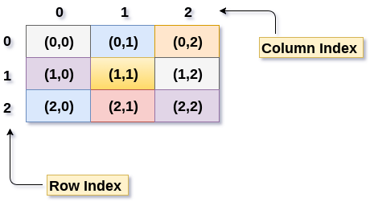

There are two main techniques of storing 2D array elements into memory

### 1. Row Major ordering

In row major ordering, all the rows of the 2D array are stored into the memory contiguously. Considering the array shown in the above image, its memory allocation according to row major order is shown as follows.

DS 2D Array

first, the 1st row of the array is stored into the memory completely, then the 2nd row of the array is stored into the memory completely and so on till the last row.

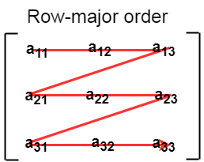

### 2. Column Major ordering

According to the column major ordering, all the columns of the 2D array are stored into the memory contiguously. The memory allocation of the array which is shown in in the above image is given as follows.

DS 2D Array

first, the 1st column of the array is stored into the memory completely, then the 2nd row of the array is stored into the memory completely and so on till the last column of the array.

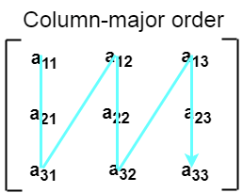

## Calculating the Address of the random element of a 2D array

Due to the fact that, there are two different techniques of storing the two dimensional array into the memory, there are two different formulas to calculate the address of a random element of the 2D array.

### By Row Major Order

If array is declared by a[m][n] where m is the number of rows while n is the number of columns, then address of an element a[i][j] of the array stored in row major order is calculated as,

1. Address(a[i][j]) = B. A. + (i * n + j) * size

where, B. A. is the base address or the address of the first element of the array a[0][0] .

**Example :**

1. a[10...30, 55...75], base address of the array (BA) = 0, size of an element = 4 bytes .
2. Find the location of a[15][68].
4. Address(a[15][68]) = 0 +
5. ((15 - 10) x (68 - 55 + 1) + (68 - 55)) x 4
7. = (5 x 14 + 13) x 4
8. = 83 x 4
9. = 332 answer

### By Column major order

If array is declared by a[m][n] where m is the number of rows while n is the number of columns, then address of an element a[i][j] of the array stored in row major order is calculated as,

1. Address(a[i][j]) = ((j*m)+i)*Size + BA

where BA is the base address of the array.

**Example:**

1. A [-5 ... +20][20 ... 70], BA = 1020, Size of element = 8 bytes. Find the location of a[0][30].
3. Address [A[0][30]) = ((30-20) x 24 + 5)  x 8 + 1020   =  245 x 8 + 1020 = 2980 bytes

Linked list

In this article, we will see the introduction of linked list.

Linked list is a linear data structure that includes a series of connected nodes. Linked list can be defined as the nodes that are randomly stored in the memory. A node in the linked list contains two parts, i.e., first is the data part and second is the address part. The last node of the list contains a pointer to the null. After array, linked list is the second most used data structure. In a linked list, every link contains a connection to another link.

Representation of a Linked list

Linked list can be represented as the connection of nodes in which each node points to the next node of the list. The representation of the linked list is shown below -

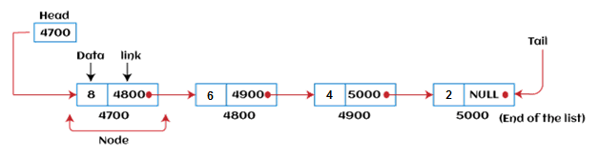

Till now, we have been using array data structure to organize the group of elements that are to be stored individually in the memory. However, Array has several advantages and disadvantages that must be known to decide the data structure that will be used throughout the program.

Now, the question arises why we should use linked list over array?

Why use linked list over array?

Linked list is a data structure that overcomes the limitations of arrays. Let's first see some of the limitations of arrays -

* The size of the array must be known in advance before using it in the program.
* Increasing the size of the array is a time taking process. It is almost impossible to expand the size of the array at run time.
* All the elements in the array need to be contiguously stored in the memory. Inserting an element in the array needs shifting of all its predecessors.

Linked list is useful because -

* It allocates the memory dynamically. All the nodes of the linked list are non-contiguously stored in the memory and linked together with the help of pointers.
* In linked list, size is no longer a problem since we do not need to define its size at the time of declaration. List grows as per the program's demand and limited to the available memory space.

How to declare a linked list?

It is simple to declare an array, as it is of single type, while the declaration of linked list is a bit more typical than array. Linked list contains two parts, and both are of different types, i.e., one is the simple variable, while another is the pointer variable. We can declare the linked list by using the user-defined data type **structure.**

The declaration of linked list is given as follows -

1. struct node
2. {
3. int data;
4. struct node *next;
5. }

In the above declaration, we have defined a structure named as **node** that contains two variables, one is **data** that is of integer type, and another one is **next** that is a pointer which contains the address of next node.

Now, let's move towards the types of linked list.

Types of Linked list

Linked list is classified into the following types -

* **Singly-linked list -** Singly linked list can be defined as the collection of an ordered set of elements. A node in the singly linked list consists of two parts: data part and link part. Data part of the node stores actual information that is to be represented by the node, while the link part of the node stores the address of its immediate successor.
* **Doubly linked list -** Doubly linked list is a complex type of linked list in which a node contains a pointer to the previous as well as the next node in the sequence. Therefore, in a doubly-linked list, a node consists of three parts: node data, pointer to the next node in sequence (next pointer), and pointer to the previous node (previous pointer).
* **Circular singly linked list -** In a circular singly linked list, the last node of the list contains a pointer to the first node of the list. We can have circular singly linked list as well as circular doubly linked list.
* **Circular doubly linked list -** Circular doubly linked list is a more complex type of data structure in which a node contains pointers to its previous node as well as the next node. Circular doubly linked list doesn't contain NULL in any of the nodes. The last node of the list contains the address of the first node of the list. The first node of the list also contains the address of the last node in its previous pointer.

Now, let's see the benefits and limitations of using the Linked list.

Advantages of Linked list

The advantages of using the Linked list are given as follows -

* **Dynamic data structure -** The size of the linked list may vary according to the requirements. Linked list does not have a fixed size.
* **Insertion and deletion -** Unlike arrays, insertion, and deletion in linked list is easier. Array elements are stored in the consecutive location, whereas the elements in the linked list are stored at a random location. To insert or delete an element in an array, we have to shift the elements for creating the space. Whereas, in linked list, instead of shifting, we just have to update the address of the pointer of the node.
* **Memory efficient -** The size of a linked list can grow or shrink according to the requirements, so memory consumption in linked list is efficient.
* **Implementation -** We can implement both stacks and queues using linked list.

Disadvantages of Linked list

The limitations of using the Linked list are given as follows -

* **Memory usage -** In linked list, node occupies more memory than array. Each node of the linked list occupies two types of variables, i.e., one is a simple variable, and another one is the pointer variable.
* **Traversal -** Traversal is not easy in the linked list. If we have to access an element in the linked list, we cannot access it randomly, while in case of array we can randomly access it by index. For example, if we want to access the 3rd node, then we need to traverse all the nodes before it. So, the time required to access a particular node is large.
* **Reverse traversing -** Backtracking or reverse traversing is difficult in a linked list. In a doubly-linked list, it is easier but requires more memory to store the back pointer.

Applications of Linked list

The applications of the Linked list are given as follows -

* With the help of a linked list, the polynomials can be represented as well as we can perform the operations on the polynomial.
* A linked list can be used to represent the sparse matrix.
* The various operations like student's details, employee's details, or product details can be implemented using the linked list as the linked list uses the structure data type that can hold different data types.
* Using linked list, we can implement stack, queue, tree, and other various data structures.
* The graph is a collection of edges and vertices, and the graph can be represented as an adjacency matrix and adjacency list. If we want to represent the graph as an adjacency matrix, then it can be implemented as an array. If we want to represent the graph as an adjacency list, then it can be implemented as a linked list.
* A linked list can be used to implement dynamic memory allocation. The dynamic memory allocation is the memory allocation done at the run-time.

Operations performed on Linked list

The basic operations that are supported by a list are mentioned as follows -

* **Insertion -** This operation is performed to add an element into the list.
* **Deletion -** It is performed to delete an operation from the list.
* **Display -** It is performed to display the elements of the list.
* **Search -** It is performed to search an element from the list using the given key.

Complexity of Linked list

Now, let's see the time and space complexity of the linked list for the operations search, insert, and delete.

1. Time Complexity

|  |  |  |
| --- | --- | --- |
| **Operations** | **Average case time complexity** | **Worst-case time complexity** |
| **Insertion** | O(1) | O(1) |
| **Deletion** | O(1) | O(1) |
| **Search** | O(n) | O(n) |

Where 'n' is the number of nodes in the given tree.

2. Space Complexity

|  |  |
| --- | --- |
| **Operations** | **Space complexity** |
| **Insertion** | O(n) |
| **Deletion** | O(n) |
| **Search** | O(n) |

The space complexity of linked list is **O(n).**

So, that's all about the introduction of linked list. Hope the article will be helpful and informative to you.

# Types of Linked List

Before knowing about the types of a linked list, we should know what is **linked list**. So, to know about the linked list, click on the link given below:

## Types of Linked list

**The following are the types of linked list:**

* [Singly Linked list](https://www.javatpoint.com/ds-types-of-linked-list#Singly)
* [Doubly Linked list](https://www.javatpoint.com/ds-types-of-linked-list#Doubly)
* [Circular Linked list](https://www.javatpoint.com/ds-types-of-linked-list#Circular)
* [Doubly Circular Linked list](https://www.javatpoint.com/ds-types-of-linked-list#Doubly-Circular)

### Singly Linked list

It is the commonly used linked list in programs. If we are talking about the linked list, it means it is a singly linked list. The singly linked list is a data structure that contains two parts, i.e., one is the data part, and the other one is the address part, which contains the address of the next or the successor node. The address part in a node is also known as a **pointer**.

Suppose we have three nodes, and the addresses of these three nodes are 100, 200 and 300 respectively. The representation of three nodes as a linked list is shown in the below figure:

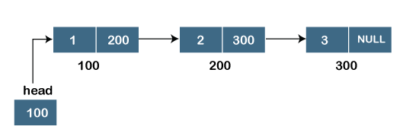

We can observe in the above figure that there are three different nodes having address 100, 200 and 300 respectively. The first node contains the address of the next node, i.e., 200, the second node contains the address of the last node, i.e., 300, and the third node contains the NULL value in its address part as it does not point to any node. The pointer that holds the address of the initial node is known as a **head pointer**.

The linked list, which is shown in the above diagram, is known as a singly linked list as it contains only a single link. In this list, only forward traversal is possible; we cannot traverse in the backward direction as it has only one link in the list.

**Representation of the node in a singly linked list**

1. struct node
2. {
3. **int** data;
4. struct node *next;
5. }

In the above representation, we have defined a user-defined structure named a **node** containing two members, the first one is data of integer type, and the other one is the pointer (next) of the node type.

To know more about a singly linked list, click on the link given below:

<https://www.javatpoint.com/singly-linked-list>

### Doubly linked list

As the name suggests, the doubly linked list contains two pointers. We can define the doubly linked list as a linear data structure with three parts: the data part and the other two address part. In other words, a doubly linked list is a list that has three parts in a single node, includes one data part, a pointer to its previous node, and a pointer to the next node.

Suppose we have three nodes, and the address of these nodes are 100, 200 and 300, respectively. The representation of these nodes in a doubly-linked list is shown below:

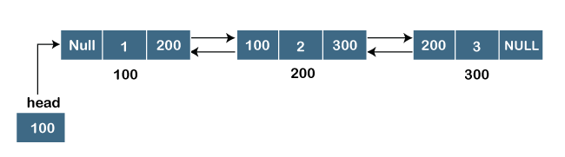

As we can observe in the above figure, the node in a doubly-linked list has two address parts; one part stores the **address of the next** while the other part of the node stores the **previous node's address**. The initial node in the doubly linked list has the **NULL** value in the address part, which provides the address of the previous node.

**Representation of the node in a doubly linked list**

1. struct node
2. {
3. **int** data;
4. struct node *next;
5. struct node *prev;
6. }

In the above representation, we have defined a user-defined structure named **a node** with three members, one is **data** of integer type, and the other two are the pointers, i.e., **next and prev** of the node type. The **next pointer** variable holds the address of the next node, and the **prev pointer** holds the address of the previous node. The type of both the pointers, i.e., **next and prev** is **struct node** as both the pointers are storing the address of the node of the **struct node** type.

To know more about doubly linked list, click on the link given below:

<https://www.javatpoint.com/doubly-linked-list>

### Circular linked list

A circular linked list is a variation of a singly linked list. The only difference between the **singly linked list** and a **circular linked** list is that the last node does not point to any node in a singly linked list, so its link part contains a NULL value. On the other hand, the circular linked list is a list in which the last node connects to the first node, so the link part of the last node holds the first node's address. The circular linked list has no starting and ending node. We can traverse in any direction, i.e., either backward or forward. The diagrammatic representation of the circular linked list is shown below:

1. struct node
2. {
3. **int** data;
4. struct node *next;
5. }

A circular linked list is a sequence of elements in which each node has a link to the next node, and the last node is having a link to the first node. The representation of the circular linked list will be similar to the singly linked list, as shown below:

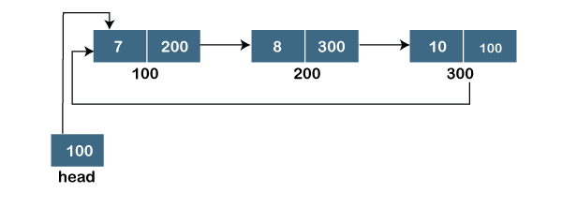

To know more about the circular linked list, click on the link given below:

<https://www.javatpoint.com/circular-singly-linked-list>

### Doubly Circular linked list

The doubly circular linked list has the features of both the **circular linked list** and **doubly linked list**.

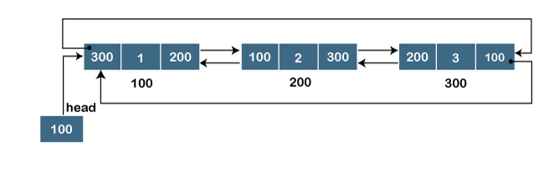

The above figure shows the representation of the doubly circular linked list in which the last node is attached to the first node and thus creates a circle. It is a doubly linked list also because each node holds the address of the previous node also. The main difference between the doubly linked list and doubly circular linked list is that the doubly circular linked list does not contain the NULL value in the previous field of the node. As the doubly circular linked contains three parts, i.e., two address parts and one data part so its representation is similar to the doubly linked list.

1. struct node
2. {
3. **int** data;
4. struct node *next;
5. struct node *prev;
6. }

To know more about the doubly circular linked list, click on the link given below:

<https://www.javatpoint.com/circular-doubly-linked-list>

# Linked List

* Linked List can be defined as collection of objects called **nodes** that are randomly stored in the memory.
* A node contains two fields i.e. data stored at that particular address and the pointer which contains the address of the next node in the memory.
* The last node of the list contains pointer to the null.

DS Linked List

## Uses of Linked List

* The list is not required to be contiguously present in the memory. The node can reside any where in the memory and linked together to make a list. This achieves optimized utilization of space.
* list size is limited to the memory size and doesn't need to be declared in advance.
* Empty node can not be present in the linked list.
* We can store values of primitive types or objects in the singly linked list.

## Why use linked list over array?

Till now, we were using array data structure to organize the group of elements that are to be stored individually in the memory. However, Array has several advantages and disadvantages which must be known in order to decide the data structure which will be used throughout the program.

Array contains following limitations:

1. The size of array must be known in advance before using it in the program.
2. Increasing size of the array is a time taking process. It is almost impossible to expand the size of the array at run time.
3. All the elements in the array need to be contiguously stored in the memory. Inserting any element in the array needs shifting of all its predecessors.

Linked list is the data structure which can overcome all the limitations of an array. Using linked list is useful because,

1. It allocates the memory dynamically. All the nodes of linked list are non-contiguously stored in the memory and linked together with the help of pointers.
2. Sizing is no longer a problem since we do not need to define its size at the time of declaration. List grows as per the program's demand and limited to the available memory space.

## Singly linked list or One way chain

Singly linked list can be defined as the collection of ordered set of elements. The number of elements may vary according to need of the program. A node in the singly linked list consist of two parts: data part and link part. Data part of the node stores actual information that is to be represented by the node while the link part of the node stores the address of its immediate successor.

One way chain or singly linked list can be traversed only in one direction. In other words, we can say that each node contains only next pointer, therefore we can not traverse the list in the reverse direction.

Consider an example where the marks obtained by the student in three subjects are stored in a linked list as shown in the figure.

DS Singly Linked List

In the above figure, the arrow represents the links. The data part of every node contains the marks obtained by the student in the different subject. The last node in the list is identified by the null pointer which is present in the address part of the last node. We can have as many elements we require, in the data part of the list.

## Complexity

|  |  |  |  |  |  |  |  |  |  |
| --- | --- | --- | --- | --- | --- | --- | --- | --- | --- |
| **Data Structure** | **Time Complexity** | | | | | | | | **Space Compleity** |
|  | **Average** | | | | **Worst** | | | | **Worst** |
|  | Access | Search | Insertion | Deletion | Access | Search | Insertion | Deletion |  |
| Singly Linked List | θ(n) | θ(n) | θ(1) | θ(1) | O(n) | O(n) | O(1) | O(1) | O(n) |

## Operations on Singly Linked List

There are various operations which can be performed on singly linked list. A list of all such operations is given below.

### Node Creation

1. struct node
2. {
3. **int** data;
4. struct node *next;
5. };
6. struct node *head, *ptr;
7. ptr = (struct node *)malloc(sizeof(struct node *));

### Insertion

The insertion into a singly linked list can be performed at different positions. Based on the position of the new node being inserted, the insertion is categorized into the following categories.

|  |  |  |
| --- | --- | --- |
| **SN** | **Operation** | **Description** |
| 1 | [Insertion at beginning](https://www.javatpoint.com/insertion-in-singly-linked-list-at-beginning) | It involves inserting any element at the front of the list. We just need to a few link adjustments to make the new node as the head of the list. |
| 2 | [Insertion at end of the list](https://www.javatpoint.com/insertion-in-singly-linked-list-at-end) | It involves insertion at the last of the linked list. The new node can be inserted as the only node in the list or it can be inserted as the last one. Different logics are implemented in each scenario. |
| 3 | [Insertion after specified node](https://www.javatpoint.com/insertion-in-singly-linked-list-after-specified-node) | It involves insertion after the specified node of the linked list. We need to skip the desired number of nodes in order to reach the node after which the new node will be inserted. . |

### Deletion and Traversing

The Deletion of a node from a singly linked list can be performed at different positions. Based on the position of the node being deleted, the operation is categorized into the following categories.

|  |  |  |
| --- | --- | --- |
| **SN** | **Operation** | **Description** |
| 1 | [Deletion at beginning](https://www.javatpoint.com/deletion-in-singly-linked-list-at-beginning) | It involves deletion of a node from the beginning of the list. This is the simplest operation among all. It just need a few adjustments in the node pointers. |
| 2 | [Deletion at the end of the list](https://www.javatpoint.com/deletion-in-singly-linked-list-at-end) | It involves deleting the last node of the list. The list can either be empty or full. Different logic is implemented for the different scenarios. |
| 3 | [Deletion after specified node](https://www.javatpoint.com/deletion-in-singly-linked-list-after-specified-node) | It involves deleting the node after the specified node in the list. we need to skip the desired number of nodes to reach the node after which the node will be deleted. This requires traversing through the list. |
| 4 | [Traversing](https://www.javatpoint.com/traversing-in-singly-linked-list) | In traversing, we simply visit each node of the list at least once in order to perform some specific operation on it, for example, printing data part of each node present in the list. |
| 5 | [Searching](https://www.javatpoint.com/searching-in-singly-linked-list) | In searching, we match each element of the list with the given element. If the element is found on any of the location then location of that element is returned otherwise null is returned. . |

## Linked List in C: Menu Driven Program

1. #include<stdio.h>
2. #include<stdlib.h>
3. struct node
4. {
5. **int** data;
6. struct node *next;
7. };
8. struct node *head;
10. **void** beginsert ();
11. **void** lastinsert ();
12. **void** randominsert();
13. **void** begin_delete();
14. **void** last_delete();
15. **void** random_delete();
16. **void** display();
17. **void** search();
18. **void** main ()
19. {
20. **int** choice =0;
21. **while**(choice != 9)
22. {
23. printf("\n\n*********Main Menu*********\n");
24. printf("\nChoose one option from the following list ...\n");
25. printf("\n===============================================\n");
26. printf("\n1.Insert in begining\n2.Insert at last\n3.Insert at any random location\n4.Delete from Beginning\n
27. 5.Delete from last\n6.Delete node after specified location\n7.Search **for** an element\n8.Show\n9.Exit\n");
28. printf("\nEnter your choice?\n");
29. scanf("\n%d",&choice);
30. **switch**(choice)
31. {
32. **case** 1:
33. beginsert();
34. **break**;
35. **case** 2:
36. lastinsert();
37. **break**;
38. **case** 3:
39. randominsert();
40. **break**;
41. **case** 4:
42. begin_delete();
43. **break**;
44. **case** 5:
45. last_delete();
46. **break**;
47. **case** 6:
48. random_delete();
49. **break**;
50. **case** 7:
51. search();
52. **break**;
53. **case** 8:
54. display();
55. **break**;
56. **case** 9:
57. exit(0);
58. **break**;
59. **default**:
60. printf("Please enter valid choice..");
61. }
62. }
63. }
64. **void** beginsert()
65. {
66. struct node *ptr;
67. **int** item;
68. ptr = (struct node *) malloc(sizeof(struct node *));
69. **if**(ptr == NULL)
70. {
71. printf("\nOVERFLOW");
72. }
73. **else**
74. {
75. printf("\nEnter value\n");
76. scanf("%d",&item);
77. ptr->data = item;
78. ptr->next = head;
79. head = ptr;
80. printf("\nNode inserted");
81. }
83. }
84. **void** lastinsert()
85. {
86. struct node *ptr,*temp;
87. **int** item;
88. ptr = (struct node*)malloc(sizeof(struct node));
89. **if**(ptr == NULL)
90. {
91. printf("\nOVERFLOW");
92. }
93. **else**
94. {
95. printf("\nEnter value?\n");
96. scanf("%d",&item);
97. ptr->data = item;
98. **if**(head == NULL)
99. {
100. ptr -> next = NULL;
101. head = ptr;
102. printf("\nNode inserted");
103. }
104. **else**
105. {
106. temp = head;
107. **while** (temp -> next != NULL)
108. {
109. temp = temp -> next;
110. }
111. temp->next = ptr;
112. ptr->next = NULL;
113. printf("\nNode inserted");
115. }
116. }
117. }
118. **void** randominsert()
119. {
120. **int** i,loc,item;
121. struct node *ptr, *temp;
122. ptr = (struct node *) malloc (sizeof(struct node));
123. **if**(ptr == NULL)
124. {
125. printf("\nOVERFLOW");
126. }
127. **else**
128. {
129. printf("\nEnter element value");
130. scanf("%d",&item);
131. ptr->data = item;
132. printf("\nEnter the location after which you want to insert ");
133. scanf("\n%d",&loc);
134. temp=head;
135. **for**(i=0;i<loc;i++)
136. {
137. temp = temp->next;
138. **if**(temp == NULL)
139. {
140. printf("\ncan't insert\n");
141. **return**;
142. }
144. }
145. ptr ->next = temp ->next;
146. temp ->next = ptr;
147. printf("\nNode inserted");
148. }
149. }
150. **void** begin_delete()
151. {
152. struct node *ptr;
153. **if**(head == NULL)
154. {
155. printf("\nList is empty\n");
156. }
157. **else**
158. {
159. ptr = head;
160. head = ptr->next;
161. free(ptr);
162. printf("\nNode deleted from the begining ...\n");
163. }
164. }
165. **void** last_delete()
166. {
167. struct node *ptr,*ptr1;
168. **if**(head == NULL)
169. {
170. printf("\nlist is empty");
171. }
172. **else** **if**(head -> next == NULL)
173. {
174. head = NULL;
175. free(head);
176. printf("\nOnly node of the list deleted ...\n");
177. }
179. **else**
180. {
181. ptr = head;
182. **while**(ptr->next != NULL)
183. {
184. ptr1 = ptr;
185. ptr = ptr ->next;
186. }
187. ptr1->next = NULL;
188. free(ptr);
189. printf("\nDeleted Node from the last ...\n");
190. }
191. }
192. **void** random_delete()
193. {
194. struct node *ptr,*ptr1;
195. **int** loc,i;
196. printf("\n Enter the location of the node after which you want to perform deletion \n");
197. scanf("%d",&loc);
198. ptr=head;
199. **for**(i=0;i<loc;i++)
200. {
201. ptr1 = ptr;
202. ptr = ptr->next;
204. **if**(ptr == NULL)
205. {
206. printf("\nCan't delete");
207. **return**;
208. }
209. }
210. ptr1 ->next = ptr ->next;
211. free(ptr);
212. printf("\nDeleted node %d ",loc+1);
213. }
214. **void** search()
215. {
216. struct node *ptr;
217. **int** item,i=0,flag;
218. ptr = head;
219. **if**(ptr == NULL)
220. {
221. printf("\nEmpty List\n");
222. }
223. **else**
224. {
225. printf("\nEnter item which you want to search?\n");
226. scanf("%d",&item);
227. **while** (ptr!=NULL)
228. {
229. **if**(ptr->data == item)
230. {
231. printf("item found at location %d ",i+1);
232. flag=0;
233. }
234. **else**
235. {
236. flag=1;
237. }
238. i++;
239. ptr = ptr -> next;
240. }
241. **if**(flag==1)
242. {
243. printf("Item not found\n");
244. }
245. }
247. }
249. **void** display()
250. {
251. struct node *ptr;
252. ptr = head;
253. **if**(ptr == NULL)
254. {
255. printf("Nothing to print");
256. }
257. **else**
258. {
259. printf("\nprinting values . . . . .\n");
260. **while** (ptr!=NULL)
261. {
262. printf("\n%d",ptr->data);
263. ptr = ptr -> next;
264. }
265. }
266. }

**Output:**

*********Main Menu*********

Choose one option from the following list ...

===============================================

1.Insert in begining

2.Insert at last

3.Insert at any random location

4.Delete from Beginning

5.Delete from last

6.Delete node after specified location

7.Search for an element

8.Show

9.Exit

Enter your choice?

1

Enter value

1

Node inserted

*********Main Menu*********

Choose one option from the following list ...

===============================================

1.Insert in begining

2.Insert at last

3.Insert at any random location

4.Delete from Beginning

5.Delete from last

6.Delete node after specified location

7.Search for an element

8.Show

9.Exit

Enter your choice?

2

Enter value?

2

Node inserted

*********Main Menu*********

Choose one option from the following list ...

===============================================

1.Insert in begining

2.Insert at last

3.Insert at any random location

4.Delete from Beginning

5.Delete from last

6.Delete node after specified location

7.Search for an element

8.Show

9.Exit

Enter your choice?

3

Enter element value1

Enter the location after which you want to insert 1

Node inserted

*********Main Menu*********

Choose one option from the following list ...

===============================================

1.Insert in begining

2.Insert at last

3.Insert at any random location

4.Delete from Beginning

5.Delete from last

6.Delete node after specified location

7.Search for an element

8.Show

9.Exit

Enter your choice?

8

printing values . . . . .

1

2

1

*********Main Menu*********

Choose one option from the following list ...

===============================================

1.Insert in begining

2.Insert at last

3.Insert at any random location

4.Delete from Beginning

5.Delete from last

6.Delete node after specified location

7.Search for an element

8.Show

9.Exit

Enter your choice?

2

Enter value?

123

Node inserted

*********Main Menu*********

Choose one option from the following list ...

===============================================

1.Insert in begining

2.Insert at last

3.Insert at any random location

4.Delete from Beginning

5.Delete from last

6.Delete node after specified location

7.Search for an element

8.Show

9.Exit

Enter your choice?

1

Enter value

1234

Node inserted

*********Main Menu*********

Choose one option from the following list ...

===============================================

1.Insert in begining

2.Insert at last

3.Insert at any random location

4.Delete from Beginning

5.Delete from last

6.Delete node after specified location

7.Search for an element

8.Show

9.Exit

Enter your choice?

4

Node deleted from the begining ...

*********Main Menu*********

Choose one option from the following list ...

===============================================

1.Insert in begining

2.Insert at last

3.Insert at any random location

4.Delete from Beginning

5.Delete from last

6.Delete node after specified location

7.Search for an element

8.Show

9.Exit

Enter your choice?

5

Deleted Node from the last ...

*********Main Menu*********

Choose one option from the following list ...

===============================================

1.Insert in begining

2.Insert at last

3.Insert at any random location

4.Delete from Beginning

5.Delete from last

6.Delete node after specified location

7.Search for an element

8.Show

9.Exit

Enter your choice?

6

Enter the location of the node after which you want to perform deletion

1

Deleted node 2

*********Main Menu*********

Choose one option from the following list ...

===============================================

1.Insert in begining

2.Insert at last

3.Insert at any random location

4.Delete from Beginning

5.Delete from last

6.Delete node after specified location

7.Search for an element

8.Show

9.Exit

Enter your choice?

8

printing values . . . . .

1

1

*********Main Menu*********

Choose one option from the following list ...

===============================================

1.Insert in begining

2.Insert at last

3.Insert at any random location

4.Delete from Beginning

5.Delete from last

6.Delete node after specified location

7.Search for an element

8.Show

9.Exit

Enter your choice?

7

Enter item which you want to search?

1

item found at location 1

item found at location 2

*********Main Menu*********

Choose one option from the following list ...

===============================================

1.Insert in begining

2.Insert at last

3.Insert at any random location

4.Delete from Beginning

5.Delete from last

6.Delete node after specified location

7.Search for an element

8.Show

9.Exit

Enter your choice?

9

# Doubly linked list

Doubly linked list is a complex type of linked list in which a node contains a pointer to the previous as well as the next node in the sequence. Therefore, in a doubly linked list, a node consists of three parts: node data, pointer to the next node in sequence (next pointer) , pointer to the previous node (previous pointer). A sample node in a doubly linked list is shown in the figure.

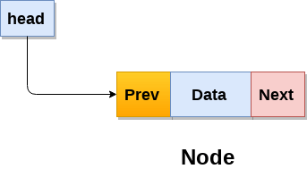

A doubly linked list containing three nodes having numbers from 1 to 3 in their data part, is shown in the following image.

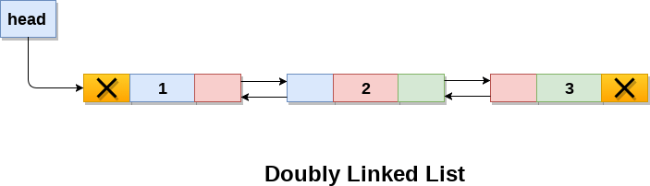

In C, structure of a node in doubly linked list can be given as :

1. struct node
2. {
3. struct node *prev;
4. **int** data;
5. struct node *next;
6. }

The **prev** part of the first node and the **next** part of the last node will always contain null indicating end in each direction.

In a singly linked list, we could traverse only in one direction, because each node contains address of the next node and it doesn't have any record of its previous nodes. However, doubly linked list overcome this limitation of singly linked list. Due to the fact that, each node of the list contains the address of its previous node, we can find all the details about the previous node as well by using the previous address stored inside the previous part of each node.

## Memory Representation of a doubly linked list

Memory Representation of a doubly linked list is shown in the following image. Generally, doubly linked list consumes more space for every node and therefore, causes more expansive basic operations such as insertion and deletion. However, we can easily manipulate the elements of the list since the list maintains pointers in both the directions (forward and backward).

In the following image, the first element of the list that is i.e. 13 stored at address 1. The head pointer points to the starting address 1. Since this is the first element being added to the list therefore the **prev** of the list **contains** null. The next node of the list resides at address 4 therefore the first node contains 4 in its next pointer.

We can traverse the list in this way until we find any node containing null or -1 in its next part.

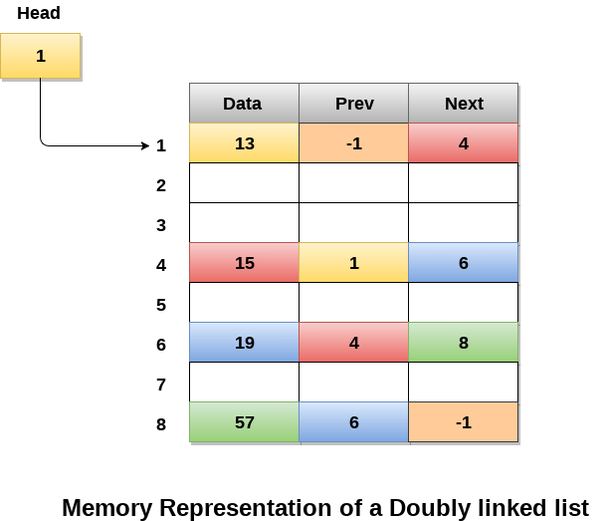

## Operations on doubly linked list

**Node Creation**

1. struct node
2. {
3. struct node *prev;
4. **int** data;
5. struct node *next;
6. };
7. struct node *head;

All the remaining operations regarding doubly linked list are described in the following table.

|  |  |  |
| --- | --- | --- |
| **SN** | **Operation** | **Description** |
| 1 | [Insertion at beginning](https://www.javatpoint.com/insertion-in-doubly-linked-list-at-beginning) | Adding the node into the linked list at beginning. |
| 2 | [Insertion at end](https://www.javatpoint.com/insertion-in-doubly-linked-list-at-the-end) | Adding the node into the linked list to the end. |
| 3 | [Insertion after specified node](https://www.javatpoint.com/insertion-in-doubly-linked-list-after-specified-node) | Adding the node into the linked list after the specified node. |
| 4 | [Deletion at beginning](https://www.javatpoint.com/deletion-in-doubly-linked-list-at-beginning) | Removing the node from beginning of the list |
| 5 | [Deletion at the end](https://www.javatpoint.com/deletion-in-doubly-linked-list-at-the-end) | Removing the node from end of the list. |
| 6 | [Deletion of the node having given data](https://www.javatpoint.com/deletion-in-doubly-linked-list-after-the-specified-node) | Removing the node which is present just after the node containing the given data. |
| 7 | [Searching](https://www.javatpoint.com/searching-in-doubly-linked-list) | Comparing each node data with the item to be searched and return the location of the item in the list if the item found else return null. |
| 8 | [Traversing](https://www.javatpoint.com/traversing-in-doubly-linked-list) | Visiting each node of the list at least once in order to perform some specific operation like searching, sorting, display, etc. |

## Menu Driven Program in C to implement all the operations of doubly linked list

1. #include<stdio.h>
2. #include<stdlib.h>
3. struct node
4. {
5. struct node *prev;
6. struct node *next;
7. **int** data;
8. };
9. struct node *head;
10. **void** insertion_beginning();
11. **void** insertion_last();
12. **void** insertion_specified();
13. **void** deletion_beginning();
14. **void** deletion_last();
15. **void** deletion_specified();
16. **void** display();
17. **void** search();
18. **void** main ()
19. {
20. **int** choice =0;
21. **while**(choice != 9)
22. {
23. printf("\n*********Main Menu*********\n");
24. printf("\nChoose one option from the following list ...\n");
25. printf("\n===============================================\n");
26. printf("\n1.Insert in begining\n2.Insert at last\n3.Insert at any random location\n4.Delete from Beginning\n
27. 5.Delete from last\n6.Delete the node after the given data\n7.Search\n8.Show\n9.Exit\n");
28. printf("\nEnter your choice?\n");
29. scanf("\n%d",&choice);
30. **switch**(choice)
31. {
32. **case** 1:
33. insertion_beginning();
34. **break**;
35. **case** 2:
36. insertion_last();
37. **break**;
38. **case** 3:
39. insertion_specified();
40. **break**;
41. **case** 4:
42. deletion_beginning();
43. **break**;
44. **case** 5:
45. deletion_last();
46. **break**;
47. **case** 6:
48. deletion_specified();
49. **break**;
50. **case** 7:
51. search();
52. **break**;
53. **case** 8:
54. display();
55. **break**;
56. **case** 9:
57. exit(0);
58. **break**;
59. **default**:
60. printf("Please enter valid choice..");
61. }
62. }
63. }
64. **void** insertion_beginning()
65. {
66. struct node *ptr;
67. **int** item;
68. ptr = (struct node *)malloc(sizeof(struct node));
69. **if**(ptr == NULL)
70. {
71. printf("\nOVERFLOW");
72. }
73. **else**
74. {
75. printf("\nEnter Item value");
76. scanf("%d",&item);
78. **if**(head==NULL)
79. {
80. ptr->next = NULL;
81. ptr->prev=NULL;
82. ptr->data=item;
83. head=ptr;
84. }
85. **else**
86. {
87. ptr->data=item;
88. ptr->prev=NULL;
89. ptr->next = head;
90. head->prev=ptr;
91. head=ptr;
92. }
93. printf("\nNode inserted\n");
94. }
96. }
97. **void** insertion_last()
98. {
99. struct node *ptr,*temp;
100. **int** item;
101. ptr = (struct node *) malloc(sizeof(struct node));
102. **if**(ptr == NULL)
103. {
104. printf("\nOVERFLOW");
105. }
106. **else**
107. {
108. printf("\nEnter value");
109. scanf("%d",&item);
110. ptr->data=item;
111. **if**(head == NULL)
112. {
113. ptr->next = NULL;
114. ptr->prev = NULL;
115. head = ptr;
116. }
117. **else**
118. {
119. temp = head;
120. **while**(temp->next!=NULL)
121. {
122. temp = temp->next;
123. }
124. temp->next = ptr;
125. ptr ->prev=temp;
126. ptr->next = NULL;
127. }
129. }
130. printf("\nnode inserted\n");
131. }
132. **void** insertion_specified()
133. {
134. struct node *ptr,*temp;
135. **int** item,loc,i;
136. ptr = (struct node *)malloc(sizeof(struct node));
137. **if**(ptr == NULL)
138. {
139. printf("\n OVERFLOW");
140. }
141. **else**
142. {
143. temp=head;
144. printf("Enter the location");
145. scanf("%d",&loc);
146. **for**(i=0;i<loc;i++)
147. {
148. temp = temp->next;
149. **if**(temp == NULL)
150. {
151. printf("\n There are less than %d elements", loc);
152. **return**;
153. }
154. }
155. printf("Enter value");
156. scanf("%d",&item);
157. ptr->data = item;
158. ptr->next = temp->next;
159. ptr -> prev = temp;
160. temp->next = ptr;
161. temp->next->prev=ptr;
162. printf("\nnode inserted\n");
163. }
164. }
165. **void** deletion_beginning()
166. {
167. struct node *ptr;
168. **if**(head == NULL)
169. {
170. printf("\n UNDERFLOW");
171. }
172. **else** **if**(head->next == NULL)
173. {
174. head = NULL;
175. free(head);
176. printf("\nnode deleted\n");
177. }
178. **else**
179. {
180. ptr = head;
181. head = head -> next;
182. head -> prev = NULL;
183. free(ptr);
184. printf("\nnode deleted\n");
185. }
187. }
188. **void** deletion_last()
189. {
190. struct node *ptr;
191. **if**(head == NULL)
192. {
193. printf("\n UNDERFLOW");
194. }
195. **else** **if**(head->next == NULL)
196. {
197. head = NULL;
198. free(head);
199. printf("\nnode deleted\n");
200. }
201. **else**
202. {
203. ptr = head;
204. **if**(ptr->next != NULL)
205. {
206. ptr = ptr -> next;
207. }
208. ptr -> prev -> next = NULL;
209. free(ptr);
210. printf("\nnode deleted\n");
211. }
212. }
213. **void** deletion_specified()
214. {
215. struct node *ptr, *temp;
216. **int** val;
217. printf("\n Enter the data after which the node is to be deleted : ");
218. scanf("%d", &val);
219. ptr = head;
220. **while**(ptr -> data != val)
221. ptr = ptr -> next;
222. **if**(ptr -> next == NULL)
223. {
224. printf("\nCan't delete\n");
225. }
226. **else** **if**(ptr -> next -> next == NULL)
227. {
228. ptr ->next = NULL;
229. }
230. **else**
231. {
232. temp = ptr -> next;
233. ptr -> next = temp -> next;
234. temp -> next -> prev = ptr;
235. free(temp);
236. printf("\nnode deleted\n");
237. }
238. }
239. **void** display()
240. {
241. struct node *ptr;
242. printf("\n printing values...\n");
243. ptr = head;
244. **while**(ptr != NULL)
245. {
246. printf("%d\n",ptr->data);
247. ptr=ptr->next;
248. }
249. }
250. **void** search()
251. {
252. struct node *ptr;
253. **int** item,i=0,flag;
254. ptr = head;
255. **if**(ptr == NULL)
256. {
257. printf("\nEmpty List\n");
258. }
259. **else**
260. {
261. printf("\nEnter item which you want to search?\n");
262. scanf("%d",&item);
263. **while** (ptr!=NULL)
264. {
265. **if**(ptr->data == item)
266. {
267. printf("\nitem found at location %d ",i+1);
268. flag=0;
269. **break**;
270. }
271. **else**
272. {
273. flag=1;
274. }
275. i++;
276. ptr = ptr -> next;
277. }
278. **if**(flag==1)
279. {
280. printf("\nItem not found\n");
281. }
282. }
284. }

**Output**

*********Main Menu*********

Choose one option from the following list ...

===============================================

1.Insert in begining

2.Insert at last

3.Insert at any random location

4.Delete from Beginning

5.Delete from last

6.Delete the node after the given data

7.Search

8.Show

9.Exit

Enter your choice?

8

printing values...

*********Main Menu*********

Choose one option from the following list ...

===============================================

1.Insert in begining

2.Insert at last

3.Insert at any random location

4.Delete from Beginning

5.Delete from last

6.Delete the node after the given data

7.Search

8.Show

9.Exit

Enter your choice?

1

Enter Item value12

Node inserted

*********Main Menu*********

Choose one option from the following list ...

===============================================

1.Insert in begining

2.Insert at last

3.Insert at any random location

4.Delete from Beginning

5.Delete from last

6.Delete the node after the given data

7.Search

8.Show

9.Exit

Enter your choice?

1

Enter Item value123

Node inserted

*********Main Menu*********

Choose one option from the following list ...

===============================================

1.Insert in begining

2.Insert at last

3.Insert at any random location

4.Delete from Beginning

5.Delete from last

6.Delete the node after the given data

7.Search

8.Show

9.Exit

Enter your choice?

1

Enter Item value1234

Node inserted

*********Main Menu*********

Choose one option from the following list ...

===============================================

1.Insert in begining

2.Insert at last

3.Insert at any random location

4.Delete from Beginning

5.Delete from last

6.Delete the node after the given data

7.Search

8.Show

9.Exit

Enter your choice?

8

printing values...

1234

123

12

*********Main Menu*********

Choose one option from the following list ...

===============================================

1.Insert in begining

2.Insert at last

3.Insert at any random location

4.Delete from Beginning

5.Delete from last

6.Delete the node after the given data

7.Search

8.Show

9.Exit

Enter your choice?

2

Enter value89

node inserted

*********Main Menu*********

Choose one option from the following list ...

===============================================

1.Insert in begining

2.Insert at last

3.Insert at any random location

4.Delete from Beginning

5.Delete from last

6.Delete the node after the given data

7.Search

8.Show

9.Exit

Enter your choice?

3

Enter the location1

Enter value12345

node inserted

*********Main Menu*********

Choose one option from the following list ...

===============================================

1.Insert in begining

2.Insert at last

3.Insert at any random location

4.Delete from Beginning

5.Delete from last

6.Delete the node after the given data

7.Search

8.Show

9.Exit

Enter your choice?

8

printing values...

1234

123

12345

12

89

*********Main Menu*********

Choose one option from the following list ...

===============================================

1.Insert in begining

2.Insert at last

3.Insert at any random location

4.Delete from Beginning

5.Delete from last

6.Delete the node after the given data

7.Search

8.Show

9.Exit

Enter your choice?

4

node deleted

*********Main Menu*********

Choose one option from the following list ...

===============================================

1.Insert in begining

2.Insert at last

3.Insert at any random location

4.Delete from Beginning

5.Delete from last

6.Delete the node after the given data

7.Search

8.Show

9.Exit

Enter your choice?

5

node deleted

*********Main Menu*********

Choose one option from the following list ...

===============================================

1.Insert in begining

2.Insert at last

3.Insert at any random location

4.Delete from Beginning

5.Delete from last

6.Delete the node after the given data

7.Search

8.Show

9.Exit

Enter your choice?

8

printing values...

123

12345

*********Main Menu*********

Choose one option from the following list ...

===============================================

1.Insert in begining

2.Insert at last

3.Insert at any random location

4.Delete from Beginning

5.Delete from last

6.Delete the node after the given data

7.Search

8.Show

9.Exit

Enter your choice?

6

Enter the data after which the node is to be deleted : 123

*********Main Menu*********

Choose one option from the following list ...

===============================================

1.Insert in begining

2.Insert at last

3.Insert at any random location

4.Delete from Beginning

5.Delete from last

6.Delete the node after the given data

7.Search

8.Show

9.Exit

Enter your choice?

8

printing values...

123

*********Main Menu*********

Choose one option from the following list ...

===============================================

1.Insert in begining

2.Insert at last

3.Insert at any random location

4.Delete from Beginning

5.Delete from last

6.Delete the node after the given data

7.Search

8.Show

9.Exit

Enter your choice?

7

Enter item which you want to search?

123

item found at location 1

*********Main Menu*********

Choose one option from the following list ...

===============================================

1.Insert in begining

2.Insert at last

3.Insert at any random location

4.Delete from Beginning

5.Delete from last

6.Delete the node after the given data

7.Search

8.Show

9.Exit

Enter your choice?

6

Enter the data after which the node is to be deleted : 123

Can't delete

*********Main Menu*********

Choose one option from the following list ...

===============================================

1.Insert in begining

2.Insert at last

3.Insert at any random location

4.Delete from Beginning

5.Delete from last

6.Delete the node after the given data

7.Search

8.Show

9.Exit

Enter your choice?

9

Exited..

# Circular Singly Linked List

In a circular Singly linked list, the last node of the list contains a pointer to the first node of the list. We can have circular singly linked list as well as circular doubly linked list.

We traverse a circular singly linked list until we reach the same node where we started. The circular singly liked list has no beginning and no ending. There is no null value present in the next part of any of the nodes.

The following image shows a circular singly linked list.

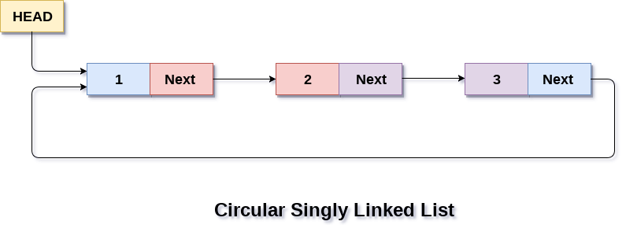

Circular linked list are mostly used in task maintenance in operating systems. There are many examples where circular linked list are being used in computer science including browser surfing where a record of pages visited in the past by the user, is maintained in the form of circular linked lists and can be accessed again on clicking the previous button.

## Memory Representation of circular linked list:

In the following image, memory representation of a circular linked list containing marks of a student in 4 subjects. However, the image shows a glimpse of how the circular list is being stored in the memory. The start or head of the list is pointing to the element with the index 1 and containing 13 marks in the data part and 4 in the next part. Which means that it is linked with the node that is being stored at 4th index of the list.

However, due to the fact that we are considering circular linked list in the memory therefore the last node of the list contains the address of the first node of the list.

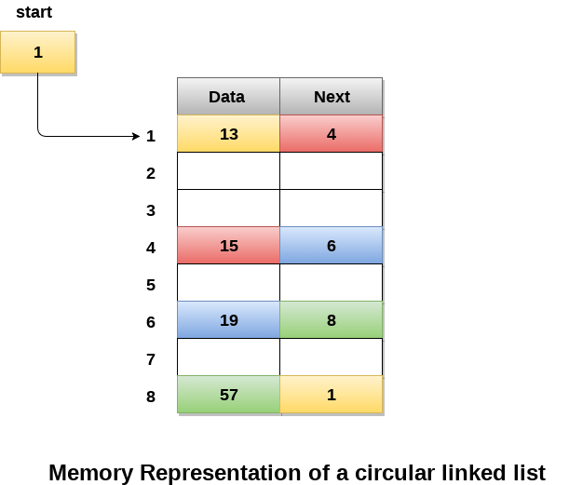

We can also have more than one number of linked list in the memory with the different start pointers pointing to the different start nodes in the list. The last node is identified by its next part which contains the address of the start node of the list. We must be able to identify the last node of any linked list so that we can find out the number of iterations which need to be performed while traversing the list.

## Operations on Circular Singly linked list:

### Insertion

|  |  |  |
| --- | --- | --- |
| **SN** | **Operation** | **Description** |
| 1 | [Insertion at beginning](https://www.javatpoint.com/insertion-in-circular-singly-list-at-beginning) | Adding a node into circular singly linked list at the beginning. |
| 2 | [Insertion at the end](https://www.javatpoint.com/insertion-in-circular-singly-linked-list-at-end) | Adding a node into circular singly linked list at the end. |

### Deletion & Traversing

|  |  |  |
| --- | --- | --- |
| **SN** | **Operation** | **Description** |
| 1 | [Deletion at beginning](https://www.javatpoint.com/deletion-in-circular-singly-linked-list-at-beginning) | Removing the node from circular singly linked list at the beginning. |
| 2 | [Deletion at the end](https://www.javatpoint.com/deletion-in-circular-singly-linked-list-at-end) | Removing the node from circular singly linked list at the end. |
| 3 | [Searching](https://www.javatpoint.com/searching-in-circular-singly-linked-list) | Compare each element of the node with the given item and return the location at which the item is present in the list otherwise return null. |
| 4 | [Traversing](https://www.javatpoint.com/traversing-in-circular-singly-linked-list) | Visiting each element of the list at least once in order to perform some specific operation. |

## Menu-driven program in C implementing all operations

### on circular singly linked list

1. #include<stdio.h>
2. #include<stdlib.h>
3. struct node
4. {
5. **int** data;
6. struct node *next;
7. };
8. struct node *head;
10. **void** beginsert ();
11. **void** lastinsert ();
12. **void** randominsert();
13. **void** begin_delete();
14. **void** last_delete();
15. **void** random_delete();
16. **void** display();
17. **void** search();
18. **void** main ()
19. {
20. **int** choice =0;
21. **while**(choice != 7)
22. {
23. printf("\n*********Main Menu*********\n");
24. printf("\nChoose one option from the following list ...\n");
25. printf("\n===============================================\n");
26. printf("\n1.Insert in begining\n2.Insert at last\n3.Delete from Beginning\n4.Delete from last\n5.Search for an element\n6.Show\n7.Exit\n");
27. printf("\nEnter your choice?\n");
28. scanf("\n%d",&choice);
29. **switch**(choice)
30. {
31. **case** 1:
32. beginsert();
33. **break**;
34. **case** 2:
35. lastinsert();
36. **break**;
37. **case** 3:
38. begin_delete();
39. **break**;
40. **case** 4:
41. last_delete();
42. **break**;
43. **case** 5:
44. search();
45. **break**;
46. **case** 6:
47. display();
48. **break**;
49. **case** 7:
50. exit(0);
51. **break**;
52. **default**:
53. printf("Please enter valid choice..");
54. }
55. }
56. }
57. **void** beginsert()
58. {
59. struct node *ptr,*temp;
60. **int** item;
61. ptr = (struct node *)malloc(sizeof(struct node));
62. **if**(ptr == NULL)
63. {
64. printf("\nOVERFLOW");
65. }
66. **else**
67. {
68. printf("\nEnter the node data?");
69. scanf("%d",&item);
70. ptr -> data = item;
71. **if**(head == NULL)
72. {
73. head = ptr;
74. ptr -> next = head;
75. }
76. **else**
77. {
78. temp = head;
79. **while**(temp->next != head)
80. temp = temp->next;
81. ptr->next = head;
82. temp -> next = ptr;
83. head = ptr;
84. }
85. printf("\nnode inserted\n");
86. }
88. }
89. **void** lastinsert()
90. {
91. struct node *ptr,*temp;
92. **int** item;
93. ptr = (struct node *)malloc(sizeof(struct node));
94. **if**(ptr == NULL)
95. {
96. printf("\nOVERFLOW\n");
97. }
98. **else**
99. {
100. printf("\nEnter Data?");
101. scanf("%d",&item);
102. ptr->data = item;
103. **if**(head == NULL)
104. {
105. head = ptr;
106. ptr -> next = head;
107. }
108. **else**
109. {
110. temp = head;
111. **while**(temp -> next != head)
112. {
113. temp = temp -> next;
114. }
115. temp -> next = ptr;
116. ptr -> next = head;
117. }
119. printf("\nnode inserted\n");
120. }
122. }
124. **void** begin_delete()
125. {
126. struct node *ptr;
127. **if**(head == NULL)
128. {
129. printf("\nUNDERFLOW");
130. }
131. **else** **if**(head->next == head)
132. {
133. head = NULL;
134. free(head);
135. printf("\nnode deleted\n");
136. }
138. **else**
139. {   ptr = head;
140. **while**(ptr -> next != head)
141. ptr = ptr -> next;
142. ptr->next = head->next;
143. free(head);
144. head = ptr->next;
145. printf("\nnode deleted\n");
147. }
148. }
149. **void** last_delete()
150. {
151. struct node *ptr, *preptr;
152. **if**(head==NULL)
153. {
154. printf("\nUNDERFLOW");
155. }
156. **else** **if** (head ->next == head)
157. {
158. head = NULL;
159. free(head);
160. printf("\nnode deleted\n");
162. }
163. **else**
164. {
165. ptr = head;
166. **while**(ptr ->next != head)
167. {
168. preptr=ptr;
169. ptr = ptr->next;
170. }
171. preptr->next = ptr -> next;
172. free(ptr);
173. printf("\nnode deleted\n");
175. }
176. }
178. **void** search()
179. {
180. struct node *ptr;
181. **int** item,i=0,flag=1;
182. ptr = head;
183. **if**(ptr == NULL)
184. {
185. printf("\nEmpty List\n");
186. }
187. **else**
188. {
189. printf("\nEnter item which you want to search?\n");
190. scanf("%d",&item);
191. **if**(head ->data == item)
192. {
193. printf("item found at location %d",i+1);
194. flag=0;
195. }
196. **else**
197. {
198. **while** (ptr->next != head)
199. {
200. **if**(ptr->data == item)
201. {
202. printf("item found at location %d ",i+1);
203. flag=0;
204. **break**;
205. }
206. **else**
207. {
208. flag=1;
209. }
210. i++;
211. ptr = ptr -> next;
212. }
213. }
214. **if**(flag != 0)
215. {
216. printf("Item not found\n");
217. }
218. }
220. }
222. **void** display()
223. {
224. struct node *ptr;
225. ptr=head;
226. **if**(head == NULL)
227. {
228. printf("\nnothing to print");
229. }
230. **else**
231. {
232. printf("\n printing values ... \n");
234. **while**(ptr -> next != head)
235. {
237. printf("%d\n", ptr -> data);
238. ptr = ptr -> next;
239. }
240. printf("%d\n", ptr -> data);
241. }
243. }

**Output:**

*********Main Menu*********

Choose one option from the following list ...

===============================================

1.Insert in begining

2.Insert at last

3.Delete from Beginning

4.Delete from last

5.Search for an element

6.Show

7.Exit

Enter your choice?

1

Enter the node data?10

node inserted

*********Main Menu*********

Choose one option from the following list ...

===============================================

1.Insert in begining

2.Insert at last

3.Delete from Beginning

4.Delete from last

5.Search for an element

6.Show

7.Exit

Enter your choice?

2

Enter Data?20

node inserted

*********Main Menu*********

Choose one option from the following list ...

===============================================

1.Insert in begining

2.Insert at last

3.Delete from Beginning

4.Delete from last

5.Search for an element

6.Show

7.Exit

Enter your choice?

2

Enter Data?30

node inserted

*********Main Menu*********

Choose one option from the following list ...

===============================================

1.Insert in begining

2.Insert at last

3.Delete from Beginning

4.Delete from last

5.Search for an element

6.Show

7.Exit

Enter your choice?

3

node deleted

*********Main Menu*********

Choose one option from the following list ...

===============================================

1.Insert in begining

2.Insert at last

3.Delete from Beginning

4.Delete from last

5.Search for an element

6.Show

7.Exit

Enter your choice?

4

node deleted

*********Main Menu*********

Choose one option from the following list ...

===============================================

1.Insert in begining

2.Insert at last

3.Delete from Beginning

4.Delete from last

5.Search for an element

6.Show

7.Exit

Enter your choice?

5

Enter item which you want to search?

20

item found at location 1

*********Main Menu*********

Choose one option from the following list ...

===============================================

1.Insert in begining

2.Insert at last

3.Delete from Beginning

4.Delete from last

5.Search for an element

6.Show

7.Exit

Enter your choice?

6

printing values ...

20

*********Main Menu*********

Choose one option from the following list ...

===============================================

1.Insert in begining

2.Insert at last

3.Delete from Beginning

4.Delete from last

5.Search for an element

6.Show

7.Exit

Enter your choice?

7

# Circular Doubly Linked List

Circular doubly linked list is a more complexed type of data structure in which a node contain pointers to its previous node as well as the next node. Circular doubly linked list doesn't contain NULL in any of the node. The last node of the list contains the address of the first node of the list. The first node of the list also contain address of the last node in its previous pointer.

A circular doubly linked list is shown in the following figure.

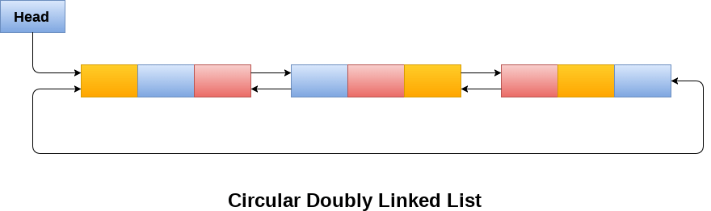

Due to the fact that a circular doubly linked list contains three parts in its structure therefore, it demands more space per node and more expensive basic operations. However, a circular doubly linked list provides easy manipulation of the pointers and the searching becomes twice as efficient.

## Memory Management of Circular Doubly linked list

The following figure shows the way in which the memory is allocated for a circular doubly linked list. The variable head contains the address of the first element of the list i.e. 1 hence the starting node of the list contains data A is stored at address 1. Since, each node of the list is supposed to have three parts therefore, the starting node of the list contains address of the last node i.e. 8 and the next node i.e. 4. The last node of the list that is stored at address 8 and containing data as 6, contains address of the first node of the list as shown in the image i.e. 1. In circular doubly linked list, the last node is identified by the address of the first node which is stored in the next part of the last node therefore the node which contains the address of the first node, is actually the last node of the list.

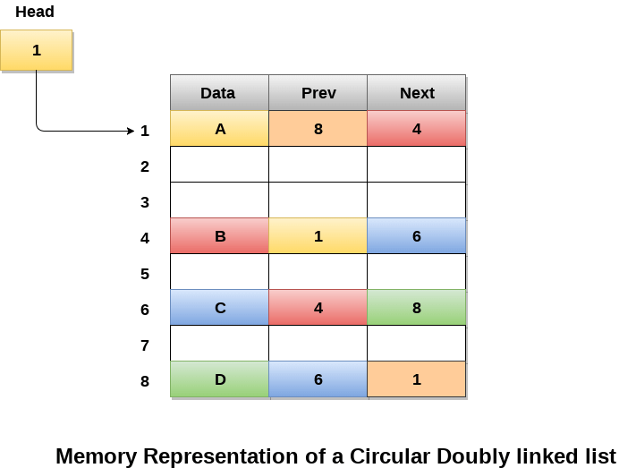

## Operations on circular doubly linked list :

There are various operations which can be performed on circular doubly linked list. The node structure of a circular doubly linked list is similar to doubly linked list. However, the operations on circular doubly linked list is described in the following table.

|  |  |  |
| --- | --- | --- |
| **SN** | **Operation** | **Description** |
| 1 | [Insertion at beginning](https://www.javatpoint.com/insertion-in-circular-doubly-linked-list-at-beginning) | Adding a node in circular doubly linked list at the beginning. |
| 2 | [Insertion at end](https://www.javatpoint.com/insertion-in-circular-doubly-linked-list-at-end) | Adding a node in circular doubly linked list at the end. |
| 3 | [Deletion at beginning](https://www.javatpoint.com/deletion-in-circular-doubly-linked-list-at-beginning) | Removing a node in circular doubly linked list from beginning. |
| 4 | [Deletion at end](https://www.javatpoint.com/deletion-in-circular-doubly-linked-list-at-end) | Removing a node in circular doubly linked list at the end. |

Traversing and searching in circular doubly linked list is similar to that in the circular singly linked list.

## C program to implement all the operations on circular doubly linked list

1. #include<stdio.h>
2. #include<stdlib.h>
3. struct node
4. {
5. struct node *prev;
6. struct node *next;
7. **int** data;
8. };
9. struct node *head;
10. **void** insertion_beginning();
11. **void** insertion_last();
12. **void** deletion_beginning();
13. **void** deletion_last();
14. **void** display();
15. **void** search();
16. **void** main ()
17. {
18. **int** choice =0;
19. **while**(choice != 9)
20. {
21. printf("\n*********Main Menu*********\n");
22. printf("\nChoose one option from the following list ...\n");
23. printf("\n===============================================\n");
24. printf("\n1.Insert in Beginning\n2.Insert at last\n3.Delete from Beginning\n4.Delete from last\n5.Search\n6.Show\n7.Exit\n");
25. printf("\nEnter your choice?\n");
26. scanf("\n%d",&choice);
27. **switch**(choice)
28. {
29. **case** 1:
30. insertion_beginning();
31. **break**;
32. **case** 2:
33. insertion_last();
34. **break**;
35. **case** 3:
36. deletion_beginning();
37. **break**;
38. **case** 4:
39. deletion_last();
40. **break**;
41. **case** 5:
42. search();
43. **break**;
44. **case** 6:
45. display();
46. **break**;
47. **case** 7:
48. exit(0);
49. **break**;
50. **default**:
51. printf("Please enter valid choice..");
52. }
53. }
54. }
55. **void** insertion_beginning()
56. {
57. struct node *ptr,*temp;
58. **int** item;
59. ptr = (struct node *)malloc(sizeof(struct node));
60. **if**(ptr == NULL)
61. {
62. printf("\nOVERFLOW");
63. }
64. **else**
65. {
66. printf("\nEnter Item value");
67. scanf("%d",&item);
68. ptr->data=item;
69. **if**(head==NULL)
70. {
71. head = ptr;
72. ptr -> next = head;
73. ptr -> prev = head;
74. }
75. **else**
76. {
77. temp = head;
78. **while**(temp -> next != head)
79. {
80. temp = temp -> next;
81. }
82. temp -> next = ptr;
83. ptr -> prev = temp;
84. head -> prev = ptr;
85. ptr -> next = head;
86. head = ptr;
87. }
88. printf("\nNode inserted\n");
89. }
91. }
92. **void** insertion_last()
93. {
94. struct node *ptr,*temp;
95. **int** item;
96. ptr = (struct node *) malloc(sizeof(struct node));
97. **if**(ptr == NULL)
98. {
99. printf("\nOVERFLOW");
100. }
101. **else**
102. {
103. printf("\nEnter value");
104. scanf("%d",&item);
105. ptr->data=item;
106. **if**(head == NULL)
107. {
108. head = ptr;
109. ptr -> next = head;
110. ptr -> prev = head;
111. }
112. **else**
113. {
114. temp = head;
115. **while**(temp->next !=head)
116. {
117. temp = temp->next;
118. }
119. temp->next = ptr;
120. ptr ->prev=temp;
121. head -> prev = ptr;
122. ptr -> next = head;
123. }
124. }
125. printf("\nnode inserted\n");
126. }
128. **void** deletion_beginning()
129. {
130. struct node *temp;
131. **if**(head == NULL)
132. {
133. printf("\n UNDERFLOW");
134. }
135. **else** **if**(head->next == head)
136. {
137. head = NULL;
138. free(head);
139. printf("\nnode deleted\n");
140. }
141. **else**
142. {
143. temp = head;
144. **while**(temp -> next != head)
145. {
146. temp = temp -> next;
147. }
148. temp -> next = head -> next;
149. head -> next -> prev = temp;
150. free(head);
151. head = temp -> next;
152. }
154. }
155. **void** deletion_last()
156. {
157. struct node *ptr;
158. **if**(head == NULL)
159. {
160. printf("\n UNDERFLOW");
161. }
162. **else** **if**(head->next == head)
163. {
164. head = NULL;
165. free(head);
166. printf("\nnode deleted\n");
167. }
168. **else**
169. {
170. ptr = head;
171. **if**(ptr->next != head)
172. {
173. ptr = ptr -> next;
174. }
175. ptr -> prev -> next = head;
176. head -> prev = ptr -> prev;
177. free(ptr);
178. printf("\nnode deleted\n");
179. }
180. }
182. **void** display()
183. {
184. struct node *ptr;
185. ptr=head;
186. **if**(head == NULL)
187. {
188. printf("\nnothing to print");
189. }
190. **else**
191. {
192. printf("\n printing values ... \n");
194. **while**(ptr -> next != head)
195. {
197. printf("%d\n", ptr -> data);
198. ptr = ptr -> next;
199. }
200. printf("%d\n", ptr -> data);
201. }
203. }
205. **void** search()
206. {
207. struct node *ptr;
208. **int** item,i=0,flag=1;
209. ptr = head;
210. **if**(ptr == NULL)
211. {
212. printf("\nEmpty List\n");
213. }
214. **else**
215. {
216. printf("\nEnter item which you want to search?\n");
217. scanf("%d",&item);
218. **if**(head ->data == item)
219. {
220. printf("item found at location %d",i+1);
221. flag=0;
222. }
223. **else**
224. {
225. **while** (ptr->next != head)
226. {
227. **if**(ptr->data == item)
228. {
229. printf("item found at location %d ",i+1);
230. flag=0;
231. **break**;
232. }
233. **else**
234. {
235. flag=1;
236. }
237. i++;
238. ptr = ptr -> next;
239. }
240. }
241. **if**(flag != 0)
242. {
243. printf("Item not found\n");
244. }
245. }
247. }

**Output:**

*********Main Menu*********

Choose one option from the following list ...

===============================================

1.Insert in Beginning

2.Insert at last

3.Delete from Beginning

4.Delete from last

5.Search

6.Show

7.Exit

Enter your choice?

1

Enter Item value123

Node inserted

*********Main Menu*********

Choose one option from the following list ...

===============================================

1.Insert in Beginning

2.Insert at last

3.Delete from Beginning

4.Delete from last

5.Search

6.Show

7.Exit

Enter your choice?

2

Enter value234

node inserted

*********Main Menu*********

Choose one option from the following list ...

===============================================

1.Insert in Beginning

2.Insert at last

3.Delete from Beginning

4.Delete from last

5.Search

6.Show

7.Exit

Enter your choice?

1

Enter Item value90

Node inserted

*********Main Menu*********

Choose one option from the following list ...

===============================================

1.Insert in Beginning

2.Insert at last

3.Delete from Beginning

4.Delete from last

5.Search

6.Show

7.Exit

Enter your choice?

2

Enter value80

node inserted

*********Main Menu*********

Choose one option from the following list ...

===============================================

1.Insert in Beginning

2.Insert at last

3.Delete from Beginning

4.Delete from last

5.Search

6.Show

7.Exit

Enter your choice?

3

*********Main Menu*********

Choose one option from the following list ...

===============================================

1.Insert in Beginning

2.Insert at last

3.Delete from Beginning

4.Delete from last

5.Search

6.Show

7.Exit

Enter your choice?

4

node deleted

*********Main Menu*********

Choose one option from the following list ...

===============================================

1.Insert in Beginning

2.Insert at last

3.Delete from Beginning

4.Delete from last

5.Search

6.Show

7.Exit

Enter your choice?

6

printing values ...

123

*********Main Menu*********

Choose one option from the following list ...

===============================================

1.Insert in Beginning

2.Insert at last

3.Delete from Beginning

4.Delete from last

5.Search

6.Show

7.Exit

Enter your choice?

5

Enter item which you want to search?

123

item found at location 1

*********Main Menu*********

Choose one option from the following list ...

============================================

1.Insert in Beginning

2.Insert at last

3.Delete from Beginning

4.Delete from last

5.Search

6.Show

7.Exit

Enter your choice?

7

# Skip list in Data structure

## What is a skip list?

A skip list is a probabilistic data structure. The skip list is used to store a sorted list of elements or data with a linked list. It allows the process of the elements or data to view efficiently. In one single step, it skips several elements of the entire list, which is why it is known as a skip list.

The skip list is an extended version of the linked list. It allows the user to search, remove, and insert the element very quickly. It consists of a base list that includes a set of elements which maintains the link hierarchy of the subsequent elements.

## Skip list structure

It is built in two layers: The lowest layer and Top layer.

The lowest layer of the skip list is a common sorted linked list, and the top layers of the skip list are like an "express line" where the elements are skipped.

## Complexity table of the Skip list

|  |  |  |  |
| --- | --- | --- | --- |
| **S. No** | **Complexity** | **Average case** | **Worst case** |
| 1. | Access complexity | O(logn) | O(n) |
| 2. | Search complexity | O(logn) | O(n) |
| 3. | Delete complexity | O(logn) | O(n) |
| 4. | Insert complexity | O(logn) | O(n) |
| 5. | Space complexity | - | O(nlogn) |

## Working of the Skip list

Let's take an example to understand the working of the skip list. In this example, we have 14 nodes, such that these nodes are divided into two layers, as shown in the diagram.

The lower layer is a common line that links all nodes, and the top layer is an express line that links only the main nodes, as you can see in the diagram.

Suppose you want to find 47 in this example. You will start the search from the first node of the express line and continue running on the express line until you find a node that is equal a 47 or more than 47.

You can see in the example that 47 does not exist in the express line, so you search for a node of less than 47, which is 40. Now, you go to the normal line with the help of 40, and search the 47, as shown in the diagram.

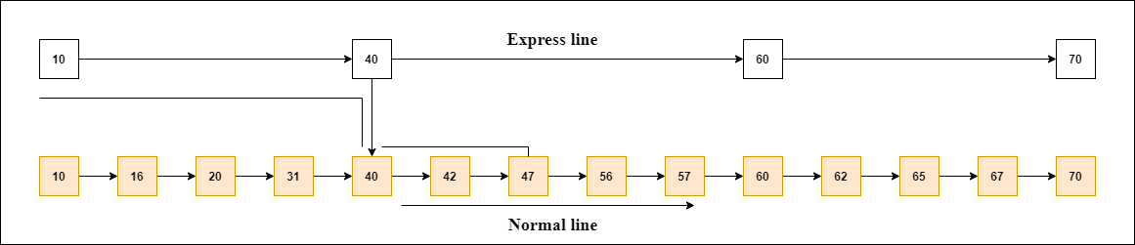

#### Note: Once you find a node like this on the "express line", you go from this node to a "normal lane" using a pointer, and when you search for the node in the normal line.

## Skip List Basic Operations

There are the following types of operations in the skip list.

* **Insertion operation:** It is used to add a new node to a particular location in a specific situation.
* **Deletion operation:** It is used to delete a node in a specific situation.
* **Search Operation:** The search operation is used to search a particular node in a skip list.

**Algorithm of the insertion operation**

1. Insertion (L, Key)
2. local update [0...Max_Level + 1]
3. a = L → header
4. **for** i = L → level down to 0 **do**.
5. **while** a → forward[i] → key  forward[i]
6. update[i] = a
8. a = a → forward[0]
9. lvl = random_Level()
10. **if** lvl > L → level then
11. **for** i = L → level + 1 to lvl **do**
12. update[i] = L → header
13. L → level = lvl
15. a = makeNode(lvl, Key, value)
16. **for** i = 0 to level **do**
17. a → forward[i] = update[i] → forward[i]
18. update[i] → forward[i] = a

**Algorithm of deletion operation**

1. Deletion (L, Key)
2. local update [0... Max_Level + 1]
3. a = L → header
4. **for** i = L → level down to 0 **do**.
5. **while** a → forward[i] → key forward[i]
6. update[i] = a
7. a = a → forward[0]
8. **if** a → key = Key then
9. **for** i = 0 to L → level **do**
10. **if** update[i] → forward[i] ? a then **break**
11. update[i] → forward[i] = a → forward[i]
12. free(a)
13. **while** L → level > 0 and L → header → forward[L → level] = NIL **do**
14. L → level = L → level - 1

**Algorithm of searching operation**

1. Searching (L, SKey)
2. a = L → header
3. loop invariant: a → key level down to 0 **do**.
4. **while** a → forward[i] → key forward[i]
5. a = a → forward[0]
6. **if** a → key = SKey then **return** a → value
7. **else** **return** failure

**Example 1:** Create a skip list, we want to insert these following keys in the empty skip list.

1. 6 with level 1.
2. 29 with level 1.
3. 22 with level 4.
4. 9 with level 3.
5. 17 with level 1.
6. 4 with level 2.

**Ans:**

**Step 1:** Insert 6 with level 1

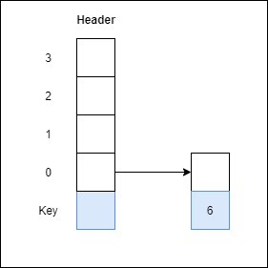

**Step 2:** Insert 29 with level 1

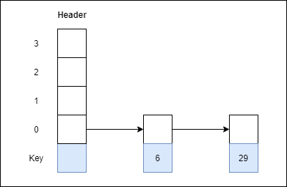

**Step 3:** Insert 22 with level 4

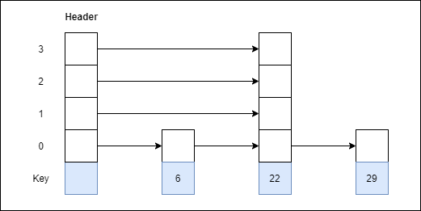

**Step 4:** Insert 9 with level 3

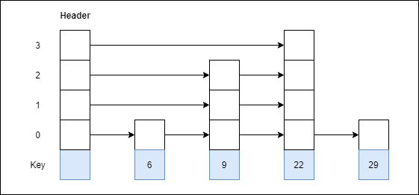

**Step 5:** Insert 17 with level 1

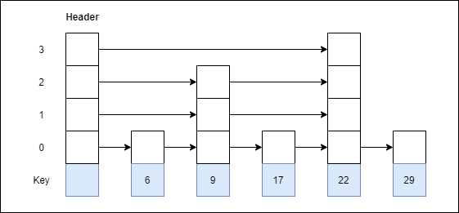

**Step 6:** Insert 4 with level 2

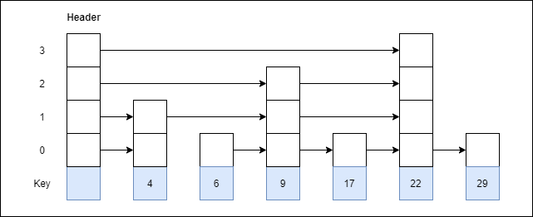

**Example 2:** Consider this example where we want to search for key 17.



**Ans:**

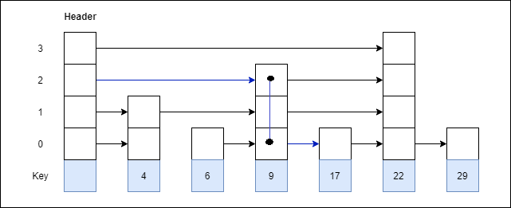

## Advantages of the Skip list

1. If you want to insert a new node in the skip list, then it will insert the node very fast because there are no rotations in the skip list.
2. The skip list is simple to implement as compared to the hash table and the binary search tree.
3. It is very simple to find a node in the list because it stores the nodes in sorted form.
4. The skip list algorithm can be modified very easily in a more specific structure, such as indexable skip lists, trees, or priority queues.
5. The skip list is a robust and reliable list.

## Disadvantages of the Skip list

1. It requires more memory than the balanced tree.
2. Reverse searching is not allowed.
3. The skip list searches the node much slower than the linked list.

## Applications of the Skip list

1. It is used in distributed applications, and it represents the pointers and system in the distributed applications.
2. It is used to implement a dynamic elastic concurrent queue with low lock contention.
3. It is also used with the QMap template class.
4. The indexing of the skip list is used in running median problems.
5. The skip list is used for the delta-encoding posting in the Lucene search.

What is a Stack?

A Stack is a linear data structure that follows the **LIFO (Last-In-First-Out)** principle. Stack has one end, whereas the Queue has two ends (**front and rear**). It contains only one pointer **top pointer** pointing to the topmost element of the stack. Whenever an element is added in the stack, it is added on the top of the stack, and the element can be deleted only from the stack. In other words, a ***stack can be defined as a container in which insertion and deletion can be done from the one end known as the top of the stack.***

Some key points related to stack

* It is called as stack because it behaves like a real-world stack, piles of books, etc.
* A Stack is an abstract data type with a pre-defined capacity, which means that it can store the elements of a limited size.
* It is a data structure that follows some order to insert and delete the elements, and that order can be LIFO or FILO.

Working of Stack

Stack works on the LIFO pattern. As we can observe in the below figure there are five memory blocks in the stack; therefore, the size of the stack is 5.

Suppose we want to store the elements in a stack and let's assume that stack is empty. We have taken the stack of size 5 as shown below in which we are pushing the elements one by one until the stack becomes full.

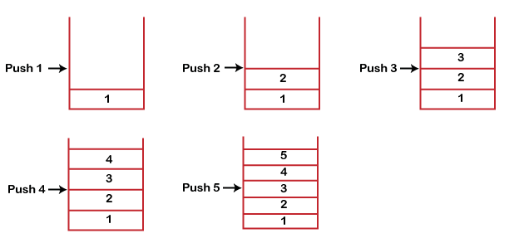

Since our stack is full as the size of the stack is 5. In the above cases, we can observe that it goes from the top to the bottom when we were entering the new element in the stack. The stack gets filled up from the bottom to the top.

When we perform the delete operation on the stack, there is only one way for entry and exit as the other end is closed. It follows the LIFO pattern, which means that the value entered first will be removed last. In the above case, the value 5 is entered first, so it will be removed only after the deletion of all the other elements.

Standard Stack Operations

**The following are some common operations implemented on the stack:**

* **push():** When we insert an element in a stack then the operation is known as a push. If the stack is full then the overflow condition occurs.
* **pop():** When we delete an element from the stack, the operation is known as a pop. If the stack is empty means that no element exists in the stack, this state is known as an underflow state.
* **isEmpty():** It determines whether the stack is empty or not.
* **isFull():** It determines whether the stack is full or not.'
* **peek():** It returns the element at the given position.
* **count():** It returns the total number of elements available in a stack.
* **change():** It changes the element at the given position.
* **display():** It prints all the elements available in the stack.

PUSH operation

**The steps involved in the PUSH operation is given below:**

* Before inserting an element in a stack, we check whether the stack is full.
* If we try to insert the element in a stack, and the stack is full, then the ***overflow*** condition occurs.
* When we initialize a stack, we set the value of top as -1 to check that the stack is empty.
* When the new element is pushed in a stack, first, the value of the top gets incremented, i.e., **top=top+1,** and the element will be placed at the new position of the **top**.
* The elements will be inserted until we reach the ***max*** size of the stack.

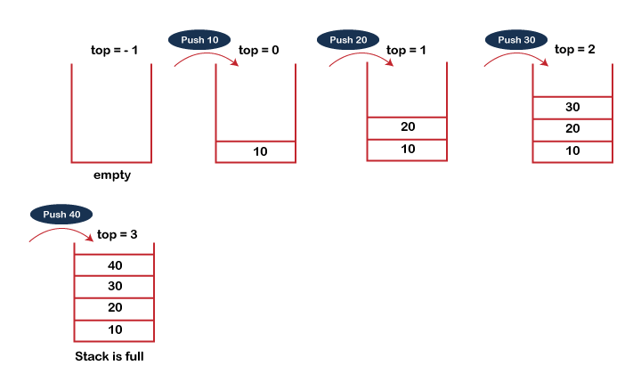

POP operation

**The steps involved in the POP operation is given below:**

* Before deleting the element from the stack, we check whether the stack is empty.
* If we try to delete the element from the empty stack, then the ***underflow*** condition occurs.
* If the stack is not empty, we first access the element which is pointed by the ***top***
* Once the pop operation is performed, the top is decremented by 1, i.e., **top=top-1**.

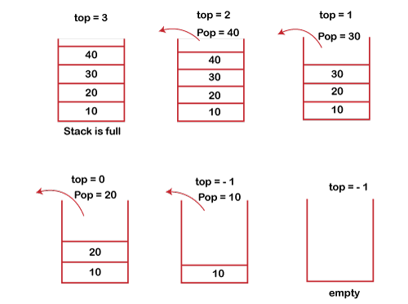

Applications of Stack

**The following are the applications of the stack:**

* **Balancing of symbols:** Stack is used for balancing a symbol. For example, we have the following program:

1. **int** main()
2. {
3. cout<<"Hello";
4. cout<<"javaTpoint";
5. }

As we know, each program has *an opening* and *closing* braces; when the opening braces come, we push the braces in a stack, and when the closing braces appear, we pop the opening braces from the stack. Therefore, the net value comes out to be zero. If any symbol is left in the stack, it means that some syntax occurs in a program.

* **String reversal:** Stack is also used for reversing a string. For example, we want to reverse a "**javaTpoint**" string, so we can achieve this with the help of a stack.  
  First, we push all the characters of the string in a stack until we reach the null character.  
  After pushing all the characters, we start taking out the character one by one until we reach the bottom of the stack.
* **UNDO/REDO:** It can also be used for performing UNDO/REDO operations. For example, we have an editor in which we write 'a', then 'b', and then 'c'; therefore, the text written in an editor is abc. So, there are three states, a, ab, and abc, which are stored in a stack. There would be two stacks in which one stack shows UNDO state, and the other shows REDO state.  
  If we want to perform UNDO operation, and want to achieve 'ab' state, then we implement pop operation.
* **Recursion:** The recursion means that the function is calling itself again. To maintain the previous states, the compiler creates a system stack in which all the previous records of the function are maintained.
* **DFS(Depth First Search):** This search is implemented on a Graph, and Graph uses the stack data structure.
* **Backtracking:** Suppose we have to create a path to solve a maze problem. If we are moving in a particular path, and we realize that we come on the wrong way. In order to come at the beginning of the path to create a new path, we have to use the stack data structure.
* **Expression conversion:** Stack can also be used for expression conversion. This is one of the most important applications of stack. The list of the expression conversion is given below:
* Infix to prefix
* Infix to postfix
* Prefix to infix
* Prefix to postfix

Postfix to infix

* **Memory management:** The stack manages the memory. The memory is assigned in the contiguous memory blocks. The memory is known as stack memory as all the variables are assigned in a function call stack memory. The memory size assigned to the program is known to the compiler. When the function is created, all its variables are assigned in the stack memory. When the function completed its execution, all the variables assigned in the stack are released.

Array implementation of Stack

In array implementation, the stack is formed by using the array. All the operations regarding the stack are performed using arrays. Lets see how each operation can be implemented on the stack using array data structure.

Adding an element onto the stack (push operation)

Adding an element into the top of the stack is referred to as push operation. Push operation involves following two steps.

1. Increment the variable Top so that it can now refere to the next memory location.
2. Add element at the position of incremented top. This is referred to as adding new element at the top of the stack.

Stack is overflown when we try to insert an element into a completely filled stack therefore, our main function must always avoid stack overflow condition.

**Algorithm:**

1. begin
2. **if** top = n then stack full
3. top = top + 1
4. stack (top) : = item;
5. end

**Time Complexity : o(1)**

implementation of push algorithm in C language

1. **void** push (**int** val,**int** n) //n is size of the stack
2. {
3. **if** (top == n )
4. printf("\n Overflow");
5. **else**
6. {
7. top = top +1;
8. stack[top] = val;
9. }
10. }

Deletion of an element from a stack (Pop operation)

Deletion of an element from the top of the stack is called pop operation. The value of the variable top will be incremented by 1 whenever an item is deleted from the stack. The top most element of the stack is stored in an another variable and then the top is decremented by 1. the operation returns the deleted value that was stored in another variable as the result.

The underflow condition occurs when we try to delete an element from an already empty stack.

**Algorithm :**

1. begin
2. **if** top = 0 then stack empty;
3. item := stack(top);
4. top = top - 1;
5. end;

**Time Complexity : o(1)**

Implementation of POP algorithm using C language

1. **int** pop ()
2. {
3. **if**(top == -1)
4. {
5. printf("Underflow");
6. **return** 0;
7. }
8. **else**
9. {
10. **return** stack[top - - ];
11. }
12. }

Visiting each element of the stack (Peek operation)

Peek operation involves returning the element which is present at the top of the stack without deleting it. Underflow condition can occur if we try to return the top element in an already empty stack.

**Algorithm :**

PEEK (STACK, TOP)

1. Begin
2. **if** top = -1 then stack empty
3. item = stack[top]
4. **return** item
5. End

**Time complexity: o(n)**

Implementation of Peek algorithm in C language

1. **int** peek()
2. {
3. **if** (top == -1)
4. {
5. printf("Underflow");
6. **return** 0;
7. }
8. **else**
9. {
10. **return** stack [top];
11. }
12. }

**C program**

1. #include <stdio.h>
2. **int** stack[100],i,j,choice=0,n,top=-1;
3. **void** push();
4. **void** pop();
5. **void** show();
6. **void** main ()
7. {
9. printf("Enter the number of elements in the stack ");
10. scanf("%d",&n);
11. printf("*********Stack operations using array*********");
13. printf("\n----------------------------------------------\n");
14. **while**(choice != 4)
15. {
16. printf("Chose one from the below options...\n");
17. printf("\n1.Push\n2.Pop\n3.Show\n4.Exit");
18. printf("\n Enter your choice \n");
19. scanf("%d",&choice);
20. **switch**(choice)
21. {
22. **case** 1:
23. {
24. push();
25. **break**;
26. }
27. **case** 2:
28. {
29. pop();
30. **break**;
31. }
32. **case** 3:
33. {
34. show();
35. **break**;
36. }
37. **case** 4:
38. {
39. printf("Exiting....");
40. **break**;
41. }
42. **default**:
43. {
44. printf("Please Enter valid choice ");
45. }
46. };
47. }
48. }
50. **void** push ()
51. {
52. **int** val;
53. **if** (top == n )
54. printf("\n Overflow");
55. **else**
56. {
57. printf("Enter the value?");
58. scanf("%d",&val);
59. top = top +1;
60. stack[top] = val;
61. }
62. }
64. **void** pop ()
65. {
66. **if**(top == -1)
67. printf("Underflow");
68. **else**
69. top = top -1;
70. }
71. **void** show()
72. {
73. **for** (i=top;i>=0;i--)
74. {
75. printf("%d\n",stack[i]);
76. }
77. **if**(top == -1)
78. {
79. printf("Stack is empty");
80. }
81. }

**Java Program**

1. **import** java.util.Scanner;
2. **class** Stack
3. {
4. **int** top;
5. **int** maxsize = 10;
6. **int**[] arr = **new** **int**[maxsize];

9. **boolean** isEmpty()
10. {
11. **return** (top < 0);
12. }
13. Stack()
14. {
15. top = -1;
16. }
17. **boolean** push (Scanner sc)
18. {
19. **if**(top == maxsize-1)
20. {
21. System.out.println("Overflow !!");
22. **return** **false**;
23. }
24. **else**
25. {
26. System.out.println("Enter Value");
27. **int** val = sc.nextInt();
28. top++;
29. arr[top]=val;
30. System.out.println("Item pushed");
31. **return** **true**;
32. }
33. }
34. **boolean** pop ()
35. {
36. **if** (top == -1)
37. {
38. System.out.println("Underflow !!");
39. **return** **false**;
40. }
41. **else**
42. {
43. top --;
44. System.out.println("Item popped");
45. **return** **true**;
46. }
47. }
48. **void** display ()
49. {
50. System.out.println("Printing stack elements .....");
51. **for**(**int** i = top; i>=0;i--)
52. {
53. System.out.println(arr[i]);
54. }
55. }
56. }
57. **public** **class** Stack_Operations {
58. **public** **static** **void** main(String[] args) {
59. **int** choice=0;
60. Scanner sc = **new** Scanner(System.in);
61. Stack s = **new** Stack();
62. System.out.println("*********Stack operations using array*********\n");
63. System.out.println("\n------------------------------------------------\n");
64. **while**(choice != 4)
65. {
66. System.out.println("\nChose one from the below options...\n");
67. System.out.println("\n1.Push\n2.Pop\n3.Show\n4.Exit");
68. System.out.println("\n Enter your choice \n");
69. choice = sc.nextInt();
70. **switch**(choice)
71. {
72. **case** 1:
73. {
74. s.push(sc);
75. **break**;
76. }
77. **case** 2:
78. {
79. s.pop();
80. **break**;
81. }
82. **case** 3:
83. {
84. s.display();
85. **break**;
86. }
87. **case** 4:
88. {
89. System.out.println("Exiting....");
90. System.exit(0);
91. **break**;
92. }
93. **default**:
94. {
95. System.out.println("Please Enter valid choice ");
96. }
97. };
98. }
99. }
100. }

**C# Program**

1. using System;
3. **public** **class** Stack
4. {
5. **int** top;
6. **int** maxsize=10;
7. **int**[] arr = **new** **int**[10];
8. **public** **static** **void** Main()
9. {
10. Stack st = **new** Stack();
11. st.top=-1;
12. **int** choice=0;
13. Console.WriteLine("*********Stack operations using array*********");
14. Console.WriteLine("\n----------------------------------------------\n");
15. **while**(choice != 4)
16. {
17. Console.WriteLine("Chose one from the below options...\n");
18. Console.WriteLine("\n1.Push\n2.Pop\n3.Show\n4.Exit");
19. Console.WriteLine("\n Enter your choice \n");
20. choice = Convert.ToInt32(Console.ReadLine());
21. **switch**(choice)
22. {
23. **case** 1:
24. {
25. st.push();
26. **break**;
27. }
28. **case** 2:
29. {
30. st.pop();
31. **break**;
32. }
33. **case** 3:
34. {
35. st.show();
36. **break**;
37. }
38. **case** 4:
39. {
40. Console.WriteLine("Exiting....");
41. **break**;
42. }
43. **default**:
44. {
45. Console.WriteLine("Please Enter valid choice ");
46. **break**;
47. }
48. };
49. }
50. }
52. Boolean push ()
53. {
54. **int** val;
55. **if**(top == maxsize-1)
56. {
58. Console.WriteLine("\n Overflow");
59. **return** **false**;
60. }
61. **else**
62. {
63. Console.WriteLine("Enter the value?");
64. val = Convert.ToInt32(Console.ReadLine());
65. top = top +1;
66. arr[top] = val;
67. Console.WriteLine("Item pushed");
68. **return** **true**;
69. }
70. }
72. Boolean pop ()
73. {
74. **if** (top == -1)
75. {
76. Console.WriteLine("Underflow");
77. **return** **false**;
78. }
80. **else**
82. {
83. top = top -1;
84. Console.WriteLine("Item popped");
85. **return** **true**;
86. }
87. }
88. **void** show()
89. {
91. **for** (**int** i=top;i>=0;i--)
92. {
93. Console.WriteLine(arr[i]);
94. }
95. **if**(top == -1)
96. {
97. Console.WriteLine("Stack is empty");
98. }
99. }
100. }

# Linked list implementation of stack

Instead of using array, we can also use linked list to implement stack. Linked list allocates the memory dynamically. However, time complexity in both the scenario is same for all the operations i.e. push, pop and peek.

In linked list implementation of stack, the nodes are maintained non-contiguously in the memory. Each node contains a pointer to its immediate successor node in the stack. Stack is said to be overflown if the space left in the memory heap is not enough to create a node.

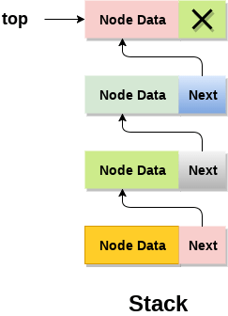

The top most node in the stack always contains null in its address field. Lets discuss the way in which, each operation is performed in linked list implementation of stack.

## Adding a node to the stack (Push operation)

Adding a node to the stack is referred to as **push** operation. Pushing an element to a stack in linked list implementation is different from that of an array implementation. In order to push an element onto the stack, the following steps are involved.

1. Create a node first and allocate memory to it.
2. If the list is empty then the item is to be pushed as the start node of the list. This includes assigning value to the data part of the node and assign null to the address part of the node.
3. If there are some nodes in the list already, then we have to add the new element in the beginning of the list (to not violate the property of the stack). For this purpose, assign the address of the starting element to the address field of the new node and make the new node, the starting node of the list.

**Time Complexity : o(1)**

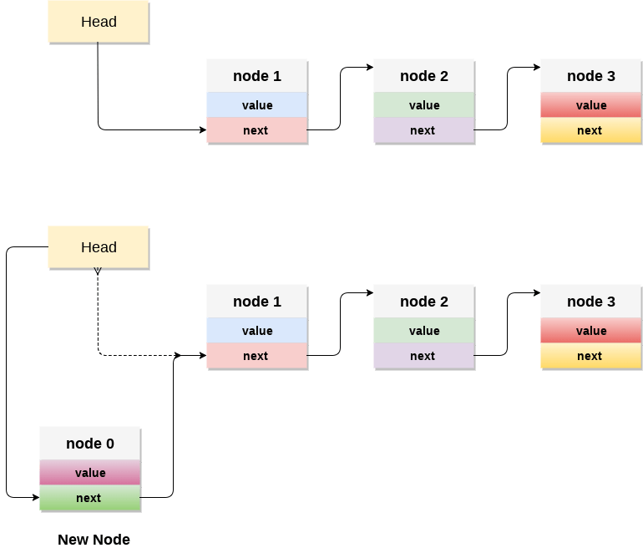

### C implementation :

* 1. **void** push ()
  2. {
  3. **int** val;
  4. struct node *ptr =(struct node*)malloc(sizeof(struct node));
  5. **if**(ptr == NULL)
  6. {
  7. printf("not able to push the element");
  8. }
  9. **else**
  10. {
  11. printf("Enter the value");
  12. scanf("%d",&val);
  13. **if**(head==NULL)
  14. {
  15. ptr->val = val;
  16. ptr -> next = NULL;
  17. head=ptr;
  18. }
  19. **else**
  20. {
  21. ptr->val = val;
  22. ptr->next = head;
  23. head=ptr;
  25. }
  26. printf("Item pushed");
  28. }
  29. }

## Deleting a node from the stack (POP operation)

Deleting a node from the top of stack is referred to as **pop** operation. Deleting a node from the linked list implementation of stack is different from that in the array implementation. In order to pop an element from the stack, we need to follow the following steps :

* 1. **Check for the underflow condition:** The underflow condition occurs when we try to pop from an already empty stack. The stack will be empty if the head pointer of the list points to null.
  2. **Adjust the head pointer accordingly:** In stack, the elements are popped only from one end, therefore, the value stored in the head pointer must be deleted and the node must be freed. The next node of the head node now becomes the head node.

**Time Complexity : o(n)**

### C implementation

* 1. **void** pop()
  2. {
  3. **int** item;
  4. struct node *ptr;
  5. **if** (head == NULL)
  6. {
  7. printf("Underflow");
  8. }
  9. **else**
  10. {
  11. item = head->val;
  12. ptr = head;
  13. head = head->next;
  14. free(ptr);
  15. printf("Item popped");
  17. }
  18. }

## Display the nodes (Traversing)

Displaying all the nodes of a stack needs traversing all the nodes of the linked list organized in the form of stack. For this purpose, we need to follow the following steps.

* 1. Copy the head pointer into a temporary pointer.
  2. Move the temporary pointer through all the nodes of the list and print the value field attached to every node.

**Time Complexity : o(n)**

### C Implementation

* 1. **void** display()
  2. {
  3. **int** i;
  4. struct node *ptr;
  5. ptr=head;
  6. **if**(ptr == NULL)
  7. {
  8. printf("Stack is empty\n");
  9. }
  10. **else**
  11. {
  12. printf("Printing Stack elements \n");
  13. **while**(ptr!=NULL)
  14. {
  15. printf("%d\n",ptr->val);
  16. ptr = ptr->next;
  17. }
  18. }
  19. }

### Menu Driven program in C implementing all the stack operations using linked list :

* 1. #include <stdio.h>
  2. #include <stdlib.h>
  3. **void** push();
  4. **void** pop();
  5. **void** display();
  6. struct node
  7. {
  8. **int** val;
  9. struct node *next;
  10. };
  11. struct node *head;
  13. **void** main ()
  14. {
  15. **int** choice=0;
  16. printf("\n*********Stack operations using linked list*********\n");
  17. printf("\n----------------------------------------------\n");
  18. **while**(choice != 4)
  19. {
  20. printf("\n\nChose one from the below options...\n");
  21. printf("\n1.Push\n2.Pop\n3.Show\n4.Exit");
  22. printf("\n Enter your choice \n");
  23. scanf("%d",&choice);
  24. **switch**(choice)
  25. {
  26. **case** 1:
  27. {
  28. push();
  29. **break**;
  30. }
  31. **case** 2:
  32. {
  33. pop();
  34. **break**;
  35. }
  36. **case** 3:
  37. {
  38. display();
  39. **break**;
  40. }
  41. **case** 4:
  42. {
  43. printf("Exiting....");
  44. **break**;
  45. }
  46. **default**:
  47. {
  48. printf("Please Enter valid choice ");
  49. }
  50. };
  51. }
  52. }
  53. **void** push ()
  54. {
  55. **int** val;
  56. struct node *ptr = (struct node*)malloc(sizeof(struct node));
  57. **if**(ptr == NULL)
  58. {
  59. printf("not able to push the element");
  60. }
  61. **else**
  62. {
  63. printf("Enter the value");
  64. scanf("%d",&val);
  65. **if**(head==NULL)
  66. {
  67. ptr->val = val;
  68. ptr -> next = NULL;
  69. head=ptr;
  70. }
  71. **else**
  72. {
  73. ptr->val = val;
  74. ptr->next = head;
  75. head=ptr;
  77. }
  78. printf("Item pushed");
  80. }
  81. }
  83. **void** pop()
  84. {
  85. **int** item;
  86. struct node *ptr;
  87. **if** (head == NULL)
  88. {
  89. printf("Underflow");
  90. }
  91. **else**
  92. {
  93. item = head->val;
  94. ptr = head;
  95. head = head->next;
  96. free(ptr);
  97. printf("Item popped");
  99. }
  100. }
  101. **void** display()
  102. {
  103. **int** i;
  104. struct node *ptr;
  105. ptr=head;
  106. **if**(ptr == NULL)
  107. {
  108. printf("Stack is empty\n");
  109. }
  110. **else**
  111. {
  112. printf("Printing Stack elements \n");
  113. **while**(ptr!=NULL)
  114. {
  115. printf("%d\n",ptr->val);
  116. ptr = ptr->next;
  117. }
  118. }
  119. }

# Queue

1. A queue can be defined as an ordered list which enables insert operations to be performed at one end called **REAR** and delete operations to be performed at another end called **FRONT**.

2. Queue is referred to be as First In First Out list.

3. For example, people waiting in line for a rail ticket form a queue.

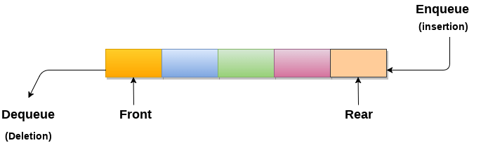

## Applications of Queue

Due to the fact that queue performs actions on first in first out basis which is quite fair for the ordering of actions. There are various applications of queues discussed as below.

1. Queues are widely used as waiting lists for a single shared resource like printer, disk, CPU.
2. Queues are used in asynchronous transfer of data (where data is not being transferred at the same rate between two processes) for eg. pipes, file IO, sockets.
3. Queues are used as buffers in most of the applications like MP3 media player, CD player, etc.
4. Queue are used to maintain the play list in media players in order to add and remove the songs from the play-list.
5. Queues are used in operating systems for handling interrupts.

## Complexity

|  |  |  |  |  |  |  |  |  |  |
| --- | --- | --- | --- | --- | --- | --- | --- | --- | --- |
| **Data Structure** | **Time Complexity** | | | | | | | | **Space Compleity** |
|  | **Average** | | | | **Worst** | | | | **Worst** |
|  | Access | Search | Insertion | Deletion | Access | Search | Insertion | Deletion |  |
| Queue | θ(n) | θ(n) | θ(1) | θ(1) | O(n) | O(n) | O(1) | O(1) | O(n) |

# Types of Queue

In this article, we will discuss the types of queue. But before moving towards the types, we should first discuss the brief introduction of the queue.

### What is a Queue?

Queue is the data structure that is similar to the queue in the real world. A queue is a data structure in which whatever comes first will go out first, and it follows the FIFO (First-In-First-Out) policy. Queue can also be defined as the list or collection in which the insertion is done from one end known as the **rear end** or the **tail** of the queue, whereas the deletion is done from another end known as the **front end** or the **head** of the queue.

The real-world example of a queue is the ticket queue outside a cinema hall, where the person who enters first in the queue gets the ticket first, and the last person enters in the queue gets the ticket at last. Similar approach is followed in the queue in data structure.

The representation of the queue is shown in the below image -

Play Videox[](https://campaign.adpushup.com/get-started/?utm_source=banner&utm_campaign=growth_hack)

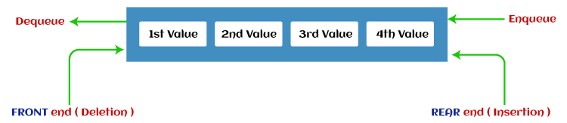

Now, let's move towards the types of queue.

### Types of Queue

There are four different types of queue that are listed as follows -

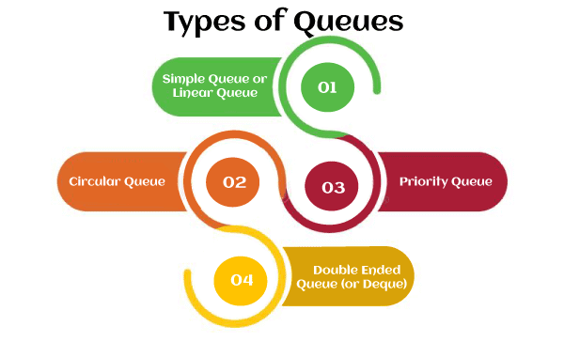

* Simple Queue or Linear Queue
* Circular Queue
* Priority Queue
* Double Ended Queue (or Deque)

Let's discuss each of the type of queue.

### Simple Queue or Linear Queue

In Linear Queue, an insertion takes place from one end while the deletion occurs from another end. The end at which the insertion takes place is known as the rear end, and the end at which the deletion takes place is known as front end. It strictly follows the FIFO rule.

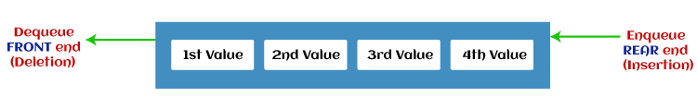

The major drawback of using a linear Queue is that insertion is done only from the rear end. If the first three elements are deleted from the Queue, we cannot insert more elements even though the space is available in a Linear Queue. In this case, the linear Queue shows the overflow condition as the rear is pointing to the last element of the Queue.

To know more about the queue in data structure, you can click the link - <https://www.javatpoint.com/data-structure-queue>

### Circular Queue

In Circular Queue, all the nodes are represented as circular. It is similar to the linear Queue except that the last element of the queue is connected to the first element. It is also known as Ring Buffer, as all the ends are connected to another end. The representation of circular queue is shown in the below image -

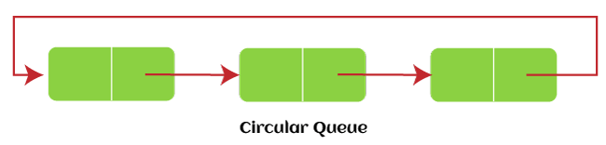

The drawback that occurs in a linear queue is overcome by using the circular queue. If the empty space is available in a circular queue, the new element can be added in an empty space by simply incrementing the value of rear. The main advantage of using the circular queue is better memory utilization.

To know more about the circular queue, you can click the link - <https://www.javatpoint.com/circular-queue>

### Priority Queue

It is a special type of queue in which the elements are arranged based on the priority. It is a special type of queue data structure in which every element has a priority associated with it. Suppose some elements occur with the same priority, they will be arranged according to the FIFO principle. The representation of priority queue is shown in the below image -

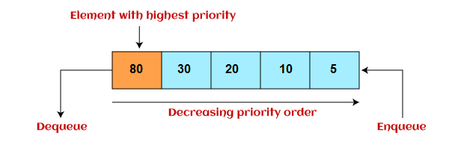

Insertion in priority queue takes place based on the arrival, while deletion in the priority queue occurs based on the priority. Priority queue is mainly used to implement the CPU scheduling algorithms.

There are two types of priority queue that are discussed as follows -

* **Ascending priority queue -** In ascending priority queue, elements can be inserted in arbitrary order, but only smallest can be deleted first. Suppose an array with elements 7, 5, and 3 in the same order, so, insertion can be done with the same sequence, but the order of deleting the elements is 3, 5, 7.
* **Descending priority queue -** In descending priority queue, elements can be inserted in arbitrary order, but only the largest element can be deleted first. Suppose an array with elements 7, 3, and 5 in the same order, so, insertion can be done with the same sequence, but the order of deleting the elements is 7, 5, 3.

To learn more about the priority queue, you can click the link - <https://www.javatpoint.com/ds-priority-queue>

### Deque (or, Double Ended Queue)

In Deque or Double Ended Queue, insertion and deletion can be done from both ends of the queue either from the front or rear. It means that we can insert and delete elements from both front and rear ends of the queue. Deque can be used as a palindrome checker means that if we read the string from both ends, then the string would be the same.

Deque can be used both as stack and queue as it allows the insertion and deletion operations on both ends. Deque can be considered as stack because stack follows the LIFO (Last In First Out) principle in which insertion and deletion both can be performed only from one end. And in deque, it is possible to perform both insertion and deletion from one end, and Deque does not follow the FIFO principle.

The representation of the deque is shown in the below image -

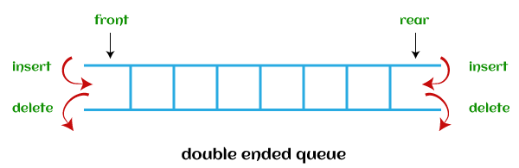

To know more about the deque, you can click the link - <https://www.javatpoint.com/ds-deque>

There are two types of deque that are discussed as follows -

* **Input restricted deque -** As the name implies, in input restricted queue, insertion operation can be performed at only one end, while deletion can be performed from both ends.  
  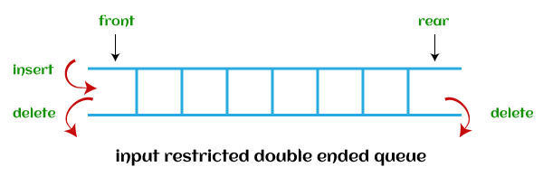
* **Output restricted deque -** As the name implies, in output restricted queue, deletion operation can be performed at only one end, while insertion can be performed from both ends.  
  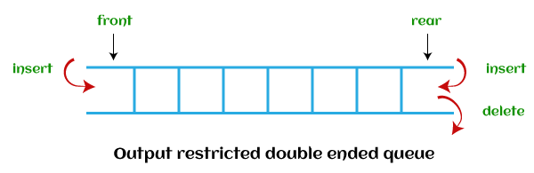

Now, let's see the operations performed on the queue.

## Operations performed on queue

The fundamental operations that can be performed on queue are listed as follows -

* **Enqueue:** The Enqueue operation is used to insert the element at the rear end of the queue. It returns void.
* **Dequeue:** It performs the deletion from the front-end of the queue. It also returns the element which has been removed from the front-end. It returns an integer value.
* **Peek:** This is the third operation that returns the element, which is pointed by the front pointer in the queue but does not delete it.
* **Queue overflow (isfull):** It shows the overflow condition when the queue is completely full.
* **Queue underflow (isempty):** It shows the underflow condition when the Queue is empty, i.e., no elements are in the Queue.

Now, let's see the ways to implement the queue.

## Ways to implement the queue

There are two ways of implementing the Queue:

* **Implementation using array:** The sequential allocation in a Queue can be implemented using an array. For more details, click on the below link: <https://www.javatpoint.com/array-representation-of-queue>
* **Implementation using Linked list:** The linked list allocation in a Queue can be implemented using a linked list. For more details, click on the below link: <https://www.javatpoint.com/linked-list-implementation-of-queue>

So, that's all about the article. Hope, the article will be helpful and informative to you.

# Array representation of Queue

We can easily represent queue by using linear arrays. There are two variables i.e. front and rear, that are implemented in the case of every queue. Front and rear variables point to the position from where insertions and deletions are performed in a queue. Initially, the value of front and queue is -1 which represents an empty queue. Array representation of a queue containing 5 elements along with the respective values of front and rear, is shown in the following figure.

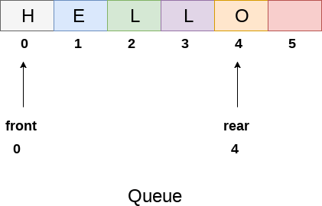

The above figure shows the queue of characters forming the English word **"HELLO"**. Since, No deletion is performed in the queue till now, therefore the value of front remains -1 . However, the value of rear increases by one every time an insertion is performed in the queue. After inserting an element into the queue shown in the above figure, the queue will look something like following. The value of rear will become 5 while the value of front remains same.

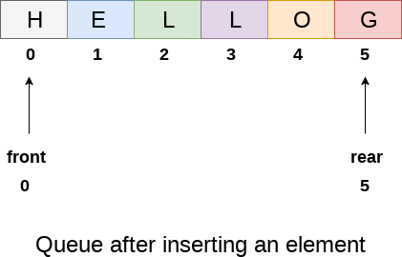

After deleting an element, the value of front will increase from -1 to 0. however, the queue will look something like following.

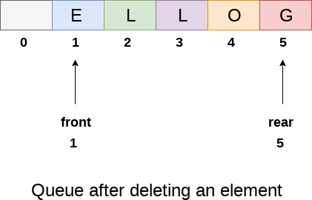

## Algorithm to insert any element in a queue

Check if the queue is already full by comparing rear to max - 1. if so, then return an overflow error.

If the item is to be inserted as the first element in the list, in that case set the value of front and rear to 0 and insert the element at the rear end.

Otherwise keep increasing the value of rear and insert each element one by one having rear as the index.

## Algorithm

* **Step 1:** IF REAR = MAX - 1  
  Write OVERFLOW  
  Go to step  
  [END OF IF]
* **Step 2:** IF FRONT = -1 and REAR = -1  
  SET FRONT = REAR = 0  
  ELSE  
  SET REAR = REAR + 1  
  [END OF IF]
* **Step 3:** Set QUEUE[REAR] = NUM
* **Step 4:** EXIT

## C Function

1. **void** insert (**int** queue[], **int** max, **int** front, **int** rear, **int** item)
2. {
3. **if** (rear + 1 == max)
4. {
5. printf("overflow");
6. }
7. **else**
8. {
9. **if**(front == -1 && rear == -1)
10. {
11. front = 0;
12. rear = 0;
13. }
14. **else**
15. {
16. rear = rear + 1;
17. }
18. queue[rear]=item;
19. }
20. }

## Algorithm to delete an element from the queue

If, the value of front is -1 or value of front is greater than rear , write an underflow message and exit.

Otherwise, keep increasing the value of front and return the item stored at the front end of the queue at each time.

## Algorithm

* **Step 1:** IF FRONT = -1 or FRONT > REAR  
  Write UNDERFLOW  
  ELSE  
  SET VAL = QUEUE[FRONT]  
  SET FRONT = FRONT + 1  
  [END OF IF]
* **Step 2:** EXIT

## C Function

1. **int** delete (**int** queue[], **int** max, **int** front, **int** rear)
2. {
3. **int** y;
4. **if** (front == -1 || front > rear)
6. {
7. printf("underflow");
8. }
9. **else**
10. {
11. y = queue[front];
12. **if**(front == rear)
13. {
14. front = rear = -1;
15. **else**
16. front = front + 1;
18. }
19. **return** y;
20. }
21. }

## Menu driven program to implement queue using array

1. #include<stdio.h>
2. #include<stdlib.h>
3. #define maxsize 5
4. **void** insert();
5. **void** delete();
6. **void** display();
7. **int** front = -1, rear = -1;
8. **int** queue[maxsize];
9. **void** main ()
10. {
11. **int** choice;
12. **while**(choice != 4)
13. {
14. printf("\n*************************Main Menu*****************************\n");
15. printf("\n=================================================================\n");
16. printf("\n1.insert an element\n2.Delete an element\n3.Display the queue\n4.Exit\n");
17. printf("\nEnter your choice ?");
18. scanf("%d",&choice);
19. **switch**(choice)
20. {
21. **case** 1:
22. insert();
23. **break**;
24. **case** 2:
25. delete();
26. **break**;
27. **case** 3:
28. display();
29. **break**;
30. **case** 4:
31. exit(0);
32. **break**;
33. **default**:
34. printf("\nEnter valid choice??\n");
35. }
36. }
37. }
38. **void** insert()
39. {
40. **int** item;
41. printf("\nEnter the element\n");
42. scanf("\n%d",&item);
43. **if**(rear == maxsize-1)
44. {
45. printf("\nOVERFLOW\n");
46. **return**;
47. }
48. **if**(front == -1 && rear == -1)
49. {
50. front = 0;
51. rear = 0;
52. }
53. **else**
54. {
55. rear = rear+1;
56. }
57. queue[rear] = item;
58. printf("\nValue inserted ");
60. }
61. **void** delete()
62. {
63. **int** item;
64. **if** (front == -1 || front > rear)
65. {
66. printf("\nUNDERFLOW\n");
67. **return**;
69. }
70. **else**
71. {
72. item = queue[front];
73. **if**(front == rear)
74. {
75. front = -1;
76. rear = -1 ;
77. }
78. **else**
79. {
80. front = front + 1;
81. }
82. printf("\nvalue deleted ");
83. }

86. }
88. **void** display()
89. {
90. **int** i;
91. **if**(rear == -1)
92. {
93. printf("\nEmpty queue\n");
94. }
95. **else**
96. {   printf("\nprinting values .....\n");
97. **for**(i=front;i<=rear;i++)
98. {
99. printf("\n%d\n",queue[i]);
100. }
101. }
102. }

**Output:**

*************Main Menu**************

==============================================

1.insert an element

2.Delete an element

3.Display the queue

4.Exit

Enter your choice ?1

Enter the element

123

Value inserted

*************Main Menu**************

==============================================

1.insert an element

2.Delete an element

3.Display the queue

4.Exit

Enter your choice ?1

Enter the element

90

Value inserted

*************Main Menu**************

===================================

1.insert an element

2.Delete an element

3.Display the queue

4.Exit

Enter your choice ?2

value deleted

*************Main Menu**************

==============================================

1.insert an element

2.Delete an element

3.Display the queue

4.Exit

Enter your choice ?3

printing values .....

90

*************Main Menu**************

==============================================

1.insert an element

2.Delete an element

3.Display the queue

4.Exit

Enter your choice ?4

## Drawback of array implementation

Although, the technique of creating a queue is easy, but there are some drawbacks of using this technique to implement a queue.

* **Memory wastage :** The space of the array, which is used to store queue elements, can never be reused to store the elements of that queue because the elements can only be inserted at front end and the value of front might be so high so that, all the space before that, can never be filled.

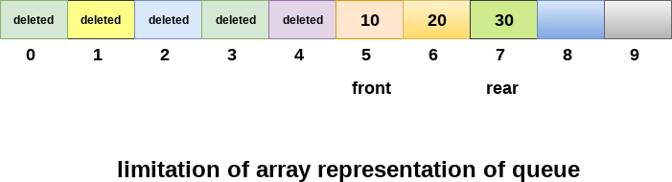

The above figure shows how the memory space is wasted in the array representation of queue. In the above figure, a queue of size 10 having 3 elements, is shown. The value of the front variable is 5, therefore, we can not reinsert the values in the place of already deleted element before the position of front. That much space of the array is wasted and can not be used in the future (for this queue).

* **Deciding the array size**

On of the most common problem with array implementation is the size of the array which requires to be declared in advance. Due to the fact that, the queue can be extended at runtime depending upon the problem, the extension in the array size is a time taking process and almost impossible to be performed at runtime since a lot of reallocations take place. Due to this reason, we can declare the array large enough so that we can store queue elements as enough as possible but the main problem with this declaration is that, most of the array slots (nearly half) can never be reused. It will again lead to memory wastage.

# Linked List implementation of Queue

Due to the drawbacks discussed in the previous section of this tutorial, the array implementation can not be used for the large scale applications where the queues are implemented. One of the alternative of array implementation is linked list implementation of queue.

The storage requirement of linked representation of a queue with n elements is o(n) while the time requirement for operations is o(1).

In a linked queue, each node of the queue consists of two parts i.e. data part and the link part. Each element of the queue points to its immediate next element in the memory.

In the linked queue, there are two pointers maintained in the memory i.e. front pointer and rear pointer. The front pointer contains the address of the starting element of the queue while the rear pointer contains the address of the last element of the queue.

Insertion and deletions are performed at rear and front end respectively. If front and rear both are NULL, it indicates that the queue is empty.

The linked representation of queue is shown in the following figure.

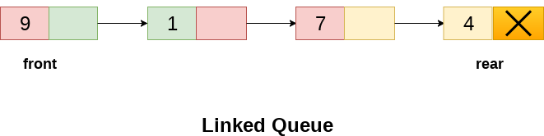

## Operation on Linked Queue

There are two basic operations which can be implemented on the linked queues. The operations are Insertion and Deletion.

## Insert operation

The insert operation append the queue by adding an element to the end of the queue. The new element will be the last element of the queue.

Firstly, allocate the memory for the new node ptr by using the following statement.

1. Ptr = (struct node *) malloc (sizeof(struct node));

There can be the two scenario of inserting this new node ptr into the linked queue.

In the first scenario, we insert element into an empty queue. In this case, the condition **front = NULL** becomes true. Now, the new element will be added as the only element of the queue and the next pointer of front and rear pointer both, will point to NULL.

1. ptr -> data = item;
2. **if**(front == NULL)
3. {
4. front = ptr;
5. rear = ptr;
6. front -> next = NULL;
7. rear -> next = NULL;
8. }

In the second case, the queue contains more than one element. The condition front = NULL becomes false. In this scenario, we need to update the end pointer rear so that the next pointer of rear will point to the new node ptr. Since, this is a linked queue, hence we also need to make the rear pointer point to the newly added node **ptr**. We also need to make the next pointer of rear point to NULL.

1. rear -> next = ptr;
2. rear = ptr;
3. rear->next = NULL;

In this way, the element is inserted into the queue. The algorithm and the C implementation is given as follows.

## Algorithm

* **Step 1:** Allocate the space for the new node PTR
* **Step 2:** SET PTR -> DATA = VAL
* **Step 3:** IF FRONT = NULL  
  SET FRONT = REAR = PTR  
  SET FRONT -> NEXT = REAR -> NEXT = NULL  
  ELSE  
  SET REAR -> NEXT = PTR  
  SET REAR = PTR  
  SET REAR -> NEXT = NULL  
  [END OF IF]
* **Step 4:** END

## C Function

1. **void** insert(struct node *ptr, **int** item; )
2. {

5. ptr = (struct node *) malloc (sizeof(struct node));
6. **if**(ptr == NULL)
7. {
8. printf("\nOVERFLOW\n");
9. **return**;
10. }
11. **else**
12. {
13. ptr -> data = item;
14. **if**(front == NULL)
15. {
16. front = ptr;
17. rear = ptr;
18. front -> next = NULL;
19. rear -> next = NULL;
20. }
21. **else**
22. {
23. rear -> next = ptr;
24. rear = ptr;
25. rear->next = NULL;
26. }
27. }
28. }

## Deletion

Deletion operation removes the element that is first inserted among all the queue elements. Firstly, we need to check either the list is empty or not. The condition front == NULL becomes true if the list is empty, in this case , we simply write underflow on the console and make exit.

Otherwise, we will delete the element that is pointed by the pointer front. For this purpose, copy the node pointed by the front pointer into the pointer ptr. Now, shift the front pointer, point to its next node and free the node pointed by the node ptr. This is done by using the following statements.

1. ptr = front;
2. front = front -> next;
3. free(ptr);

The algorithm and C function is given as follows.

## Algorithm

* **Step 1:** IF FRONT = NULL  
  Write " Underflow "  
  Go to Step 5  
  [END OF IF]
* **Step 2:** SET PTR = FRONT
* **Step 3:** SET FRONT = FRONT -> NEXT
* **Step 4:** FREE PTR
* **Step 5:** END

## C Function

1. **void** delete (struct node *ptr)
2. {
3. **if**(front == NULL)
4. {
5. printf("\nUNDERFLOW\n");
6. **return**;
7. }
8. **else**
9. {
10. ptr = front;
11. front = front -> next;
12. free(ptr);
13. }
14. }

## Menu-Driven Program implementing all the operations on Linked Queue

1. #include<stdio.h>
2. #include<stdlib.h>
3. struct node
4. {
5. **int** data;
6. struct node *next;
7. };
8. struct node *front;
9. struct node *rear;
10. **void** insert();
11. **void** delete();
12. **void** display();
13. **void** main ()
14. {
15. **int** choice;
16. **while**(choice != 4)
17. {
18. printf("\n*************************Main Menu*****************************\n");
19. printf("\n=================================================================\n");
20. printf("\n1.insert an element\n2.Delete an element\n3.Display the queue\n4.Exit\n");
21. printf("\nEnter your choice ?");
22. scanf("%d",& choice);
23. **switch**(choice)
24. {
25. **case** 1:
26. insert();
27. **break**;
28. **case** 2:
29. delete();
30. **break**;
31. **case** 3:
32. display();
33. **break**;
34. **case** 4:
35. exit(0);
36. **break**;
37. **default**:
38. printf("\nEnter valid choice??\n");
39. }
40. }
41. }
42. **void** insert()
43. {
44. struct node *ptr;
45. **int** item;
47. ptr = (struct node *) malloc (sizeof(struct node));
48. **if**(ptr == NULL)
49. {
50. printf("\nOVERFLOW\n");
51. **return**;
52. }
53. **else**
54. {
55. printf("\nEnter value?\n");
56. scanf("%d",&item);
57. ptr -> data = item;
58. **if**(front == NULL)
59. {
60. front = ptr;
61. rear = ptr;
62. front -> next = NULL;
63. rear -> next = NULL;
64. }
65. **else**
66. {
67. rear -> next = ptr;
68. rear = ptr;
69. rear->next = NULL;
70. }
71. }
72. }
73. **void** delete ()
74. {
75. struct node *ptr;
76. **if**(front == NULL)
77. {
78. printf("\nUNDERFLOW\n");
79. **return**;
80. }
81. **else**
82. {
83. ptr = front;
84. front = front -> next;
85. free(ptr);
86. }
87. }
88. **void** display()
89. {
90. struct node *ptr;
91. ptr = front;
92. **if**(front == NULL)
93. {
94. printf("\nEmpty queue\n");
95. }
96. **else**
97. {   printf("\nprinting values .....\n");
98. **while**(ptr != NULL)
99. {
100. printf("\n%d\n",ptr -> data);
101. ptr = ptr -> next;
102. }
103. }
104. }

**Output:**

***********Main Menu**********

==============================

1.insert an element

2.Delete an element

3.Display the queue

4.Exit

Enter your choice ?1

Enter value?

123

***********Main Menu**********

==============================

1.insert an element

2.Delete an element

3.Display the queue

4.Exit

Enter your choice ?1

Enter value?

90

***********Main Menu**********

==============================

1.insert an element

2.Delete an element

3.Display the queue

4.Exit

Enter your choice ?3

printing values .....

123

90

***********Main Menu**********

==============================

1.insert an element

2.Delete an element

3.Display the queue

4.Exit

Enter your choice ?2

***********Main Menu**********

==============================

1.insert an element

2.Delete an element

3.Display the queue

4.Exit

Enter your choice ?3

printing values .....

90

***********Main Menu**********

==============================

1.insert an element

2.Delete an element

3.Display the queue

4.Exit

Enter your choice ?4

Circular Queue

Why was the concept of the circular queue introduced?

There was one limitation in the array implementation of [Queue](https://www.javatpoint.com/data-structure-queue). If the rear reaches to the end position of the Queue then there might be possibility that some vacant spaces are left in the beginning which cannot be utilized. So, to overcome such limitations, the concept of the circular queue was introduced.

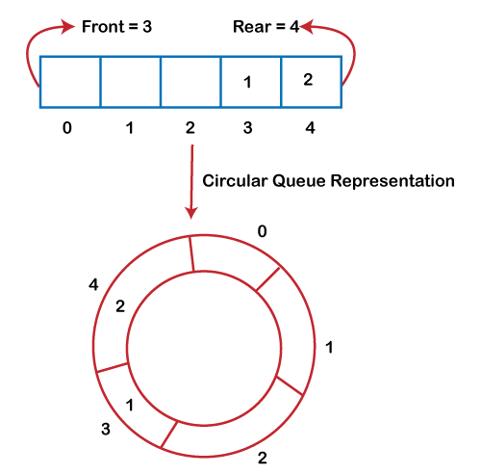

As we can see in the above image, the rear is at the last position of the Queue and front is pointing somewhere rather than the 0th position. In the above array, there are only two elements and other three positions are empty. The rear is at the last position of the Queue; if we try to insert the element then it will show that there are no empty spaces in the Queue. There is one solution to avoid such wastage of memory space by shifting both the elements at the left and adjust the front and rear end accordingly. It is not a practically good approach because shifting all the elements will consume lots of time. The efficient approach to avoid the wastage of the memory is to use the circular queue data structure.

What is a Circular Queue?

A circular queue is similar to a linear queue as it is also based on the FIFO (First In First Out) principle except that the last position is connected to the first position in a circular queue that forms a circle. It is also known as a ***Ring Buffer***.

Operations on Circular Queue

The following are the operations that can be performed on a circular queue:

* **Front:** It is used to get the front element from the Queue.
* **Rear:** It is used to get the rear element from the Queue.
* **enQueue(value):** This function is used to insert the new value in the Queue. The new element is always inserted from the rear end.
* **deQueue():** This function deletes an element from the Queue. The deletion in a Queue always takes place from the front end.

Applications of Circular Queue

**The circular Queue can be used in the following scenarios:**

* **Memory management:** The circular queue provides memory management. As we have already seen that in linear queue, the memory is not managed very efficiently. But in case of a circular queue, the memory is managed efficiently by placing the elements in a location which is unused.
* **CPU Scheduling:** The operating system also uses the circular queue to insert the processes and then execute them.
* **Traffic system:** In a computer-control traffic system, traffic light is one of the best examples of the circular queue. Each light of traffic light gets ON one by one after every jinterval of time. Like red light gets ON for one minute then yellow light for one minute and then green light. After green light, the red light gets ON.

Enqueue operation

**The steps of enqueue operation are given below:**

* First, we will check whether the Queue is full or not.
* Initially the front and rear are set to -1. When we insert the first element in a Queue, front and rear both are set to 0.
* When we insert a new element, the rear gets incremented, i.e., ***rear=rear+1***.

Scenarios for inserting an element

**There are two scenarios in which queue is not full:**

* **If rear != max - 1**, then rear will be incremented to **mod(maxsize)** and the new value will be inserted at the rear end of the queue.
* **If front != 0 and rear = max - 1**, it means that queue is not full, then set the value of rear to 0 and insert the new element there.

**There are two cases in which the element cannot be inserted:**

* When **front ==0** && **rear = max-1**, which means that front is at the first position of the Queue and rear is at the last position of the Queue.
* front== rear + 1;

**Algorithm to insert an element in a circular queue**

**Step 1:** IF (REAR+1)%MAX = FRONT  
Write " OVERFLOW "  
Goto step 4  
[End OF IF]

**Step 2:** IF FRONT = -1 and REAR = -1  
SET FRONT = REAR = 0  
ELSE IF REAR = MAX - 1 and FRONT ! = 0  
SET REAR = 0  
ELSE  
SET REAR = (REAR + 1) % MAX  
[END OF IF]

**Step 3:** SET QUEUE[REAR] = VAL

**Step 4:** EXIT

Dequeue Operation

The steps of dequeue operation are given below:

* First, we check whether the Queue is empty or not. If the queue is empty, we cannot perform the dequeue operation.
* When the element is deleted, the value of front gets decremented by 1.
* If there is only one element left which is to be deleted, then the front and rear are reset to -1.

**Algorithm to delete an element from the circular queue**

**Step 1:** IF FRONT = -1  
Write " UNDERFLOW "  
Goto Step 4  
[END of IF]

**Step 2:** SET VAL = QUEUE[FRONT]

**Step 3:** IF FRONT = REAR  
SET FRONT = REAR = -1  
ELSE  
IF FRONT = MAX -1  
SET FRONT = 0  
ELSE  
SET FRONT = FRONT + 1  
[END of IF]  
[END OF IF]

**Step 4:** EXIT

**Let's understand the enqueue and dequeue operation through the diagrammatic representation.**

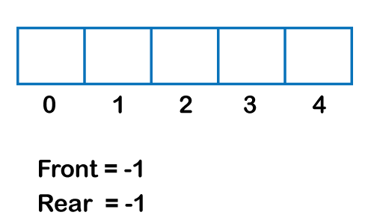  
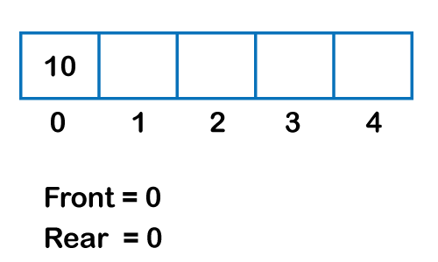  
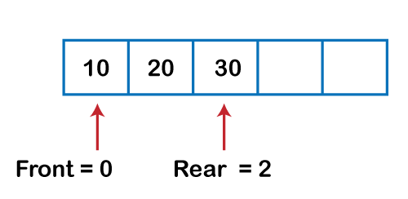  
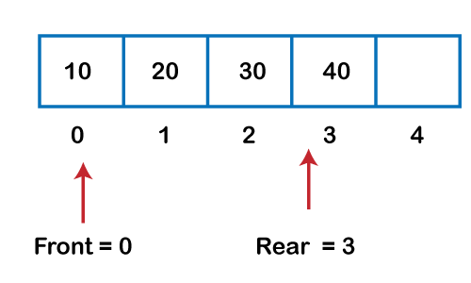  
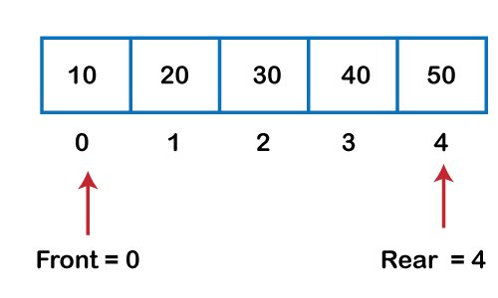  
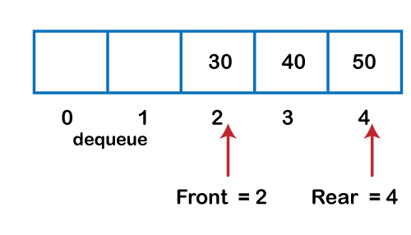  
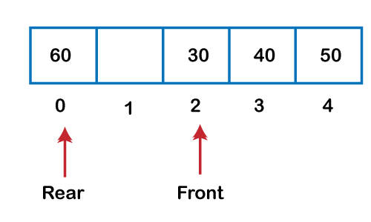  
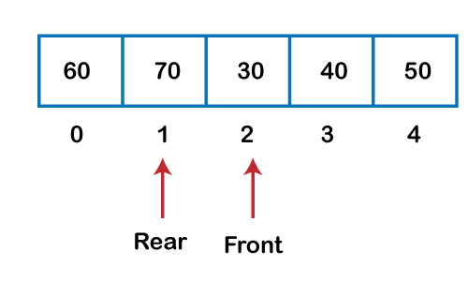

Implementation of circular queue using Array

1. #include <stdio.h>
3. # define max 6
4. **int** queue[max];  // array declaration
5. **int** front=-1;
6. **int** rear=-1;
7. // function to insert an element in a circular queue
8. **void** enqueue(**int** element)
9. {
10. **if**(front==-1 && rear==-1)   // condition to check queue is empty
11. {
12. front=0;
13. rear=0;
14. queue[rear]=element;
15. }
16. **else** **if**((rear+1)%max==front)  // condition to check queue is full
17. {
18. printf("Queue is overflow..");
19. }
20. **else**
21. {
22. rear=(rear+1)%max;       // rear is incremented
23. queue[rear]=element;     // assigning a value to the queue at the rear position.
24. }
25. }
27. // function to delete the element from the queue
28. **int** dequeue()
29. {
30. **if**((front==-1) && (rear==-1))  // condition to check queue is empty
31. {
32. printf("\nQueue is underflow..");
33. }
34. **else** **if**(front==rear)
35. {
36. printf("\nThe dequeued element is %d", queue[front]);
37. front=-1;
38. rear=-1;
39. }
40. **else**
41. {
42. printf("\nThe dequeued element is %d", queue[front]);
43. front=(front+1)%max;
44. }
45. }
46. // function to display the elements of a queue
47. **void** display()
48. {
49. **int** i=front;
50. **if**(front==-1 && rear==-1)
51. {
52. printf("\n Queue is empty..");
53. }
54. **else**
55. {
56. printf("\nElements in a Queue are :");
57. **while**(i<=rear)
58. {
59. printf("%d,", queue[i]);
60. i=(i+1)%max;
61. }
62. }
63. }
64. **int** main()
65. {
66. **int** choice=1,x;   // variables declaration
68. **while**(choice<4 && choice!=0)   // while loop
69. {
70. printf("\n Press 1: Insert an element");
71. printf("\nPress 2: Delete an element");
72. printf("\nPress 3: Display the element");
73. printf("\nEnter your choice");
74. scanf("%d", &choice);
76. **switch**(choice)
77. {
79. **case** 1:
81. printf("Enter the element which is to be inserted");
82. scanf("%d", &x);
83. enqueue(x);
84. **break**;
85. **case** 2:
86. dequeue();
87. **break**;
88. **case** 3:
89. display();
91. }}
92. **return** 0;
93. }

**Output:**

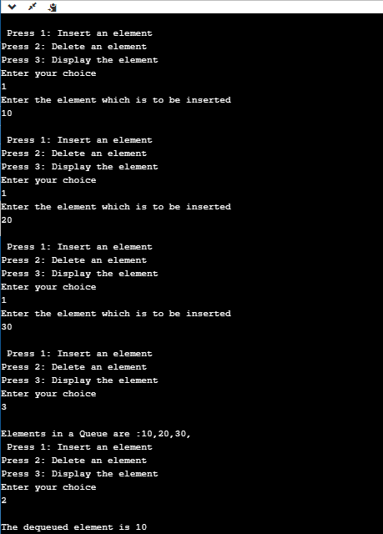

Implementation of circular queue using linked list

As we know that linked list is a linear data structure that stores two parts, i.e., data part and the address part where address part contains the address of the next node. Here, linked list is used to implement the circular queue; therefore, the linked list follows the properties of the Queue. When we are implementing the circular queue using linked list then both the ***enqueue and dequeue*** operations take ***O(1)*** time.

1. #include <stdio.h>
2. // Declaration of struct type node
3. **struct** node
4. {
5. **int** data;
6. **struct** node *next;
7. };
8. **struct** node *front=-1;
9. **struct** node *rear=-1;
10. // function to insert the element in the Queue
11. **void** enqueue(**int** x)
12. {
13. **struct** node *newnode;  // declaration of pointer of struct node type.
14. newnode=(**struct** node *)malloc(**sizeof**(**struct** node));  // allocating the memory to the newnode
15. newnode->data=x;
16. newnode->next=0;
17. **if**(rear==-1)  // checking whether the Queue is empty or not.
18. {
19. front=rear=newnode;
20. rear->next=front;
21. }
22. **else**
23. {
24. rear->next=newnode;
25. rear=newnode;
26. rear->next=front;
27. }
28. }
30. // function to delete the element from the queue
31. **void** dequeue()
32. {
33. **struct** node *temp;   // declaration of pointer of node type
34. temp=front;
35. **if**((front==-1)&&(rear==-1))  // checking whether the queue is empty or not
36. {
37. printf("\nQueue is empty");
38. }
39. **else** **if**(front==rear)  // checking whether the single element is left in the queue
40. {
41. front=rear=-1;
42. free(temp);
43. }
44. **else**
45. {
46. front=front->next;
47. rear->next=front;
48. free(temp);
49. }
50. }
52. // function to get the front of the queue
53. **int** peek()
54. {
55. **if**((front==-1) &&(rear==-1))
56. {
57. printf("\nQueue is empty");
58. }
59. **else**
60. {
61. printf("\nThe front element is %d", front->data);
62. }
63. }
65. // function to display all the elements of the queue
66. **void** display()
67. {
68. **struct** node *temp;
69. temp=front;
70. printf("\n The elements in a Queue are : ");
71. **if**((front==-1) && (rear==-1))
72. {
73. printf("Queue is empty");
74. }
76. **else**
77. {
78. **while**(temp->next!=front)
79. {
80. printf("%d,", temp->data);
81. temp=temp->next;
82. }
83. printf("%d", temp->data);
84. }
85. }
87. **void** main()
88. {
89. enqueue(34);
90. enqueue(10);
91. enqueue(23);
92. display();
93. dequeue();
94. peek();
95. }

**Output:**

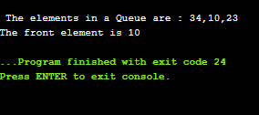

# Deque (or double-ended queue)

In this article, we will discuss the double-ended queue or deque. We should first see a brief description of the queue.

### What is a queue?

A queue is a data structure in which whatever comes first will go out first, and it follows the FIFO (First-In-First-Out) policy. Insertion in the queue is done from one end known as the **rear end** or the **tail,** whereas the deletion is done from another end known as the **front end** or the **head** of the queue.

The real-world example of a queue is the ticket queue outside a cinema hall, where the person who enters first in the queue gets the ticket first, and the person enters last in the queue gets the ticket at last.

### What is a Deque (or double-ended queue)

The deque stands for Double Ended Queue. Deque is a linear data structure where the insertion and deletion operations are performed from both ends. We can say that deque is a generalized version of the queue.

Play Videox[](https://campaign.adpushup.com/get-started/?utm_source=banner&utm_campaign=growth_hack)

Though the insertion and deletion in a deque can be performed on both ends, it does not follow the FIFO rule. The representation of a deque is given as follows -

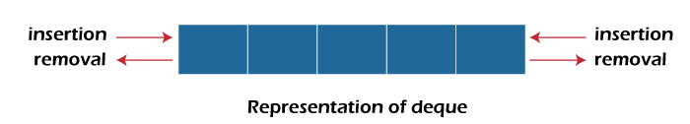

### Types of deque

There are two types of deque -

* Input restricted queue
* Output restricted queue

**Input restricted Queue**

In input restricted queue, insertion operation can be performed at only one end, while deletion can be performed from both ends.

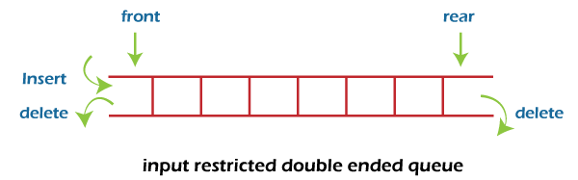

**Output restricted Queue**

In output restricted queue, deletion operation can be performed at only one end, while insertion can be performed from both ends.

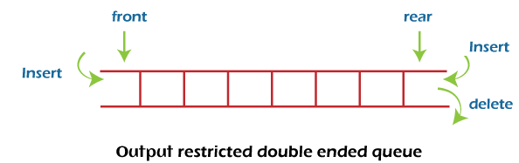

### Operations performed on deque

There are the following operations that can be applied on a deque -

* Insertion at front
* Insertion at rear
* Deletion at front
* Deletion at rear

We can also perform peek operations in the deque along with the operations listed above. Through peek operation, we can get the deque's front and rear elements of the deque. So, in addition to the above operations, following operations are also supported in deque -

* Get the front item from the deque
* Get the rear item from the deque
* Check whether the deque is full or not
* Checks whether the deque is empty or not

Now, let's understand the operation performed on deque using an example.

**Insertion at the front end**

In this operation, the element is inserted from the front end of the queue. Before implementing the operation, we first have to check whether the queue is full or not. If the queue is not full, then the element can be inserted from the front end by using the below conditions -

* If the queue is empty, both rear and front are initialized with 0. Now, both will point to the first element.
* Otherwise, check the position of the front if the front is less than 1 (front < 1), then reinitialize it by **front = n - 1**, i.e., the last index of the array.

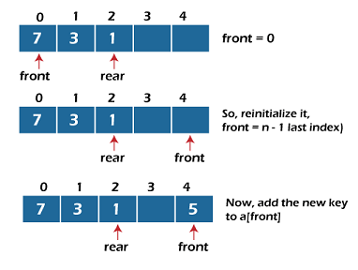

**Insertion at the rear end**

In this operation, the element is inserted from the rear end of the queue. Before implementing the operation, we first have to check again whether the queue is full or not. If the queue is not full, then the element can be inserted from the rear end by using the below conditions -

* If the queue is empty, both rear and front are initialized with 0. Now, both will point to the first element.
* Otherwise, increment the rear by 1. If the rear is at last index (or size - 1), then instead of increasing it by 1, we have to make it equal to 0.

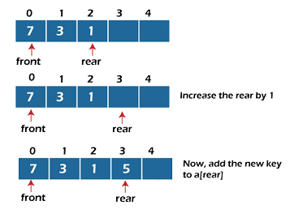

**Deletion at the front end**

In this operation, the element is deleted from the front end of the queue. Before implementing the operation, we first have to check whether the queue is empty or not.

If the queue is empty, i.e., front = -1, it is the underflow condition, and we cannot perform the deletion. If the queue is not full, then the element can be inserted from the front end by using the below conditions -

If the deque has only one element, set rear = -1 and front = -1.

Else if front is at end (that means front = size - 1), set front = 0.

Else increment the front by 1, (i.e., front = front + 1).

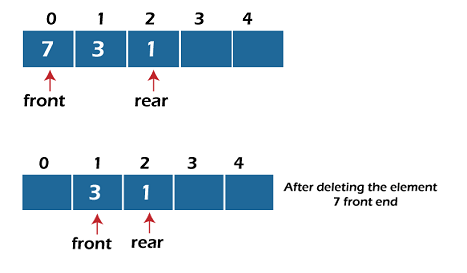

**Deletion at the rear end**

In this operation, the element is deleted from the rear end of the queue. Before implementing the operation, we first have to check whether the queue is empty or not.

If the queue is empty, i.e., front = -1, it is the underflow condition, and we cannot perform the deletion.

If the deque has only one element, set rear = -1 and front = -1.

If rear = 0 (rear is at front), then set rear = n - 1.

Else, decrement the rear by 1 (or, rear = rear -1).

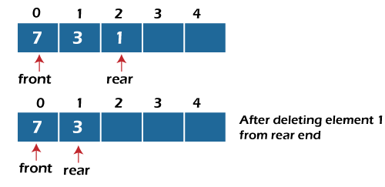

**Check empty**

This operation is performed to check whether the deque is empty or not. If front = -1, it means that the deque is empty.

**Check full**

This operation is performed to check whether the deque is full or not. If front = rear + 1, or front = 0 and rear = n - 1 it means that the deque is full.

The time complexity of all of the above operations of the deque is O(1), i.e., constant.

## ****Applications of deque****

* Deque can be used as both stack and queue, as it supports both operations.
* Deque can be used as a palindrome checker means that if we read the string from both ends, the string would be the same.

## Implementation of deque

Now, let's see the implementation of deque in C programming language.

1. #include <stdio.h>
2. #define size 5
3. **int** deque[size];
4. **int** f = -1, r = -1;
5. //  insert_front function will insert the value from the front
6. **void** insert_front(**int** x)
7. {
8. **if**((f==0 && r==size-1) || (f==r+1))
9. {
10. printf("Overflow");
11. }
12. **else** **if**((f==-1) && (r==-1))
13. {
14. f=r=0;
15. deque[f]=x;
16. }
17. **else** **if**(f==0)
18. {
19. f=size-1;
20. deque[f]=x;
21. }
22. **else**
23. {
24. f=f-1;
25. deque[f]=x;
26. }
27. }
29. // insert_rear function will insert the value from the rear
30. **void** insert_rear(**int** x)
31. {
32. **if**((f==0 && r==size-1) || (f==r+1))
33. {
34. printf("Overflow");
35. }
36. **else** **if**((f==-1) && (r==-1))
37. {
38. r=0;
39. deque[r]=x;
40. }
41. **else** **if**(r==size-1)
42. {
43. r=0;
44. deque[r]=x;
45. }
46. **else**
47. {
48. r++;
49. deque[r]=x;
50. }
52. }
54. // display function prints all the value of deque.
55. **void** display()
56. {
57. **int** i=f;
58. printf("\nElements in a deque are: ");
60. **while**(i!=r)
61. {
62. printf("%d ",deque[i]);
63. i=(i+1)%size;
64. }
65. printf("%d",deque[r]);
66. }
68. // getfront function retrieves the first value of the deque.
69. **void** getfront()
70. {
71. **if**((f==-1) && (r==-1))
72. {
73. printf("Deque is empty");
74. }
75. **else**
76. {
77. printf("\nThe value of the element at front is: %d", deque[f]);
78. }
80. }
82. // getrear function retrieves the last value of the deque.
83. **void** getrear()
84. {
85. **if**((f==-1) && (r==-1))
86. {
87. printf("Deque is empty");
88. }
89. **else**
90. {
91. printf("\nThe value of the element at rear is %d", deque[r]);
92. }
94. }
96. // delete_front() function deletes the element from the front
97. **void** delete_front()
98. {
99. **if**((f==-1) && (r==-1))
100. {
101. printf("Deque is empty");
102. }
103. **else** **if**(f==r)
104. {
105. printf("\nThe deleted element is %d", deque[f]);
106. f=-1;
107. r=-1;
109. }
110. **else** **if**(f==(size-1))
111. {
112. printf("\nThe deleted element is %d", deque[f]);
113. f=0;
114. }
115. **else**
116. {
117. printf("\nThe deleted element is %d", deque[f]);
118. f=f+1;
119. }
120. }
122. // delete_rear() function deletes the element from the rear
123. **void** delete_rear()
124. {
125. **if**((f==-1) && (r==-1))
126. {
127. printf("Deque is empty");
128. }
129. **else** **if**(f==r)
130. {
131. printf("\nThe deleted element is %d", deque[r]);
132. f=-1;
133. r=-1;
135. }
136. **else** **if**(r==0)
137. {
138. printf("\nThe deleted element is %d", deque[r]);
139. r=size-1;
140. }
141. **else**
142. {
143. printf("\nThe deleted element is %d", deque[r]);
144. r=r-1;
145. }
146. }
148. **int** main()
149. {
150. insert_front(20);
151. insert_front(10);
152. insert_rear(30);
153. insert_rear(50);
154. insert_rear(80);
155. display();  // Calling the display function to retrieve the values of deque
156. getfront();  // Retrieve the value at front-end
157. getrear();  // Retrieve the value at rear-end
158. delete_front();
159. delete_rear();
160. display(); // calling display function to retrieve values after deletion
161. **return** 0;
162. }

**Output:**

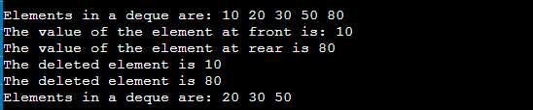

So, that's all about the article. Hope, the article will be helpful and informative to you.

What is a priority queue?

A priority queue is an abstract data type that behaves similarly to the normal queue except that each element has some priority, i.e., the element with the highest priority would come first in a priority queue. The priority of the elements in a priority queue will determine the order in which elements are removed from the priority queue.

The priority queue supports only comparable elements, which means that the elements are either arranged in an ascending or descending order.

For example, suppose we have some values like 1, 3, 4, 8, 14, 22 inserted in a priority queue with an ordering imposed on the values is from least to the greatest. Therefore, the 1 number would be having the highest priority while 22 will be having the lowest priority.

Characteristics of a Priority queue

A priority queue is an extension of a queue that contains the following characteristics:

Play Videox[](https://campaign.adpushup.com/get-started/?utm_source=banner&utm_campaign=growth_hack)

* Every element in a priority queue has some priority associated with it.
* An element with the higher priority will be deleted before the deletion of the lesser priority.
* If two elements in a priority queue have the same priority, they will be arranged using the FIFO principle.

**Let's understand the priority queue through an example.**

We have a priority queue that contains the following values:

**1, 3, 4, 8, 14, 22**

All the values are arranged in ascending order. Now, we will observe how the priority queue will look after performing the following operations:

* **poll():** This function will remove the highest priority element from the priority queue. In the above priority queue, the '1' element has the highest priority, so it will be removed from the priority queue.
* **add(2):** This function will insert '2' element in a priority queue. As 2 is the smallest element among all the numbers so it will obtain the highest priority.
* **poll():** It will remove '2' element from the priority queue as it has the highest priority queue.
* **add(5):** It will insert 5 element after 4 as 5 is larger than 4 and lesser than 8, so it will obtain the third highest priority in a priority queue.

Types of Priority Queue

**There are two types of priority queue:**

* **Ascending order priority queue:** In ascending order priority queue, a lower priority number is given as a higher priority in a priority. For example, we take the numbers from 1 to 5 arranged in an ascending order like 1,2,3,4,5; therefore, the smallest number, i.e., 1 is given as the highest priority in a priority queue.  
  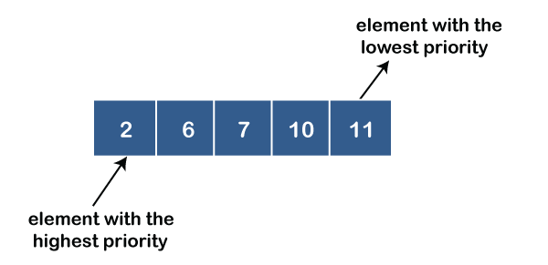
* **Descending order priority queue:** In descending order priority queue, a higher priority number is given as a higher priority in a priority. For example, we take the numbers from 1 to 5 arranged in descending order like 5, 4, 3, 2, 1; therefore, the largest number, i.e., 5 is given as the highest priority in a priority queue.  
  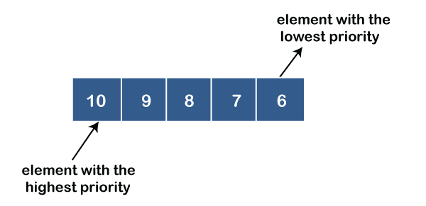

Representation of priority queue

Now, we will see how to represent the priority queue through a one-way list.

We will create the priority queue by using the list given below in which **INFO** list contains the data elements, **PRN** list contains the priority numbers of each data element available in the **INFO** list, and LINK basically contains the address of the next node.

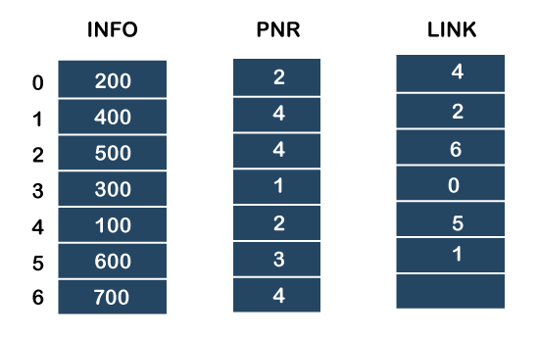

**Let's create the priority queue step by step.**

**In the case of priority queue, lower priority number is considered the higher priority, i.e.,** lower priority number = higher priority.

**Step 1:** In the list, lower priority number is 1, whose data value is 333, so it will be inserted in the list as shown in the below diagram:

**Step 2:** After inserting 333, priority number 2 is having a higher priority, and data values associated with this priority are 222 and 111. So, this data will be inserted based on the FIFO principle; therefore 222 will be added first and then 111.

**Step 3:** After inserting the elements of priority 2, the next higher priority number is 4 and data elements associated with 4 priority numbers are 444, 555, 777. In this case, elements would be inserted based on the FIFO principle; therefore, 444 will be added first, then 555, and then 777.

**Step 4:** After inserting the elements of priority 4, the next higher priority number is 5, and the value associated with priority 5 is 666, so it will be inserted at the end of the queue.

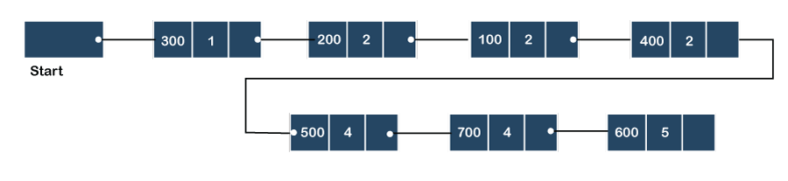

Implementation of Priority Queue

The priority queue can be implemented in four ways that include arrays, linked list, heap data structure and binary search tree. The heap data structure is the most efficient way of implementing the priority queue, so we will implement the priority queue using a heap data structure in this topic. Now, first we understand the reason why heap is the most efficient way among all the other data structures.

**Analysis of complexities using different implementations**

|  |  |  |  |
| --- | --- | --- | --- |
| Implementation | add | Remove | peek |
| Linked list | O(1) | O(n) | O(n) |
| Binary heap | O(logn) | O(logn) | O(1) |
| Binary search tree | O(logn) | O(logn) | O(1) |

What is Heap?

A heap is a tree-based data structure that forms a complete binary tree, and satisfies the heap property. If A is a parent node of B, then A is ordered with respect to the node B for all nodes A and B in a heap. It means that the value of the parent node could be more than or equal to the value of the child node, or the value of the parent node could be less than or equal to the value of the child node. Therefore, we can say that there are two types of heaps:

* **Max heap:** The max heap is a heap in which the value of the parent node is greater than the value of the child nodes.  
  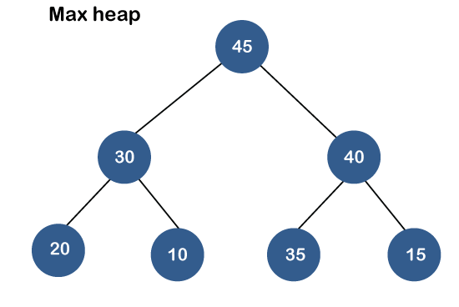
* **Min heap:** The min heap is a heap in which the value of the parent node is less than the value of the child nodes.  
  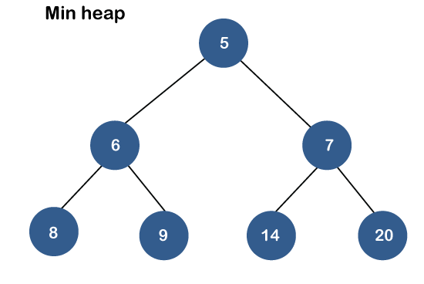

Both the heaps are the binary heap, as each has exactly two child nodes.

Priority Queue Operations

The common operations that we can perform on a priority queue are insertion, deletion and peek. Let's see how we can maintain the heap data structure.

* **Inserting the element in a priority queue (max heap)**

If we insert an element in a priority queue, it will move to the empty slot by looking from top to bottom and left to right.

If the element is not in a correct place then it is compared with the parent node; if it is found out of order, elements are swapped. This process continues until the element is placed in a correct position.

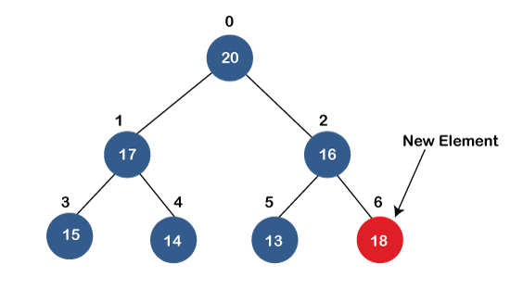  
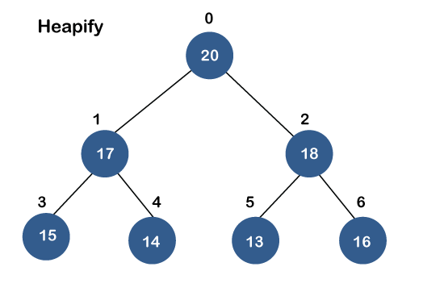

* **Removing the minimum element from the priority queue**

As we know that in a max heap, the maximum element is the root node. When we remove the root node, it creates an empty slot. The last inserted element will be added in this empty slot. Then, this element is compared with the child nodes, i.e., left-child and right child, and swap with the smaller of the two. It keeps moving down the tree until the heap property is restored.

Applications of Priority queue

**The following are the applications of the priority queue:**

* It is used in the Dijkstra's shortest path algorithm.
* It is used in prim's algorithm
* It is used in data compression techniques like Huffman code.
* It is used in heap sort.
* It is also used in operating system like priority scheduling, load balancing and interrupt handling.

**Program to create the priority queue using the binary max heap.**

1. #include <stdio.h>
2. #include <stdio.h>
3. **int** heap[40];
4. **int** size=-1;
6. // retrieving the parent node of the child node
7. **int** parent(**int** i)
8. {
10. **return** (i - 1) / 2;
11. }
13. // retrieving the left child of the parent node.
14. **int** left_child(**int** i)
15. {
16. **return** i+1;
17. }
18. // retrieving the right child of the parent
19. **int** right_child(**int** i)
20. {
21. **return** i+2;
22. }
23. // Returning the element having the highest priority
24. **int** get_Max()
25. {
26. **return** heap[0];
27. }
28. //Returning the element having the minimum priority
29. **int** get_Min()
30. {
31. **return** heap[size];
32. }
33. // function to move the node up the tree in order to restore the heap property.
34. **void** moveUp(**int** i)
35. {
36. **while** (i > 0)
37. {
38. // swapping parent node with a child node
39. **if**(heap[parent(i)] < heap[i]) {
41. **int** temp;
42. temp=heap[parent(i)];
43. heap[parent(i)]=heap[i];
44. heap[i]=temp;

47. }
48. // updating the value of i to i/2
49. i=i/2;
50. }
51. }
53. //function to move the node down the tree in order to restore the heap property.
54. **void** moveDown(**int** k)
55. {
56. **int** index = k;
58. // getting the location of the Left Child
59. **int** left = left_child(k);
61. **if** (left <= size && heap[left] > heap[index]) {
62. index = left;
63. }
65. // getting the location of the Right Child
66. **int** right = right_child(k);
68. **if** (right <= size && heap[right] > heap[index]) {
69. index = right;
70. }
72. // If k is not equal to index
73. **if** (k != index) {
74. **int** temp;
75. temp=heap[index];
76. heap[index]=heap[k];
77. heap[k]=temp;
78. moveDown(index);
79. }
80. }
82. // Removing the element of maximum priority
83. **void** removeMax()
84. {
85. **int** r= heap[0];
86. heap[0]=heap[size];
87. size=size-1;
88. moveDown(0);
89. }
90. //inserting the element in a priority queue
91. **void** insert(**int** p)
92. {
93. size = size + 1;
94. heap[size] = p;
96. // move Up to maintain heap property
97. moveUp(size);
98. }
100. //Removing the element from the priority queue at a given index i.
101. **void** **delete**(**int** i)
102. {
103. heap[i] = heap[0] + 1;
105. // move the node stored at ith location is shifted to the root node
106. moveUp(i);
108. // Removing the node having maximum priority
109. removeMax();
110. }
111. **int** main()
112. {
113. // Inserting the elements in a priority queue
115. insert(20);
116. insert(19);
117. insert(21);
118. insert(18);
119. insert(12);
120. insert(17);
121. insert(15);
122. insert(16);
123. insert(14);
124. **int** i=0;
126. printf("Elements in a priority queue are : ");
127. **for**(**int** i=0;i<=size;i++)
128. {
129. printf("%d ",heap[i]);
130. }
131. **delete**(2); // deleting the element whose index is 2.
132. printf("\nElements in a priority queue after deleting the element are : ");
133. **for**(**int** i=0;i<=size;i++)
134. {
135. printf("%d ",heap[i]);
136. }
137. **int** max=get_Max();
138. printf("\nThe element which is having the highest priority is %d: ",max);

141. **int** min=get_Min();
142. printf("\nThe element which is having the minimum priority is : %d",min);
143. **return** 0;
144. }

**In the above program, we have created the following functions:**

* **int parent(int i):** This function returns the index of the parent node of a child node, i.e., i.
* **int left_child(int i):** This function returns the index of the left child of a given index, i.e., i.
* **int right_child(int i):** This function returns the index of the right child of a given index, i.e., i.
* **void moveUp(int i):** This function will keep moving the node up the tree until the heap property is restored.
* **void moveDown(int i):** This function will keep moving the node down the tree until the heap property is restored.
* **void removeMax():** This function removes the element which is having the highest priority.
* **void insert(int p):** It inserts the element in a priority queue which is passed as an argument in a function**.**
* **void delete(int i):** It deletes the element from a priority queue at a given index.
* **int get_Max():** It returns the element which is having the highest priority, and we know that in max heap, the root node contains the element which has the largest value, and highest priority.
* **int get_Min():** It returns the element which is having the minimum priority, and we know that in max heap, the last node contains the element which has the smallest value, and lowest priority.

**Output**

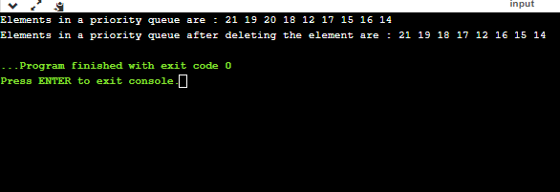

Tree Data Structure

We read the linear data structures like an array, linked list, stack and queue in which all the elements are arranged in a sequential manner. The different data structures are used for different kinds of data.

**Some factors are considered for choosing the data structure:**

* **What type of data needs to be stored**?: It might be a possibility that a certain data structure can be the best fit for some kind of data.
* **Cost of operations:** If we want to minimize the cost for the operations for the most frequently performed operations. For example, we have a simple list on which we have to perform the search operation; then, we can create an array in which elements are stored in sorted order to perform the ***binary search***. The binary search works very fast for the simple list as it divides the search space into half.
* **Memory usage:** Sometimes, we want a data structure that utilizes less memory.

***A tree*** is also one of the data structures that represent hierarchical data. Suppose we want to show the employees and their positions in the hierarchical form then it can be represented as shown below:

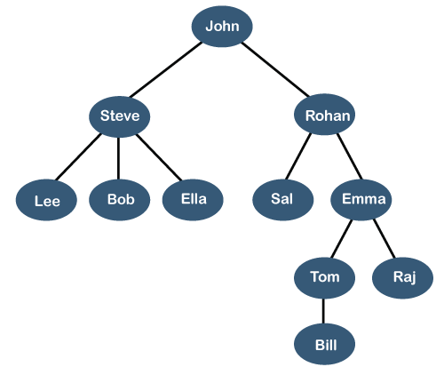

The above tree shows the **organization hierarchy** of some company. In the above structure, ***john*** is the **CEO** of the company, and John has two direct reports named as ***Steve*** and ***Rohan***. Steve has three direct reports named ***Lee, Bob, Ella*** where ***Steve*** is a manager. Bob has two direct reports named ***Sal*** and ***Emma***. **Emma** has two direct reports named ***Tom*** and ***Raj***. Tom has one direct report named ***Bill***. This particular logical structure is known as a ***Tree***. Its structure is similar to the real tree, so it is named a ***Tree***. In this structure, the ***root*** is at the top, and its branches are moving in a downward direction. Therefore, we can say that the Tree data structure is an efficient way of storing the data in a hierarchical way.

Play Videox[](https://campaign.adpushup.com/get-started/?utm_source=banner&utm_campaign=growth_hack)

**Let's understand some key points of the Tree data structure.**

* A tree data structure is defined as a collection of objects or entities known as nodes that are linked together to represent or simulate hierarchy.
* A tree data structure is a non-linear data structure because it does not store in a sequential manner. It is a hierarchical structure as elements in a Tree are arranged in multiple levels.
* In the Tree data structure, the topmost node is known as a root node. Each node contains some data, and data can be of any type. In the above tree structure, the node contains the name of the employee, so the type of data would be a string.
* Each node contains some data and the link or reference of other nodes that can be called children.

**Some basic terms used in Tree data structure.**

Let's consider the tree structure, which is shown below:

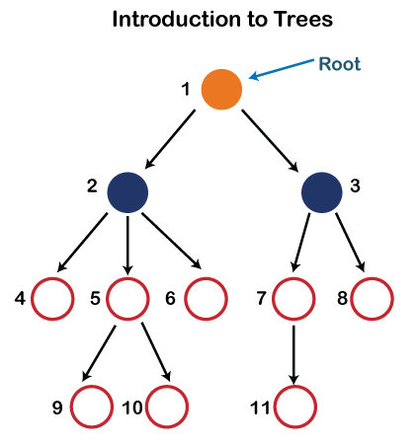

In the above structure, each node is labeled with some number. Each arrow shown in the above figure is known as a ***link*** between the two nodes.

* **Root:** The root node is the topmost node in the tree hierarchy. In other words, the root node is the one that doesn't have any parent. In the above structure, node numbered 1 is **the root node of the tree.** If a node is directly linked to some other node, it would be called a parent-child relationship.
* **Child node:** If the node is a descendant of any node, then the node is known as a child node.
* **Parent:** If the node contains any sub-node, then that node is said to be the parent of that sub-node.
* **Sibling:** The nodes that have the same parent are known as siblings.
* **Leaf Node:-** The node of the tree, which doesn't have any child node, is called a leaf node. A leaf node is the bottom-most node of the tree. There can be any number of leaf nodes present in a general tree. Leaf nodes can also be called external nodes.
* **Internal nodes:** A node has atleast one child node known as an ***internal***
* **Ancestor node:-** An ancestor of a node is any predecessor node on a path from the root to that node. The root node doesn't have any ancestors. In the tree shown in the above image, nodes 1, 2, and 5 are the ancestors of node 10.
* **Descendant:** The immediate successor of the given node is known as a descendant of a node. In the above figure, 10 is the descendant of node 5.

Properties of Tree data structure

* **Recursive data structure:** The tree is also known as a ***recursive data structure***. A tree can be defined as recursively because the distinguished node in a tree data structure is known as a ***root node***. The root node of the tree contains a link to all the roots of its subtrees. The left subtree is shown in the yellow color in the below figure, and the right subtree is shown in the red color. The left subtree can be further split into subtrees shown in three different colors. Recursion means reducing something in a self-similar manner. So, this recursive property of the tree data structure is implemented in various applications.  
  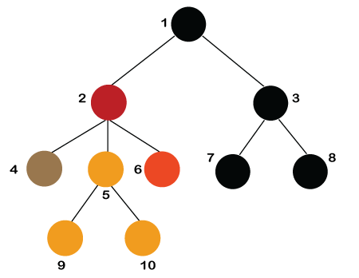
* **Number of edges:** If there are n nodes, then there would n-1 edges. Each arrow in the structure represents the link or path. Each node, except the root node, will have atleast one incoming link known as an edge. There would be one link for the parent-child relationship.
* **Depth of node x:** The depth of node x can be defined as the length of the path from the root to the node x. One edge contributes one-unit length in the path. So, the depth of node x can also be defined as the number of edges between the root node and the node x. The root node has 0 depth.
* **Height of node x:** The height of node x can be defined as the longest path from the node x to the leaf node.

Based on the properties of the Tree data structure, trees are classified into various categories.

Implementation of Tree

The tree data structure can be created by creating the nodes dynamically with the help of the pointers. The tree in the memory can be represented as shown below:

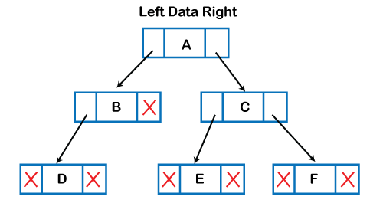

The above figure shows the representation of the tree data structure in the memory. In the above structure, the node contains three fields. The second field stores the data; the first field stores the address of the left child, and the third field stores the address of the right child.

In programming, the structure of a node can be defined as:

1. struct node
2. {
3. **int** data;
4. struct node *left;
5. struct node *right;
6. }

The above structure can only be defined for the binary trees because the binary tree can have utmost two children, and generic trees can have more than two children. The structure of the node for generic trees would be different as compared to the binary tree.

Applications of trees

The following are the applications of trees:

* **Storing naturally hierarchical data:** Trees are used to store the data in the hierarchical structure. For example, the file system. The file system stored on the disc drive, the file and folder are in the form of the naturally hierarchical data and stored in the form of trees.
* **Organize data:** It is used to organize data for efficient insertion, deletion and searching. For example, a binary tree has a logN time for searching an element.
* **Trie:** It is a special kind of tree that is used to store the dictionary. It is a fast and efficient way for dynamic spell checking.
* **Heap:** It is also a tree data structure implemented using arrays. It is used to implement priority queues.
* **B-Tree and B+Tree:** B-Tree and B+Tree are the tree data structures used to implement indexing in databases.
* **Routing table:** The tree data structure is also used to store the data in routing tables in the routers.

Types of Tree data structure

**The following are the types of a tree data structure:**

* **General tree:** The general tree is one of the types of tree data structure. In the general tree, a node can have either 0 or maximum n number of nodes. There is no restriction imposed on the degree of the node (the number of nodes that a node can contain). The topmost node in a general tree is known as a root node. The children of the parent node are known as ***subtrees***.  
  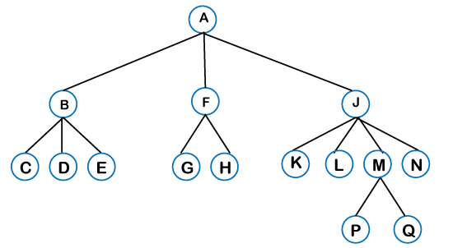  
  There can be ***n*** number of subtrees in a general tree. In the general tree, the subtrees are unordered as the nodes in the subtree cannot be ordered.  
  Every non-empty tree has a downward edge, and these edges are connected to the nodes known as ***child nodes***. The root node is labeled with level 0. The nodes that have the same parent are known as ***siblings***.
* [**Binary tree**](https://www.javatpoint.com/binary-tree)**:** Here, binary name itself suggests two numbers, i.e., 0 and 1. In a binary tree, each node in a tree can have utmost two child nodes. Here, utmost means whether the node has 0 nodes, 1 node or 2 nodes.  
  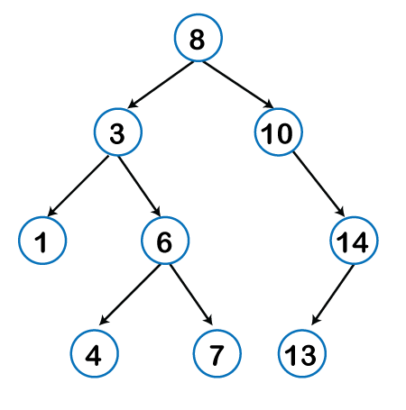  
  **To know more about the binary tree, click on the link given below:**  
  <https://www.javatpoint.com/binary-tree>
* [**Binary Search tree**](https://www.javatpoint.com/binary-search-tree)**:** Binary search tree is a non-linear data structure in which one node is connected to ***n*** number of nodes. It is a node-based data structure. A node can be represented in a binary search tree with three fields, i.e., data part, left-child, and right-child. A node can be connected to the utmost two child nodes in a binary search tree, so the node contains two pointers (left child and right child pointer).  
  Every node in the left subtree must contain a value less than the value of the root node, and the value of each node in the right subtree must be bigger than the value of the root node.

A node can be created with the help of a user-defined data type known as ***struct,*** as shown below:

1. struct node
2. {
3. **int** data;
4. struct node *left;
5. struct node *right;
6. }

The above is the node structure with three fields: data field, the second field is the left pointer of the node type, and the third field is the right pointer of the node type.

**To know more about the binary search tree, click on the link given below:**

<https://www.javatpoint.com/binary-search-tree>

* [**AVL tree**](https://www.javatpoint.com/avl-tree)

It is one of the types of the binary tree, or we can say that it is a variant of the binary search tree. AVL tree satisfies the property of the ***binary tree*** as well as of the ***binary search tree***. It is a self-balancing binary search tree that was invented by ***Adelson Velsky Lindas***. Here, self-balancing means that balancing the heights of left subtree and right subtree. This balancing is measured in terms of the ***balancing factor***.

We can consider a tree as an AVL tree if the tree obeys the binary search tree as well as a balancing factor. The balancing factor can be defined as the ***difference between the height of the left subtree and the height of the right subtree***. The balancing factor's value must be either 0, -1, or 1; therefore, each node in the AVL tree should have the value of the balancing factor either as 0, -1, or 1.

**To know more about the AVL tree, click on the link given below:**

<https://www.javatpoint.com/avl-tree>

* [**Red-Black Tree**](https://www.javatpoint.com/red-black-tree)

**The red-Black tree** is the binary search tree. The prerequisite of the Red-Black tree is that we should know about the binary search tree. In a binary search tree, the value of the left-subtree should be less than the value of that node, and the value of the right-subtree should be greater than the value of that node. As we know that the time complexity of binary search in the average case is log2n, the best case is O(1), and the worst case is O(n).

When any operation is performed on the tree, we want our tree to be balanced so that all the operations like searching, insertion, deletion, etc., take less time, and all these operations will have the time complexity of ***log2n.***

***The red-black tree*** is a self-balancing binary search tree. AVL tree is also a height balancing binary search tree then **why do we require a Red-Black tree**. In the AVL tree, we do not know how many rotations would be required to balance the tree, but in the Red-black tree, a maximum of 2 rotations are required to balance the tree. It contains one extra bit that represents either the red or black color of a node to ensure the balancing of the tree.

* **Splay tree**

The splay tree data structure is also binary search tree in which recently accessed element is placed at the root position of tree by performing some rotation operations. Here, ***splaying*** means the recently accessed node. It is a ***self-balancing*** binary search tree having no explicit balance condition like **AVL** tree.

It might be a possibility that height of the splay tree is not balanced, i.e., height of both left and right subtrees may differ, but the operations in splay tree takes order of **logN** time where **n** is the number of nodes.

Splay tree is a balanced tree but it cannot be considered as a height balanced tree because after each operation, rotation is performed which leads to a balanced tree.

* **Treap**

Treap data structure came from the Tree and Heap data structure. So, it comprises the properties of both Tree and Heap data structures. In Binary search tree, each node on the left subtree must be equal or less than the value of the root node and each node on the right subtree must be equal or greater than the value of the root node. In heap data structure, both right and left subtrees contain larger keys than the root; therefore, we can say that the root node contains the lowest value.

In treap data structure, each node has both ***key*** and ***priority*** where key is derived from the Binary search tree and priority is derived from the heap data structure.

The **Treap** data structure follows two properties which are given below:

* Right child of a node>=current node and left child of a node <=current node (binary tree)
* Children of any subtree must be greater than the node (heap)
* [**B-tree**](https://www.javatpoint.com/b-tree)

B-tree is a balanced **m-way** tree where **m** defines the order of the tree. Till now, we read that the node contains only one key but b-tree can have more than one key, and more than 2 children. It always maintains the sorted data. In binary tree, it is possible that leaf nodes can be at different levels, but in b-tree, all the leaf nodes must be at the same level.

**If order is m then node has the following properties:**

* Each node in a b-tree can have maximum **m** children
* For minimum children, a leaf node has 0 children, root node has minimum 2 children and internal node has minimum ceiling of m/2 children. For example, the value of m is 5 which means that a node can have 5 children and internal nodes can contain maximum 3 children.
* Each node has maximum (m-1) keys.

The root node must contain minimum 1 key and all other nodes must contain atleast **ceiling of m/2 minus 1** keys.

# Binary Tree

The Binary tree means that the node can have maximum two children. Here, binary name itself suggests that 'two'; therefore, each node can have either 0, 1 or 2 children.

**Let's understand the binary tree through an example.**

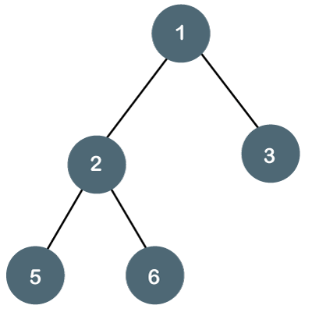

The above tree is a binary tree because each node contains the utmost two children. The logical representation of the above tree is given below:

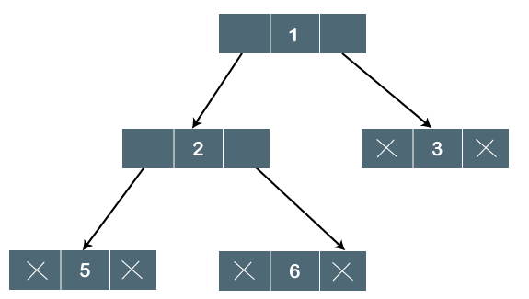

In the above tree, node 1 contains two pointers, i.e., left and a right pointer pointing to the left and right node respectively. The node 2 contains both the nodes (left and right node); therefore, it has two pointers (left and right). The nodes 3, 5 and 6 are the leaf nodes, so all these nodes contain **NULL** pointer on both left and right parts.

Play Videox[](https://campaign.adpushup.com/get-started/?utm_source=banner&utm_campaign=growth_hack)

### Properties of Binary Tree

* At each level of i, the maximum number of nodes is 2i.
* The height of the tree is defined as the longest path from the root node to the leaf node. The tree which is shown above has a height equal to 3. Therefore, the maximum number of nodes at height 3 is equal to (1+2+4+8) = 15. In general, the maximum number of nodes possible at height h is (20 + 21 + 22+….2h) = 2h+1 -1.
* The minimum number of nodes possible at height h is equal to **h+1**.
* If the number of nodes is minimum, then the height of the tree would be maximum. Conversely, if the number of nodes is maximum, then the height of the tree would be minimum.

If there are 'n' number of nodes in the binary tree.

**The minimum height can be computed as:**

As we know that,

n = 2h+1 -1

n+1 = 2h+1

Taking log on both the sides,

log2(n+1) = log2(2h+1)

log2(n+1) = h+1

**h = log2(n+1) - 1**

**The maximum height can be computed as:**

As we know that,

n = h+1

**h= n-1**

### Types of Binary Tree

**There are four types of Binary tree:**

* **Full/ proper/ strict Binary tree**
* **Complete Binary tree**
* **Perfect Binary tree**
* **Degenerate Binary tree**
* **Balanced Binary tree**

**1. Full/ proper/ strict Binary tree**

The full binary tree is also known as a strict binary tree. The tree can only be considered as the full binary tree if each node must contain either 0 or 2 children. The full binary tree can also be defined as the tree in which each node must contain 2 children except the leaf nodes.

**Let's look at the simple example of the Full Binary tree.**

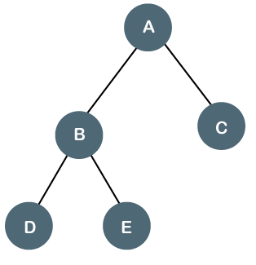

In the above tree, we can observe that each node is either containing zero or two children; therefore, it is a Full Binary tree.

**Properties of Full Binary Tree**

* The number of leaf nodes is equal to the number of internal nodes plus 1. In the above example, the number of internal nodes is 5; therefore, the number of leaf nodes is equal to 6.
* The maximum number of nodes is the same as the number of nodes in the binary tree, i.e., 2h+1 -1.
* The minimum number of nodes in the full binary tree is 2*h-1.
* The minimum height of the full binary tree is **log2(n+1) - 1.**
* The maximum height of the full binary tree can be computed as:

n= 2*h - 1

n+1 = 2*h

**h = n+1/2**

**Complete Binary Tree**

The complete binary tree is a tree in which all the nodes are completely filled except the last level. In the last level, all the nodes must be as left as possible. In a complete binary tree, the nodes should be added from the left.

Let's create a complete binary tree.

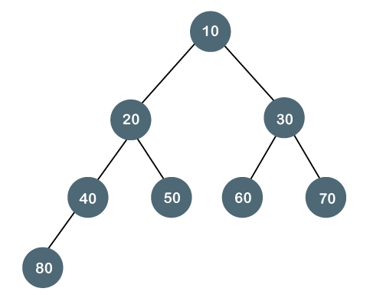

The above tree is a complete binary tree because all the nodes are completely filled, and all the nodes in the last level are added at the left first.

**Properties of Complete Binary Tree**

* The maximum number of nodes in complete binary tree is 2h+1 - 1.
* The minimum number of nodes in complete binary tree is 2h.
* The minimum height of a complete binary tree is **log2(n+1) - 1.**
* The maximum height of a complete binary tree is

**Perfect Binary Tree**

A tree is a perfect binary tree if all the internal nodes have 2 children, and all the leaf nodes are at the same level.

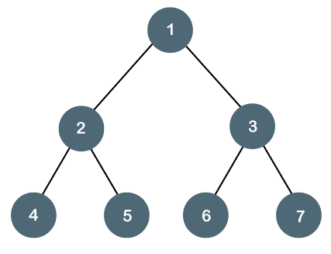

**Let's look at a simple example of a perfect binary tree.**

The below tree is not a perfect binary tree because all the leaf nodes are not at the same level.

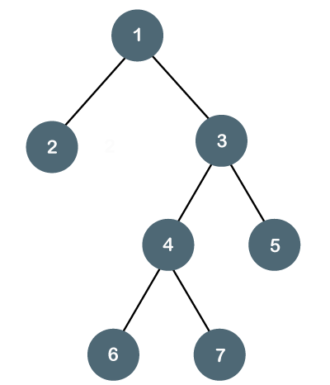

#### Note: All the perfect binary trees are the complete binary trees as well as the full binary tree, but vice versa is not true, i.e., all complete binary trees and full binary trees are the perfect binary trees.

### Degenerate Binary Tree

The degenerate binary tree is a tree in which all the internal nodes have only one children.

**Let's understand the Degenerate binary tree through examples.**

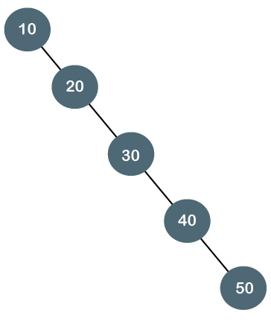

The above tree is a degenerate binary tree because all the nodes have only one child. It is also known as a right-skewed tree as all the nodes have a right child only.

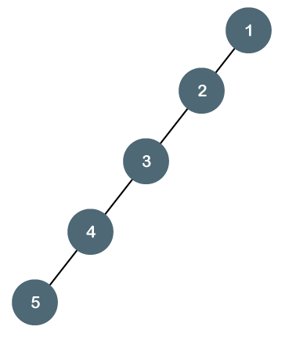

The above tree is also a degenerate binary tree because all the nodes have only one child. It is also known as a left-skewed tree as all the nodes have a left child only.

**Balanced Binary Tree**

The balanced binary tree is a tree in which both the left and right trees differ by atmost 1. For example, **AVL** and **Red-Black trees** are balanced binary tree.

**Let's understand the balanced binary tree through examples.**

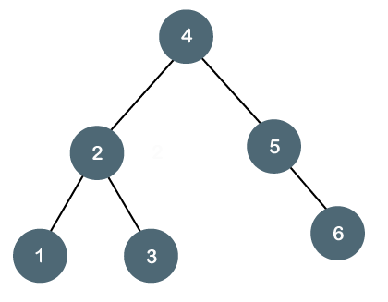

The above tree is a balanced binary tree because the difference between the left subtree and right subtree is zero.

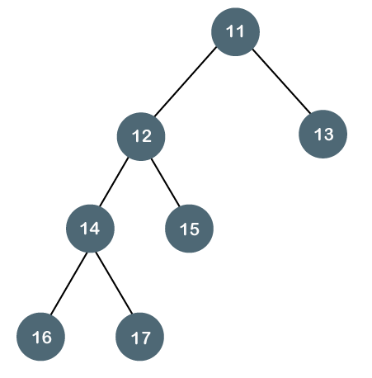

The above tree is not a balanced binary tree because the difference between the left subtree and the right subtree is greater than 1.

### Binary Tree Implementation

A Binary tree is implemented with the help of pointers. The first node in the tree is represented by the root pointer. Each node in the tree consists of three parts, i.e., data, left pointer and right pointer. To create a binary tree, we first need to create the node. We will create the node of user-defined as shown below:

1. **struct** node
2. {
3. **int** data,
4. **struct** node *left, *right;
5. }

In the above structure, **data** is the value, **left pointer** contains the address of the left node, and **right pointer** contains the address of the right node.

**Binary Tree program in C**

1. #include<stdio.h>
2. **struct** node
3. {
4. **int** data;
5. **struct** node *left, *right;
6. }
7. **void** main()
8. {
9. **struct** node *root;
10. root = create();
11. }
12. **struct** node *create()
13. {
14. **struct** node *temp;
15. **int** data;
16. temp = (**struct** node *)malloc(**sizeof**(**struct** node));
17. printf("Press 0 to exit");
18. printf("\nPress 1 for new node");
19. printf("Enter your choice : ");
20. scanf("%d", &choice);
21. **if**(choice==0)
22. {
23. **return** 0;
24. }
25. **else**
26. {
27. printf("Enter the data:");
28. scanf("%d", &data);
29. temp->data = data;
30. printf("Enter the left child of %d", data);
31. temp->left = create();
32. printf("Enter the right child of %d", data);
33. temp->right = create();
34. **return** temp;
35. }
36. }

The above code is calling the create() function recursively and creating new node on each recursive call. When all the nodes are created, then it forms a binary tree structure. The process of visiting the nodes is known as tree traversal. There are three types traversals used to visit a node:

* Inorder traversal
* Preorder traversal
* Postorder traversal

# Binary Search tree

In this article, we will discuss the Binary search tree. This article will be very helpful and informative to the students with technical background as it is an important topic of their course.

Before moving directly to the binary search tree, let's first see a brief description of the tree.

### What is a tree?

A tree is a kind of data structure that is used to represent the data in hierarchical form. It can be defined as a collection of objects or entities called as nodes that are linked together to simulate a hierarchy. Tree is a non-linear data structure as the data in a tree is not stored linearly or sequentially.

Now, let's start the topic, the Binary Search tree.

### What is a Binary Search tree?

A binary search tree follows some order to arrange the elements. In a Binary search tree, the value of left node must be smaller than the parent node, and the value of right node must be greater than the parent node. This rule is applied recursively to the left and right subtrees of the root.

Let's understand the concept of Binary search tree with an example.

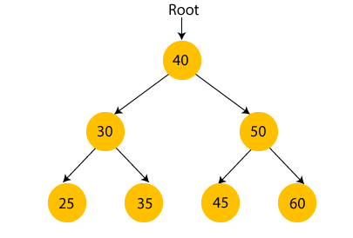

In the above figure, we can observe that the root node is 40, and all the nodes of the left subtree are smaller than the root node, and all the nodes of the right subtree are greater than the root node.

Similarly, we can see the left child of root node is greater than its left child and smaller than its right child. So, it also satisfies the property of binary search tree. Therefore, we can say that the tree in the above image is a binary search tree.

Suppose if we change the value of node 35 to 55 in the above tree, check whether the tree will be binary search tree or not.

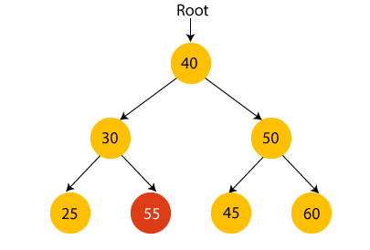

In the above tree, the value of root node is 40, which is greater than its left child 30 but smaller than right child of 30, i.e., 55. So, the above tree does not satisfy the property of Binary search tree. Therefore, the above tree is not a binary search tree.

### Advantages of Binary search tree

* Searching an element in the Binary search tree is easy as we always have a hint that which subtree has the desired element.
* As compared to array and linked lists, insertion and deletion operations are faster in BST.

### Example of creating a binary search tree

Now, let's see the creation of binary search tree using an example.

Suppose the data elements are **- 45, 15, 79, 90, 10, 55, 12, 20, 50**

* First, we have to insert **45** into the tree as the root of the tree.
* Then, read the next element; if it is smaller than the root node, insert it as the root of the left subtree, and move to the next element.
* Otherwise, if the element is larger than the root node, then insert it as the root of the right subtree.

Now, let's see the process of creating the Binary search tree using the given data element. The process of creating the BST is shown below -

**Step 1 - Insert 45.**

Binary Search tree

**Step 2 - Insert 15.**

As 15 is smaller than 45, so insert it as the root node of the left subtree.

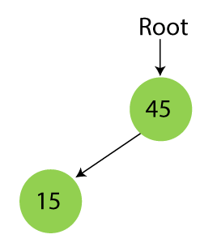

**Step 3 - Insert 79.**

As 79 is greater than 45, so insert it as the root node of the right subtree.

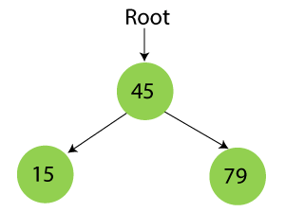

**Step 4 - Insert 90.**

90 is greater than 45 and 79, so it will be inserted as the right subtree of 79.

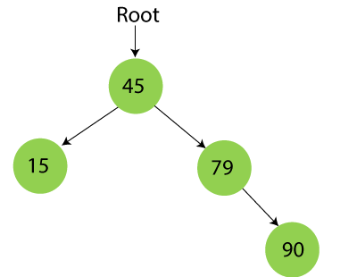

**Step 5 - Insert 10.**

10 is smaller than 45 and 15, so it will be inserted as a left subtree of 15.

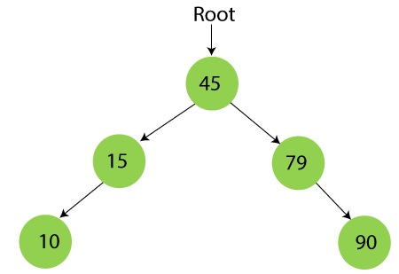

**Step 6 - Insert 55.**

55 is larger than 45 and smaller than 79, so it will be inserted as the left subtree of 79.

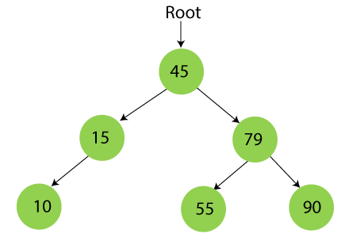

**Step 7 - Insert 12.**

12 is smaller than 45 and 15 but greater than 10, so it will be inserted as the right subtree of 10.

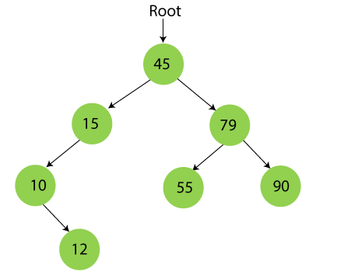

**Step 8 - Insert 20.**

20 is smaller than 45 but greater than 15, so it will be inserted as the right subtree of 15.

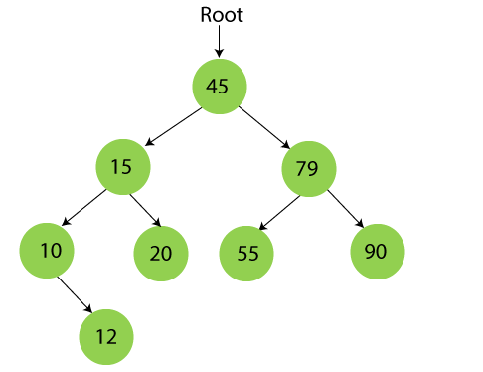

**Step 9 - Insert 50.**

50 is greater than 45 but smaller than 79 and 55. So, it will be inserted as a left subtree of 55.

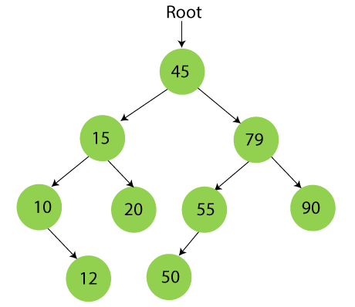

Now, the creation of binary search tree is completed. After that, let's move towards the operations that can be performed on Binary search tree.

We can perform insert, delete and search operations on the binary search tree.

Let's understand how a search is performed on a binary search tree.

## Searching in Binary search tree

Searching means to find or locate a specific element or node in a data structure. In Binary search tree, searching a node is easy because elements in BST are stored in a specific order. The steps of searching a node in Binary Search tree are listed as follows -

1. First, compare the element to be searched with the root element of the tree.
2. If root is matched with the target element, then return the node's location.
3. If it is not matched, then check whether the item is less than the root element, if it is smaller than the root element, then move to the left subtree.
4. If it is larger than the root element, then move to the right subtree.
5. Repeat the above procedure recursively until the match is found.
6. If the element is not found or not present in the tree, then return NULL.

Now, let's understand the searching in binary tree using an example. We are taking the binary search tree formed above. Suppose we have to find node 20 from the below tree.

**Step1:**

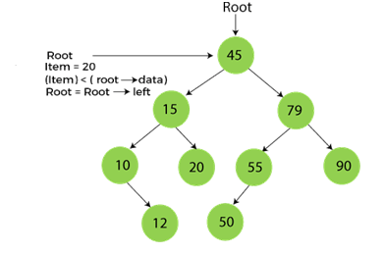

**Step2:**

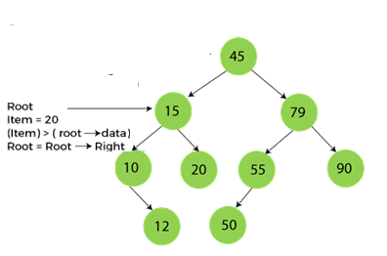

**Step3:**

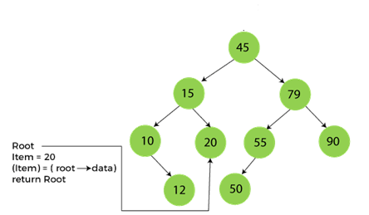

Now, let's see the algorithm to search an element in the Binary search tree.

### Algorithm to search an element in Binary search tree

1. Search (root, item)
2. Step 1 - if (item = root → data) or (root = NULL)
3. return root
4. else if (item **<** **root** → data)
5. return Search(root → left, item)
6. else
7. return Search(root → right, item)
8. END if
9. Step 2 - END

Now let's understand how the deletion is performed on a binary search tree. We will also see an example to delete an element from the given tree.

### Deletion in Binary Search tree

In a binary search tree, we must delete a node from the tree by keeping in mind that the property of BST is not violated. To delete a node from BST, there are three possible situations occur -

* The node to be deleted is the leaf node, or,
* The node to be deleted has only one child, and,
* The node to be deleted has two children

We will understand the situations listed above in detail.

**When the node to be deleted is the leaf node**

It is the simplest case to delete a node in BST. Here, we have to replace the leaf node with NULL and simply free the allocated space.

We can see the process to delete a leaf node from BST in the below image. In below image, suppose we have to delete node 90, as the node to be deleted is a leaf node, so it will be replaced with NULL, and the allocated space will free.

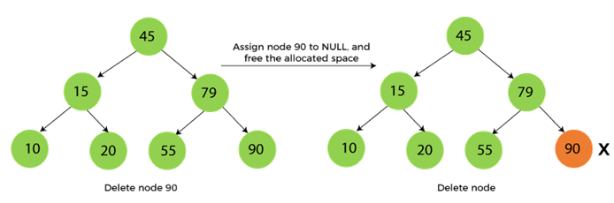

**When the node to be deleted has only one child**

In this case, we have to replace the target node with its child, and then delete the child node. It means that after replacing the target node with its child node, the child node will now contain the value to be deleted. So, we simply have to replace the child node with NULL and free up the allocated space.

We can see the process of deleting a node with one child from BST in the below image. In the below image, suppose we have to delete the node 79, as the node to be deleted has only one child, so it will be replaced with its child 55.

So, the replaced node 79 will now be a leaf node that can be easily deleted.

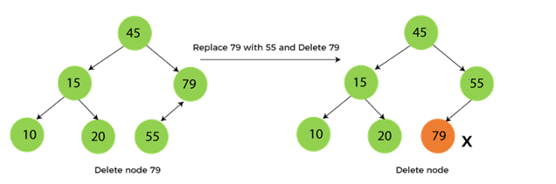

**When the node to be deleted has two children**

This case of deleting a node in BST is a bit complex among other two cases. In such a case, the steps to be followed are listed as follows -

* First, find the inorder successor of the node to be deleted.
* After that, replace that node with the inorder successor until the target node is placed at the leaf of tree.
* And at last, replace the node with NULL and free up the allocated space.

The inorder successor is required when the right child of the node is not empty. We can obtain the inorder successor by finding the minimum element in the right child of the node.

We can see the process of deleting a node with two children from BST in the below image. In the below image, suppose we have to delete node 45 that is the root node, as the node to be deleted has two children, so it will be replaced with its inorder successor. Now, node 45 will be at the leaf of the tree so that it can be deleted easily.

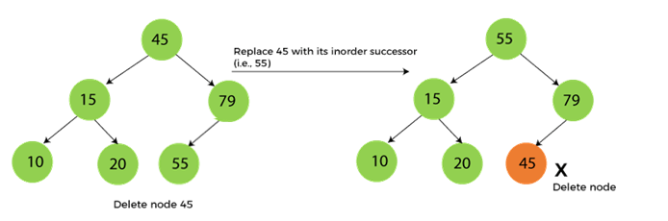

Now let's understand how insertion is performed on a binary search tree.

### Insertion in Binary Search tree

A new key in BST is always inserted at the leaf. To insert an element in BST, we have to start searching from the root node; if the node to be inserted is less than the root node, then search for an empty location in the left subtree. Else, search for the empty location in the right subtree and insert the data. Insert in BST is similar to searching, as we always have to maintain the rule that the left subtree is smaller than the root, and right subtree is larger than the root.

Now, let's see the process of inserting a node into BST using an example.

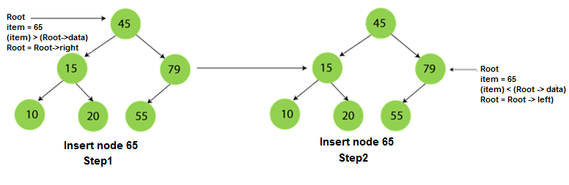  
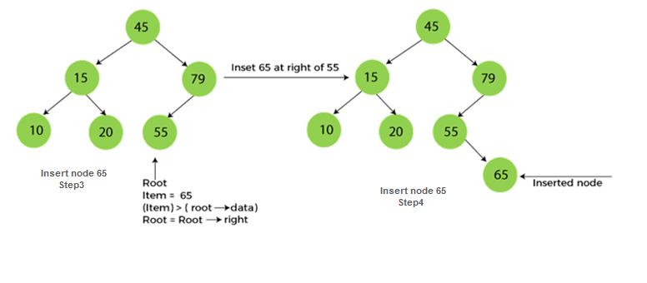

### The complexity of the Binary Search tree

Let's see the time and space complexity of the Binary search tree. We will see the time complexity for insertion, deletion, and searching operations in best case, average case, and worst case.

### 1. Time Complexity

|  |  |  |  |
| --- | --- | --- | --- |
| **Operations** | **Best case time complexity** | **Average case time complexity** | **Worst case time complexity** |
| **Insertion** | O(log n) | O(log n) | O(n) |
| **Deletion** | O(log n) | O(log n) | O(n) |
| **Search** | O(log n) | O(log n) | O(n) |

Where 'n' is the number of nodes in the given tree.

### 2. Space Complexity

|  |  |
| --- | --- |
| **Operations** | **Space complexity** |
| **Insertion** | O(n) |
| **Deletion** | O(n) |
| **Search** | O(n) |

* The space complexity of all operations of Binary search tree is O(n).

## Implementation of Binary search tree

Now, let's see the program to implement the operations of Binary Search tree.

**Program:** Write a program to perform operations of Binary Search tree in C++.

In this program, we will see the implementation of the operations of binary search tree. Here, we will see the creation, inorder traversal, insertion, and deletion operations of tree.

Here, we will see the inorder traversal of the tree to check whether the nodes of the tree are in their proper location or not. We know that the inorder traversal always gives us the data in ascending order. So, after performing the insertion and deletion operations, we perform the inorder traversal, and after traversing, if we get data in ascending order, then it is clear that the nodes are in their proper location.

1. #include <iostream>
2. **using** **namespace** std;
3. **struct** Node {
4. **int** data;
5. Node *left;
6. Node *right;
7. };
8. Node* create(**int** item)
9. {
10. Node* node = **new** Node;
11. node->data = item;
12. node->left = node->right = NULL;
13. **return** node;
14. }
15. /*Inorder traversal of the tree formed*/
16. **void** inorder(Node *root)
17. {
18. **if** (root == NULL)
19. **return**;
20. inorder(root->left); //traverse left subtree
21. cout<< root->data << "   "; //traverse root node
22. inorder(root->right); //traverse right subtree
23. }
24. Node* findMinimum(Node* cur) /*To find the inorder successor*/
25. {
26. **while**(cur->left != NULL) {
27. cur = cur->left;
28. }
29. **return** cur;
30. }
31. Node* insertion(Node* root, **int** item) /*Insert a node*/
32. {
33. **if** (root == NULL)
34. **return** create(item); /*return new node if tree is empty*/
35. **if** (item < root->data)
36. root->left = insertion(root->left, item);
37. **else**
38. root->right = insertion(root->right, item);
39. **return** root;
40. }
41. **void** search(Node* &cur, **int** item, Node* &parent)
42. {
43. **while** (cur != NULL && cur->data != item)
44. {
45. parent = cur;
46. **if** (item < cur->data)
47. cur = cur->left;
48. **else**
49. cur = cur->right;
50. }
51. }
52. **void** deletion(Node*& root, **int** item) /*function to delete a node*/
53. {
54. Node* parent = NULL;
55. Node* cur = root;
56. search(cur, item, parent); /*find the node to be deleted*/
57. **if** (cur == NULL)
58. **return**;
59. **if** (cur->left == NULL && cur->right == NULL) /*When node has no children*/
60. {
61. **if** (cur != root)
62. {
63. **if** (parent->left == cur)
64. parent->left = NULL;
65. **else**
66. parent->right = NULL;
67. }
68. **else**
69. root = NULL;
70. free(cur);
71. }
72. **else** **if** (cur->left && cur->right)
73. {
74. Node* succ  = findMinimum(cur->right);
75. **int** val = succ->data;
76. deletion(root, succ->data);
77. cur->data = val;
78. }
79. **else**
80. {
81. Node* child = (cur->left)? cur->left: cur->right;
82. **if** (cur != root)
83. {
84. **if** (cur == parent->left)
85. parent->left = child;
86. **else**
87. parent->right = child;
88. }
89. **else**
90. root = child;
91. free(cur);
92. }
93. }
94. **int** main()
95. {
96. Node* root = NULL;
97. root = insertion(root, 45);
98. root = insertion(root, 30);
99. root = insertion(root, 50);
100. root = insertion(root, 25);
101. root = insertion(root, 35);
102. root = insertion(root, 45);
103. root = insertion(root, 60);
104. root = insertion(root, 4);
105. printf("The inorder traversal of the given binary tree is - \n");
106. inorder(root);
107. deletion(root, 25);
108. printf("\nAfter deleting node 25, the inorder traversal of the given binary tree is - \n");
109. inorder(root);
110. insertion(root, 2);
111. printf("\nAfter inserting node 2, the inorder traversal of the given binary tree is - \n");
112. inorder(root);
113. **return** 0;
114. }

**Output**

After the execution of the above code, the output will be -

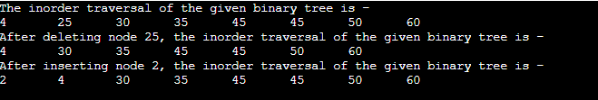

So, that's all about the article. Hope the article will be helpful and informative to you.

# AVL Tree

AVL Tree is invented by GM Adelson - Velsky and EM Landis in 1962. The tree is named AVL in honour of its inventors.

AVL Tree can be defined as height balanced binary search tree in which each node is associated with a balance factor which is calculated by subtracting the height of its right sub-tree from that of its left sub-tree.

Tree is said to be balanced if balance factor of each node is in between -1 to 1, otherwise, the tree will be unbalanced and need to be balanced.

## Balance Factor (k) = height (left(k)) - height (right(k))

If balance factor of any node is 1, it means that the left sub-tree is one level higher than the right sub-tree.

Play Videox[](https://campaign.adpushup.com/get-started/?utm_source=banner&utm_campaign=growth_hack)

If balance factor of any node is 0, it means that the left sub-tree and right sub-tree contain equal height.

If balance factor of any node is -1, it means that the left sub-tree is one level lower than the right sub-tree.

An AVL tree is given in the following figure. We can see that, balance factor associated with each node is in between -1 and +1. therefore, it is an example of AVL tree.

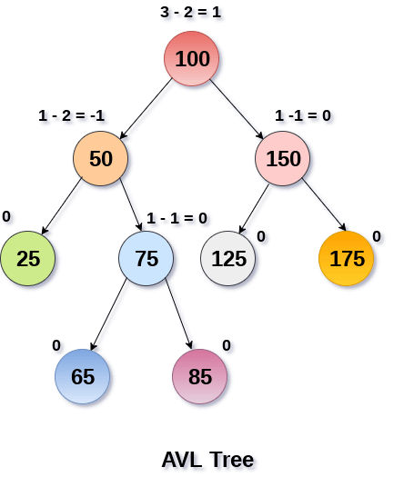

## Complexity

|  |  |  |
| --- | --- | --- |
| **Algorithm** | **Average case** | **Worst case** |
| Space | o(n) | o(n) |
| Search | o(log n) | o(log n) |
| Insert | o(log n) | o(log n) |
| Delete | o(log n) | o(log n) |

## Operations on AVL tree

Due to the fact that, AVL tree is also a binary search tree therefore, all the operations are performed in the same way as they are performed in a binary search tree. Searching and traversing do not lead to the violation in property of AVL tree. However, insertion and deletion are the operations which can violate this property and therefore, they need to be revisited.

|  |  |  |
| --- | --- | --- |
| **SN** | **Operation** | **Description** |
| 1 | [Insertion](https://www.javatpoint.com/insertion-in-avl-tree) | Insertion in AVL tree is performed in the same way as it is performed in a binary search tree. However, it may lead to violation in the AVL tree property and therefore the tree may need balancing. The tree can be balanced by applying rotations. |
| 2 | [Deletion](https://www.javatpoint.com/deletion-in-avl-tree) | Deletion can also be performed in the same way as it is performed in a binary search tree. Deletion may also disturb the balance of the tree therefore, various types of rotations are used to rebalance the tree. |

## Why AVL Tree?

AVL tree controls the height of the binary search tree by not letting it to be skewed. The time taken for all operations in a binary search tree of height h is **O(h)**. However, it can be extended to **O(n)** if the BST becomes skewed (i.e. worst case). By limiting this height to log n, AVL tree imposes an upper bound on each operation to be **O(log n)** where n is the number of nodes.

## AVL Rotations

We perform rotation in AVL tree only in case if Balance Factor is other than **-1, 0, and 1**. There are basically four types of rotations which are as follows:

1. L L rotation: Inserted node is in the left subtree of left subtree of A
2. R R rotation : Inserted node is in the right subtree of right subtree of A
3. L R rotation : Inserted node is in the right subtree of left subtree of A
4. R L rotation : Inserted node is in the left subtree of right subtree of A

Where node A is the node whose balance Factor is other than -1, 0, 1.

The first two rotations LL and RR are single rotations and the next two rotations LR and RL are double rotations. For a tree to be unbalanced, minimum height must be at least 2, Let us understand each rotation

### 1. RR Rotation

When BST becomes unbalanced, due to a node is inserted into the right subtree of the right subtree of A, then we perform RR rotation, [RR rotation](https://www.javatpoint.com/rr-rotation-in-avl-tree) is an anticlockwise rotation, which is applied on the edge below a node having balance factor -2

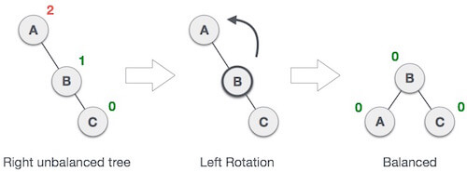

In above example, node A has balance factor -2 because a node C is inserted in the right subtree of A right subtree. We perform the RR rotation on the edge below A.

### 2. LL Rotation

When BST becomes unbalanced, due to a node is inserted into the left subtree of the left subtree of C, then we perform LL rotation, [LL rotation](https://www.javatpoint.com/ll-rotation-in-avl-tree) is clockwise rotation, which is applied on the edge below a node having balance factor 2.

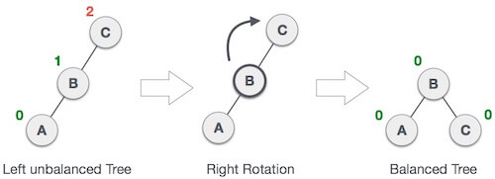

In above example, node C has balance factor 2 because a node A is inserted in the left subtree of C left subtree. We perform the LL rotation on the edge below A.

### 3. LR Rotation

Double rotations are bit tougher than single rotation which has already explained above. LR rotation = RR rotation + LL rotation, i.e., first RR rotation is performed on subtree and then LL rotation is performed on full tree, by full tree we mean the first node from the path of inserted node whose balance factor is other than -1, 0, or 1.

**Let us understand each and every step very clearly:**

|  |  |
| --- | --- |
| **State** | **Action** |
| AVL Rotations | A node B has been inserted into the right subtree of A the left subtree of C, because of which C has become an unbalanced node having balance factor 2. This case is L R rotation where: Inserted node is in the right subtree of left subtree of C |
| AVL Rotations | As LR rotation = RR + LL rotation, hence RR (anticlockwise) on subtree rooted at A is performed first. By doing RR rotation, node **A**, has become the left subtree of **B**. |
| AVL Rotations | After performing RR rotation, node C is still unbalanced, i.e., having balance factor 2, as inserted node A is in the left of left of **C** |
| AVL Rotations | Now we perform LL clockwise rotation on full tree, i.e. on node C. node **C** has now become the right subtree of node B, A is left subtree of B |
| AVL Rotations | Balance factor of each node is now either -1, 0, or 1, i.e. BST is balanced now. |

### 4. RL Rotation

As already discussed, that double rotations are bit tougher than single rotation which has already explained above. [R L rotation](https://www.javatpoint.com/rl-rotation-in-avl-tree) = LL rotation + RR rotation, i.e., first LL rotation is performed on subtree and then RR rotation is performed on full tree, by full tree we mean the first node from the path of inserted node whose balance factor is other than -1, 0, or 1.

|  |  |
| --- | --- |
| **State** | **Action** |
| AVL Rotations | A node **B** has been inserted into the left subtree of **C** the right subtree of **A**, because of which A has become an unbalanced node having balance factor - 2. This case is RL rotation where: Inserted node is in the left subtree of right subtree of A |
| AVL Rotations | As RL rotation = LL rotation + RR rotation, hence, LL (clockwise) on subtree rooted at **C** is performed first. By doing RR rotation, node **C** has become the right subtree of **B**. |
| AVL Rotations | After performing LL rotation, node **A** is still unbalanced, i.e. having balance factor -2, which is because of the right-subtree of the right-subtree node A. |
| AVL Rotations | Now we perform RR rotation (anticlockwise rotation) on full tree, i.e. on node A. node **C** has now become the right subtree of node B, and node A has become the left subtree of B. |
| AVL Rotations | Balance factor of each node is now either -1, 0, or 1, i.e., BST is balanced now. |

### Q: Construct an AVL tree having the following elements

**H, I, J, B, A, E, C, F, D, G, K, L**

**1. Insert H, I, J**

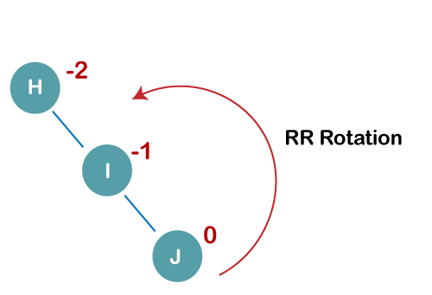

On inserting the above elements, especially in the case of H, the BST becomes unbalanced as the Balance Factor of H is -2. Since the BST is right-skewed, we will perform RR Rotation on node H.

**The resultant balance tree is:**

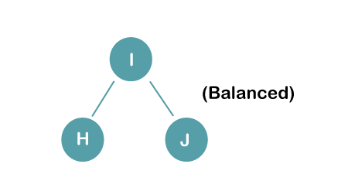

**2. Insert B, A**

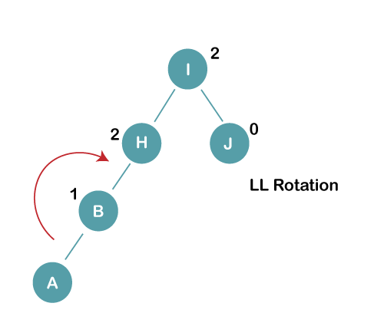

On inserting the above elements, especially in case of A, the BST becomes unbalanced as the Balance Factor of H and I is 2, we consider the first node from the last inserted node i.e. H. Since the BST from H is left-skewed, we will perform LL Rotation on node H.

**The resultant balance tree is:**

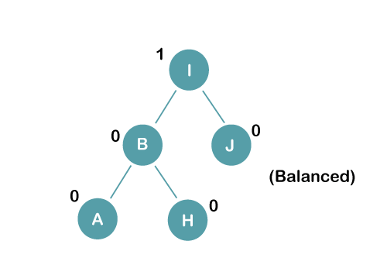

**3. Insert E**

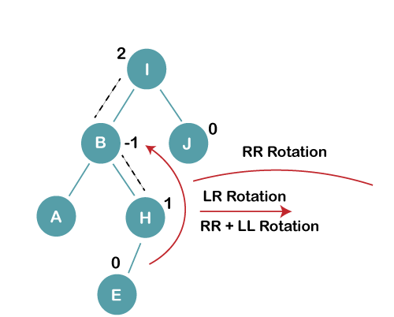

On inserting E, BST becomes unbalanced as the Balance Factor of I is 2, since if we travel from E to I we find that it is inserted in the left subtree of right subtree of I, we will perform LR Rotation on node I. LR = RR + LL rotation

**3 a) We first perform RR rotation on node B**

**The resultant tree after RR rotation is:**

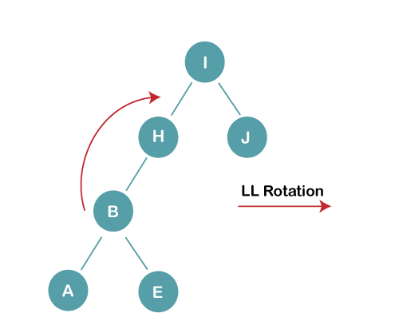

**3b) We first perform LL rotation on the node I**

**The resultant balanced tree after LL rotation is:**

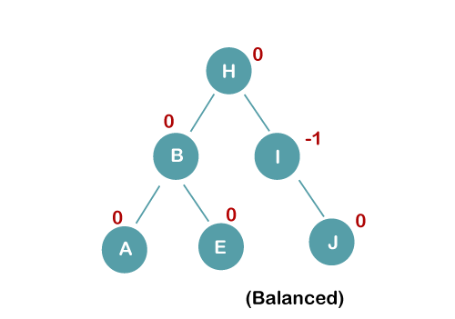

**4. Insert C, F, D**

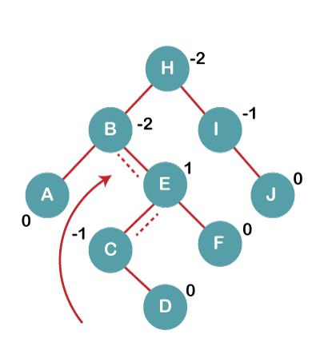

On inserting C, F, D, BST becomes unbalanced as the Balance Factor of B and H is -2, since if we travel from D to B we find that it is inserted in the right subtree of left subtree of B, we will perform RL Rotation on node I. RL = LL + RR rotation.

**4a) We first perform LL rotation on node E**

**The resultant tree after LL rotation is:**

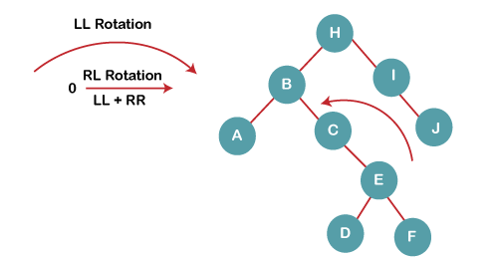

**4b) We then perform RR rotation on node B**

**The resultant balanced tree after RR rotation is:**

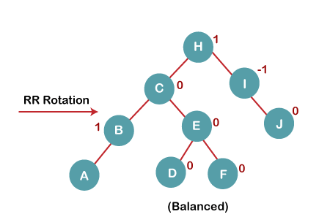

**5. Insert G**

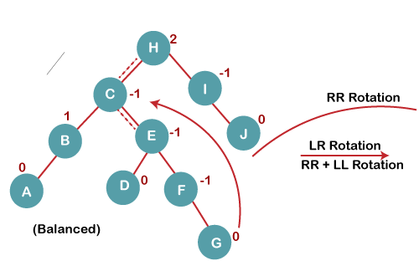

On inserting G, BST become unbalanced as the Balance Factor of H is 2, since if we travel from G to H, we find that it is inserted in the left subtree of right subtree of H, we will perform LR Rotation on node I. LR = RR + LL rotation.

**5 a) We first perform RR rotation on node C**

**The resultant tree after RR rotation is:**

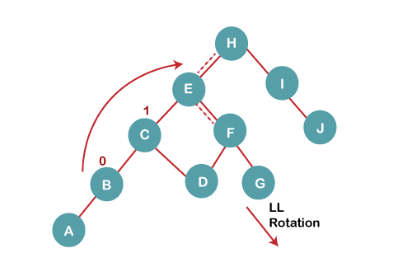

**5 b) We then perform LL rotation on node H**

**The resultant balanced tree after LL rotation is:**

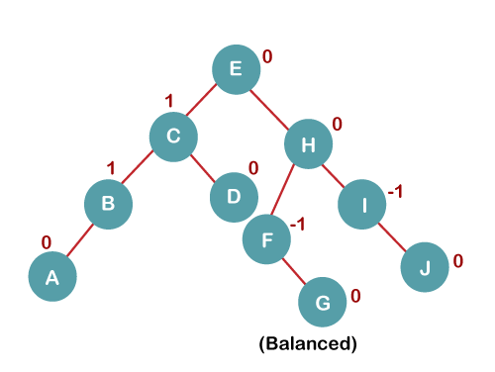

**6. Insert K**

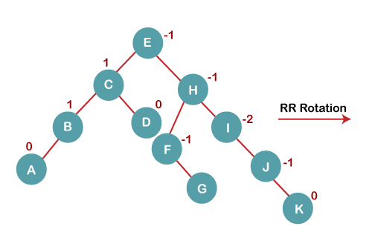

On inserting K, BST becomes unbalanced as the Balance Factor of I is -2. Since the BST is right-skewed from I to K, hence we will perform RR Rotation on the node I.

**The resultant balanced tree after RR rotation is:**

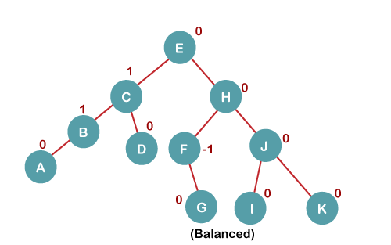

**7. Insert L**

On inserting the L tree is still balanced as the Balance Factor of each node is now either, -1, 0, +1. Hence the tree is a Balanced AVL tree

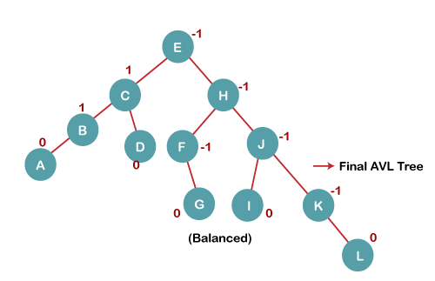

# B Tree

B Tree is a specialized m-way tree that can be widely used for disk access. A B-Tree of order m can have at most m-1 keys and m children. One of the main reason of using B tree is its capability to store large number of keys in a single node and large key values by keeping the height of the tree relatively small.

A B tree of order m contains all the properties of an M way tree. In addition, it contains the following properties.

1. Every node in a B-Tree contains at most m children.
2. Every node in a B-Tree except the root node and the leaf node contain at least m/2 children.
3. The root nodes must have at least 2 nodes.
4. All leaf nodes must be at the same level.

It is not necessary that, all the nodes contain the same number of children but, each node must have m/2 number of nodes.

A B tree of order 4 is shown in the following image.

Play Videox[](https://campaign.adpushup.com/get-started/?utm_source=banner&utm_campaign=growth_hack)

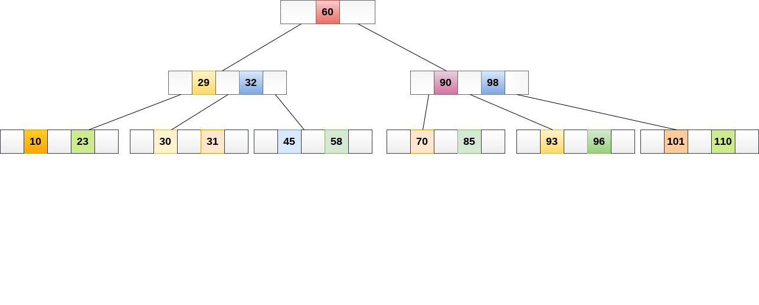

While performing some operations on B Tree, any property of B Tree may violate such as number of minimum children a node can have. To maintain the properties of B Tree, the tree may split or join.

## Operations

### Searching :

Searching in B Trees is similar to that in Binary search tree. For example, if we search for an item 49 in the following B Tree. The process will something like following :

1. Compare item 49 with root node 78. since 49 < 78 hence, move to its left sub-tree.
2. Since, 40<49<56, traverse right sub-tree of 40.
3. 49>45, move to right. Compare 49.
4. match found, return.

Searching in a B tree depends upon the height of the tree. The search algorithm takes O(log n) time to search any element in a B tree.

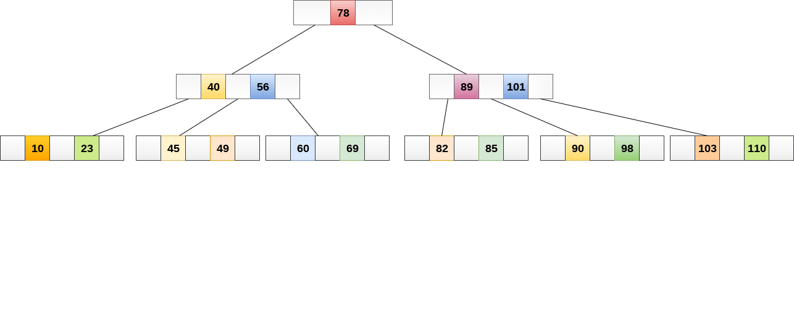

### Inserting

Insertions are done at the leaf node level. The following algorithm needs to be followed in order to insert an item into B Tree.

1. Traverse the B Tree in order to find the appropriate leaf node at which the node can be inserted.
2. If the leaf node contain less than m-1 keys then insert the element in the increasing order.
3. Else, if the leaf node contains m-1 keys, then follow the following steps.
   * Insert the new element in the increasing order of elements.
   * Split the node into the two nodes at the median.
   * Push the median element upto its parent node.
   * If the parent node also contain m-1 number of keys, then split it too by following the same steps.

**Example:**

Insert the node 8 into the B Tree of order 5 shown in the following image.

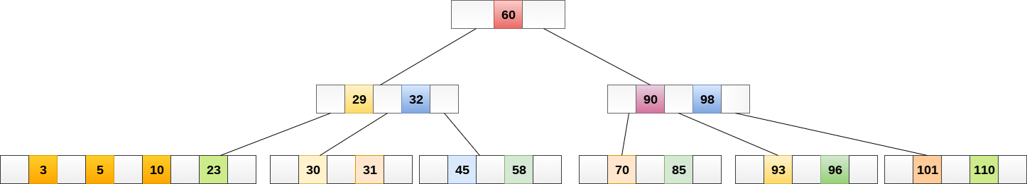

8 will be inserted to the right of 5, therefore insert 8.

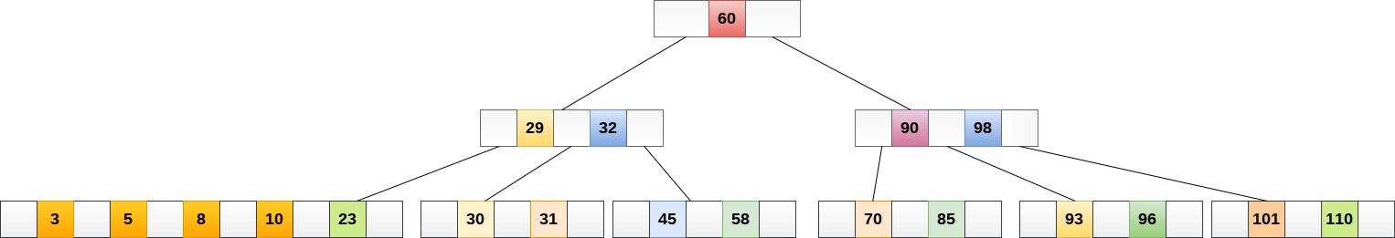

The node, now contain 5 keys which is greater than (5 -1 = 4 ) keys. Therefore split the node from the median i.e. 8 and push it up to its parent node shown as follows.

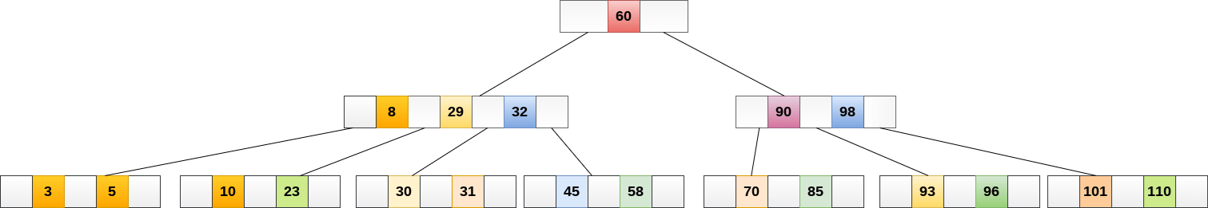

### Deletion

Deletion is also performed at the leaf nodes. The node which is to be deleted can either be a leaf node or an internal node. Following algorithm needs to be followed in order to delete a node from a B tree.

1. Locate the leaf node.
2. If there are more than m/2 keys in the leaf node then delete the desired key from the node.
3. If the leaf node doesn't contain m/2 keys then complete the keys by taking the element from eight or left sibling.
   * If the left sibling contains more than m/2 elements then push its largest element up to its parent and move the intervening element down to the node where the key is deleted.
   * If the right sibling contains more than m/2 elements then push its smallest element up to the parent and move intervening element down to the node where the key is deleted.
4. If neither of the sibling contain more than m/2 elements then create a new leaf node by joining two leaf nodes and the intervening element of the parent node.
5. If parent is left with less than m/2 nodes then, apply the above process on the parent too.

If the the node which is to be deleted is an internal node, then replace the node with its in-order successor or predecessor. Since, successor or predecessor will always be on the leaf node hence, the process will be similar as the node is being deleted from the leaf node.

**Example 1**

Delete the node 53 from the B Tree of order 5 shown in the following figure.

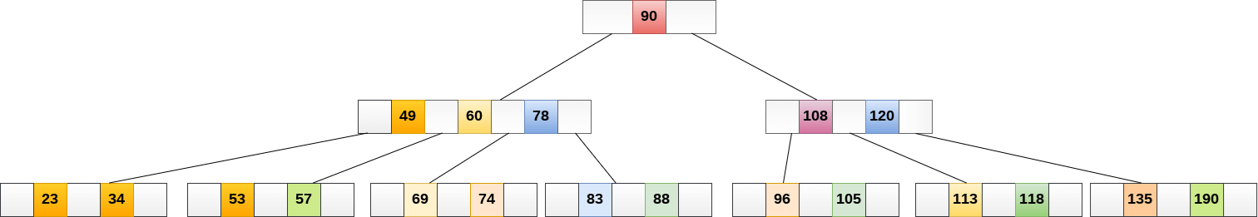

53 is present in the right child of element 49. Delete it.

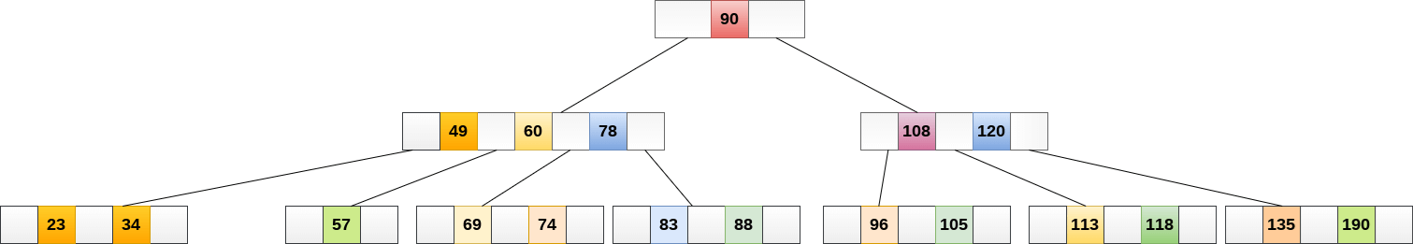

Now, 57 is the only element which is left in the node, the minimum number of elements that must be present in a B tree of order 5, is 2. it is less than that, the elements in its left and right sub-tree are also not sufficient therefore, merge it with the left sibling and intervening element of parent i.e. 49.

The final B tree is shown as follows.

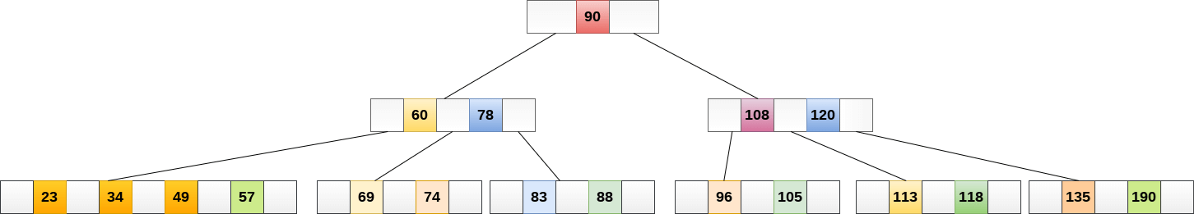

## Application of B tree

B tree is used to index the data and provides fast access to the actual data stored on the disks since, the access to value stored in a large database that is stored on a disk is a very time consuming process.

Searching an un-indexed and unsorted database containing n key values needs O(n) running time in worst case. However, if we use B Tree to index this database, it will be searched in O(log n) time in worst case.

# B+ Tree

B+ Tree is an extension of B Tree which allows efficient insertion, deletion and search operations.

In B Tree, Keys and records both can be stored in the internal as well as leaf nodes. Whereas, in B+ tree, records (data) can only be stored on the leaf nodes while internal nodes can only store the key values.

The leaf nodes of a B+ tree are linked together in the form of a singly linked lists to make the search queries more efficient.

B+ Tree are used to store the large amount of data which can not be stored in the main memory. Due to the fact that, size of main memory is always limited, the internal nodes (keys to access records) of the B+ tree are stored in the main memory whereas, leaf nodes are stored in the secondary memory.

The internal nodes of B+ tree are often called index nodes. A B+ tree of order 3 is shown in the following figure.

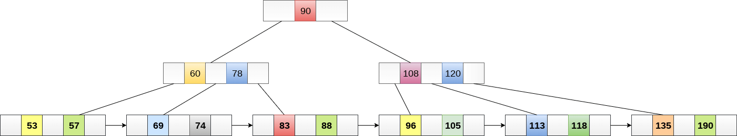

## Advantages of B+ Tree

1. Records can be fetched in equal number of disk accesses.
2. Height of the tree remains balanced and less as compare to B tree.
3. We can access the data stored in a B+ tree sequentially as well as directly.
4. Keys are used for indexing.
5. Faster search queries as the data is stored only on the leaf nodes.

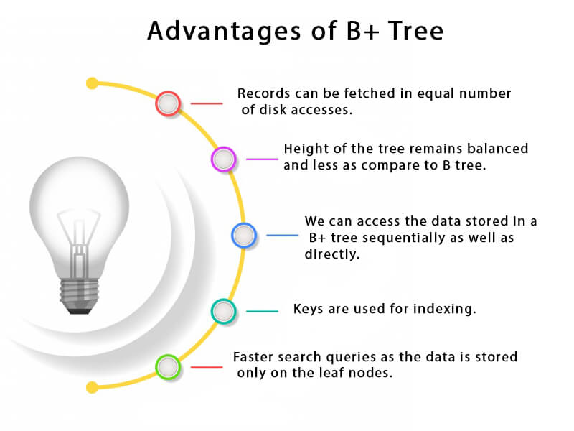

## B Tree VS B+ Tree

|  |  |  |
| --- | --- | --- |
| **SN** | **B Tree** | **B+ Tree** |
| 1 | Search keys can not be repeatedly stored. | Redundant search keys can be present. |
| 2 | Data can be stored in leaf nodes as well as internal nodes | Data can only be stored on the leaf nodes. |
| 3 | Searching for some data is a slower process since data can be found on internal nodes as well as on the leaf nodes. | Searching is comparatively faster as data can only be found on the leaf nodes. |
| 4 | Deletion of internal nodes are so complicated and time consuming. | Deletion will never be a complexed process since element will always be deleted from the leaf nodes. |
| 5 | Leaf nodes can not be linked together. | Leaf nodes are linked together to make the search operations more efficient. |

## Insertion in B+ Tree

**Step 1:** Insert the new node as a leaf node

**Step 2:** If the leaf doesn't have required space, split the node and copy the middle node to the next index node.

**Step 3:** If the index node doesn't have required space, split the node and copy the middle element to the next index page.

### Example :

Insert the value 195 into the B+ tree of order 5 shown in the following figure.

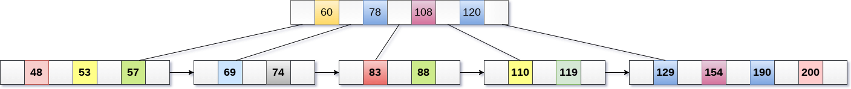

195 will be inserted in the right sub-tree of 120 after 190. Insert it at the desired position.



The node contains greater than the maximum number of elements i.e. 4, therefore split it and place the median node up to the parent.



Now, the index node contains 6 children and 5 keys which violates the B+ tree properties, therefore we need to split it, shown as follows.

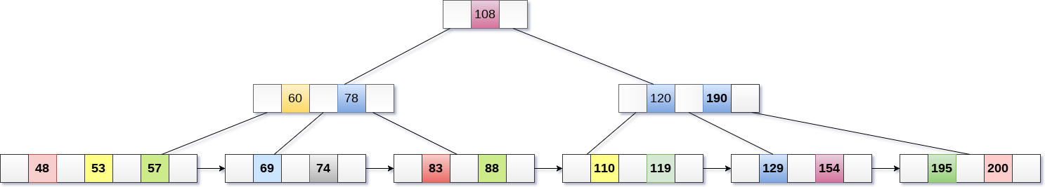

## Deletion in B+ Tree

**Step 1:** Delete the key and data from the leaves.

**Step 2:** if the leaf node contains less than minimum number of elements, merge down the node with its sibling and delete the key in between them.

**Step 3:** if the index node contains less than minimum number of elements, merge the node with the sibling and move down the key in between them.

### Example

Delete the key 200 from the B+ Tree shown in the following figure.

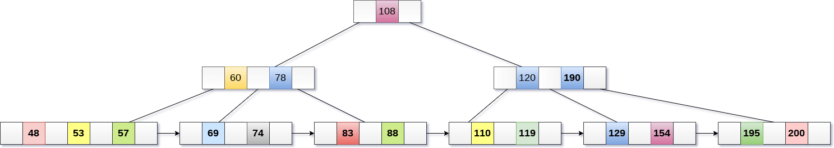

200 is present in the right sub-tree of 190, after 195. delete it.

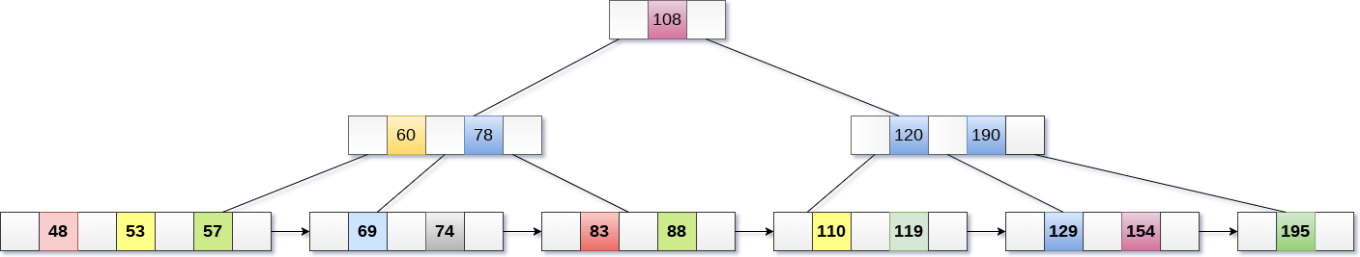

Merge the two nodes by using 195, 190, 154 and 129.

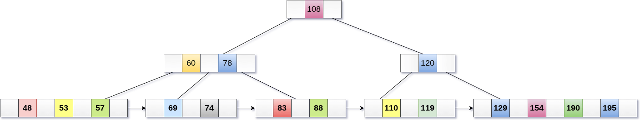

Now, element 120 is the single element present in the node which is violating the B+ Tree properties. Therefore, we need to merge it by using 60, 78, 108 and 120.

Now, the height of B+ tree will be decreased by 1.

